|  |
| --- |
|  |

|  |
| --- |
|  |
| Bachelor of Science in  Information Technology Capstone |
| 2014.02.17  Analysis of security appliances log files based on public lists of malicious internet protocol addresses  by  Panagiotis Krommydakis |
| New Hampshire, 2014 |

|  |
| --- |
|  |
| Bachelor of Science in  Information Technology Capstone |
| 2014.02.17  Analysis of security appliances log files based on public lists of malicious internet protocol addresses  by  Panagiotis Krommydakis  Approved by:   |  |  |  | | --- | --- | --- | | Panagiotis Karampelas, PhD  Assistant Professor of Information Technology  Hellenic American University |  | Christos Pavlatos, PhD  Assistant Professor of Information Technology  Hellenic American University |   submitted: [insert date]  approved: [insert date]  A capstone submitted in partial fulfillment of the requirements for the degree of BSIT |
| New Hampshire, 2014 |

Abstract

This capstone project aims to investigate the effectiveness and efficiency of a detective logical (technical) safeguard, in the form of a software tool, which will help security administrators and/or security officers identifying –in a timely fashion- external attacks occurring at the perimeter of an enterprise network. More particularly, a proof of concept (POC) will be implemented in order to evaluate the concept feasibility in real world conditions. Nevertheless, hints and tips about the next steps, according to an iterative Software Development Lifecycle (SDLC) process, will be presented as needed to the reader throughout the document. The goal, for such approach, is to support any future work having as basis this POC.

A capstone project, as defined on the “[Educational Reform](http://edglossary.org/capstone-project/)” site, is a “multifaceted assignment that serves as a culminating academic and intellectual experience”. To that end, here is the correlation of knowledge and skills gained from the BSIT program of Hellenic American University (HAUniv) with the work accomplished in the context of this project:

1. **Setup of the Business Case**

* [IT160 Networking Fundamentals I](http://www.hauniv.edu/?i=hau-uni.en.bsit-course-descriptions&id=375)
* [IT165 Networking Fundamentals II](http://www.hauniv.edu/?i=hau-uni.en.bsit-course-descriptions&id=322)
* [IT295 Implement Secure Networks](http://www.hauniv.edu/?i=hau-uni.en.bsit-course-descriptions&id=390)
* [IT420 Information Security & Assurance](http://www.hauniv.edu/?i=hau-uni.en.bsit-course-descriptions&id=386)

1. **System Analysis and Design**

* [IT280 Systems Analysis and Design](http://www.hauniv.edu/?i=hau-uni.en.bsit-course-descriptions&id=319)
* [IT340 Management Information Systems](http://www.hauniv.edu/?i=hau-uni.en.bsit-course-descriptions&id=376)

1. **Capstone Project Planning and Execution**

* [IT350 Project Management](http://www.hauniv.edu/?i=hau-uni.en.bsit-course-descriptions&id=308)

1. **System Implementation**

* [IT150 Programming Concepts](http://www.hauniv.edu/?i=hau-uni.en.bsit-course-descriptions&id=313)
* [IT200 Object-Oriented Programming](http://www.hauniv.edu/?i=hau-uni.en.bsit-course-descriptions&id=314)
* [IT220 Data Structures & Algorithms](http://www.hauniv.edu/?i=hau-uni.en.bsit-course-descriptions&id=315)
* [IT205 Advanced Programming in Java](http://www.hauniv.edu/?i=hau-uni.en.bsit-course-descriptions&id=383)
* I[T260 Database Management Systems](http://www.hauniv.edu/?i=hau-uni.en.bsit-course-descriptions&id=317)
* [IT320 Web Technology](http://www.hauniv.edu/?i=hau-uni.en.bsit-course-descriptions&id=320)
* [IT400 Emerging Technologies and Themes](http://www.hauniv.edu/?i=hau-uni.en.bsit-course-descriptions&id=311)

1. **Capstone Documentation**

* GE105 Writing I: Academic Literacies
* GE106 Writing II: Expanding Academic Literacies
* GE112 Critical Thinking

1. **Capstone Presentation to the Review Committee**

* GE115 Public Speaking

**Keywords**:

FIREWALL

SECURITY APPLIANCE

ATTACK

THREAT AGENT

MALICIOUS IP

JAVA

J2EE

WEB SERVICE

SIEM

ISMS

Acknowledgements

I would like to thank the following people for the role they played throughout the entire process of completing this capstone:

* My Significant Other, Georgia, for her words of encouragement, and her love. Thanks for your support, patience and trust in me.
* To the faculty members and employees of Hellenic American University, who have guided, supported and assisted me along my undergraduate studies—thank you all for this precious journey.
* To Dr. Zoi Ekaterinidi and my colleagues at “Software Competitiveness International” who have always “been there” for me.
* To the kind, decent and hardworking people who have touched my life. You will always inspire me to be the best I can be.

TABLE OF CONTENTS

Chapter 1. Introduction 17

Chapter 2. Information Security Governance, Risk Management and Access Controls 20

Chapter 3. Commercial Security Information and Event Management (SIEM) Solutions 28

3.1. Gartner’s annual Magic Quadrant Report on SIEM 28

3.2. Inclusion Criteria 30

3.3. Major Evaluation Criteria 30

3.4. Customer Requirements 31

Chapter 4. The Business Case 33

4.1. The Small-Medium Enterprise Network 33

Enterprise Core 34

Intranet Data Centre 35

Enterprise Campus 35

Enterprise Internet Edge 35

Enterprise WAN Edge 35

4.2. Internet Firewall Configuration Guidelines 35

4.3. Commercial Firewall Solutions 36

4.4. Open Source and Freeware Firewall Solutions 37

4.5. SysLog 38

Chapter 5. Requirements Engineering 40

5.1. Stakeholders Identification 40

5.2. High Level User Requirements Elicitation 40

Naming Conventions for the User Requirements 40

AM-UR-01: Solution shall Use Open Source and License Free Technologies 40

AM-UR-02: Solution shall Use Publicly Available Information from Trusted Sources 41

AM-UR-03: Solution shall introduce Intelligence on External Attacks Identification 41

AM-UR-04: Solution shall Identify External Attacks in a Timely Fashion 41

AM-UR-05: External Attacks shall be displayed on Smart Devices 41

AM-UR-06: Solution shall alert the End Users in case of External Attacks 41

AM-UR-07: Solution shall be based on Cutting-Edge Web Technologies 42

AM-UR-08: Solution operation shall be fully automated 42

AM-UR-09: Solution shall be Reliable 42

AM-UR-10: Solution shall be Modular 42

AM-UR-11: Solution shall be Scalable 42

AM-UR-12: Solution shall be Secure 42

AM-UR-13: Solution shall be User Friendly 42

AM-UR-14: Solution shall support Regulatory Compliance 43

5.3. User Requirements Prioritization Concept 43

5.4. User Requirements Prioritization 43

5.5. User Requirements included in the Proof of Concept 44

Chapter 6. Functional and Non-Functional Specification 47

6.1. The Internet Storm Center / DShield API 47

6.2. Attack Monitor Hardware Specifications 48

6.3. System Actors 48

Security Administrator 48

Information Security Officer 49

Security Auditor 49

6.4. Use Cases 50

6.5. Functional and No-Functional Requirement’s Naming Conventions 52

6.6. Requirements Forward Traceability Matrix 53

Chapter 7. System Architecture 54

Chapter 8. Design Specification 55

8.1. The Proof-Of-Concept Scenario 55

POC design – Step 1 55

POC design – Step 3 57

POC design – Step 4 58

POC design – Step 5 59

POC design – Step 6 60

8.2. Selection of High Level Programming Languages 61

8.3. Accessing the Internet Storm Center / DShield API 62

XML Validation 63

Reading XML Data into a DOM 65

8.4. The Relational Database 65

8.5. Log File (text) Parsing 65

8.6. The RESTful Web Service 66

8.7. The Database Connector and the Application Server 67

8.8. The RestKit Framework 67

Chapter 9. Prototype (POC) Implementation 69

9.1. Implementation and Release Notes 69

9.2. The MySQL Database 69

9.3. The XML Parser 72

The Main.java Class 73

The NodeType.java Class 75

The XmlConfigurationParser.java Class 76

9.4. The Firewall Log File Text Parser 78

The JavaFileScanner.java Class 79

9.5. The RESTFul Web Service 82

NETBeans IDE Configuration 83

The MySQLClassLib Project Creation 87

The MySQLService Project Creation 94

Testing and Troubleshooting the Web Service 103

9.6. The Demo IOs App (“Attack Monitor”) 122

Installation of the RestKit Framework 123

Attack.h 124

Attack.m 125

AppDelegate.h 125

AppDelegate.m 126

MasterViewController.h 128

MasterViewController.m 129

Chapter 10. Test Specification 134

10.1. Testing Strategy 134

10.2. Testing Environment 134

10.3. Test Activities 134

10.4. Tests Execution Strategy 135

10.5. Defects Management System 135

10.6. Inter-case Dependencies 136

10.7. Suspension Criteria and Resumption Requirements 136

10.8. Correction Verification Tests 136

10.9. Regression Tests 136

10.10. Test Automation 136

10.11. Fault Reports and Bug fixes handling 136

10.12. Quality Assurance – UAT Completion Criteria 137

10.13. Acceptance Criteria 137

10.14. User Acceptance Tests Report Form 137

10.15. Testcase Identifiers 138

10.16. Testcase Template 138

Chapter 11. Prototype Test Run and Evaluation 140

11.1. Step 1 – Database Cleanup 140

11.2. Step 2 – Retrieve the List of Malicious IPs from Internet Storm Center 144

11.3. Step 3 – Prepare the Test Data for the Simulated Attack 146

11.4. Step 4 – Parse the Firewall Log and Search for Well-Known Threats 148

11.5. Step 5 – Publish the Information regarding the Identified Attacks 149

11.6. Step 6 – Run the iOS “Attack Monitor” App 151

11.7. POC Evaluation 156

Chapter 12. Future Work 159

Chapter 13. Conclusion 160

List of figures

Figure 1: Low hacking activity 17

Figure 2: High hacking activity 18

Figure 3: Gartner Magic Quadrant for SIEM in 2013 29

Figure 4: Typical SME network 34

Figure 5: Gartner Magic Quadrant for Firewalls in 2014 37

Figure 6: System Actors 48

Figure 7: Solution Architecture 54

Figure 8: POC – Step 1 56

Figure 9: POC – Step 2 57

Figure 10: POC – Step 3 58

Figure 11: POC – Step 4 59

Figure 12: POC – Step 5 60

Figure 13: POC – Step 6 61

Figure 14: XML Input 63

Figure 14: XML Validation Result 65

Figure 16: MySQL Workbench – The new database 70

Figure 17: MySQL Workbench – The “sans” table 70

Figure 18: MySQL Workbench – Records of he “sans” table 71

Figure 19: MySQL Workbench – The “threat” table 71

Figure 20: MySQL Workbench – Records of the “threat” table 72

Figure 21: The XML Parser Eclipse project 73

Figure 22: The Java File Scanner Eclipse project 79

Figure 23: The two NetBeans projects 83

Figure 24: The RestFul Web Service 122

Figure 25: The Attack Monitor IOs App 156

List of Tables

Table 1: Requirements Prioritization Scale 43

Table 2: User Requirements Prioritization Matrix 44

Table 3: User Requirements included in the POC 46

Table 4: Fault Reports and Corrections 137

Table 5 Acceptance Criteria 137

Table 6 Testcase Template 139

Table 7: User Requirements implemented in the POC 157

# Introduction

*"There is widespread agreement that advanced attacks are bypassing our traditional signature-based security controls and persisting undetected on our systems for extended periods of time. The threat is real. You are compromised; you just don't know it."*

- Gartner, Inc.

Norse Corporation maintains a web site (<http://map.ipviking.com/>) under the domain name “map.ipviking.com”, which depicts in real time information regarding malicious internet traffic. Their global cyber intelligence network is comprised of millions of physical and virtual agents around the globe that gather live security intelligence on high-risk network traffic. IPViking continuously analyzes this live traffic data with powerful algorithms that assess over 1,500 different risk factors. The visualizations of this site reveal the hostile environment in which organizations, companies and institutions operate as well as the extent and the severity of hacking problem in our times. The screenshot below depicts a snapshot of low international hacking activity while the next one a burst of attacks:

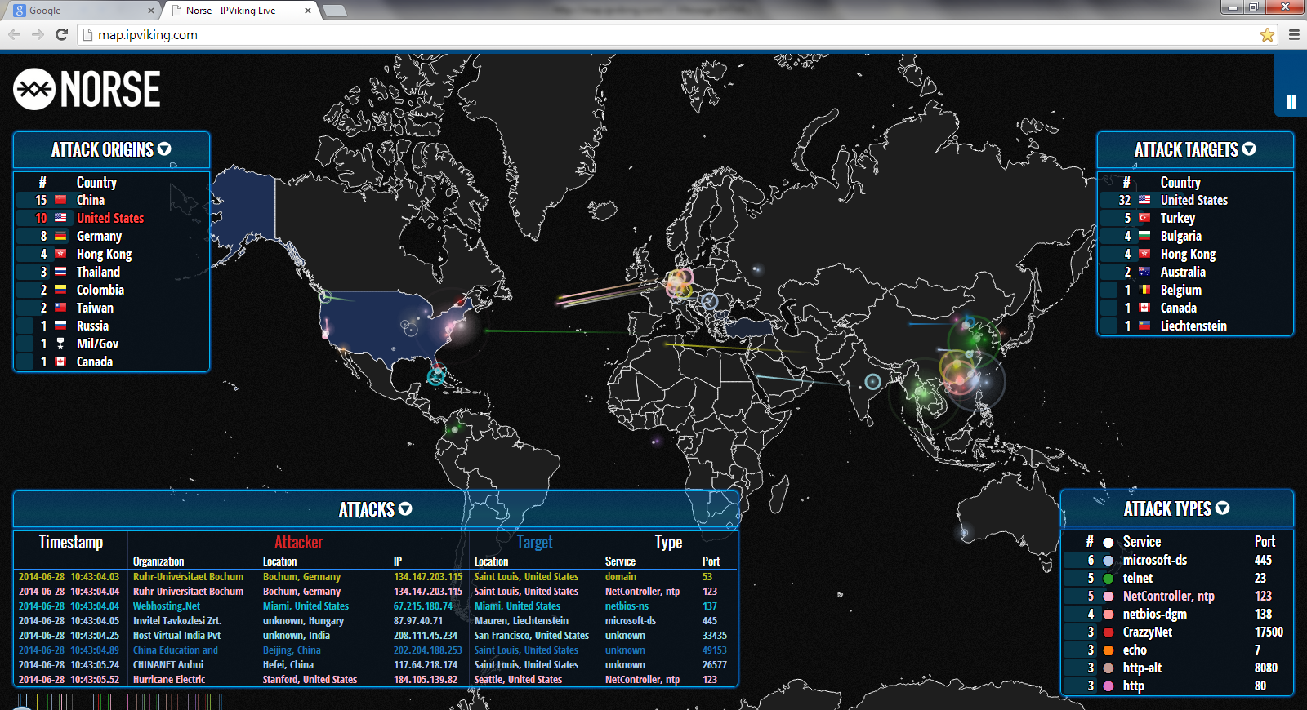

Figure 1: Low hacking activity

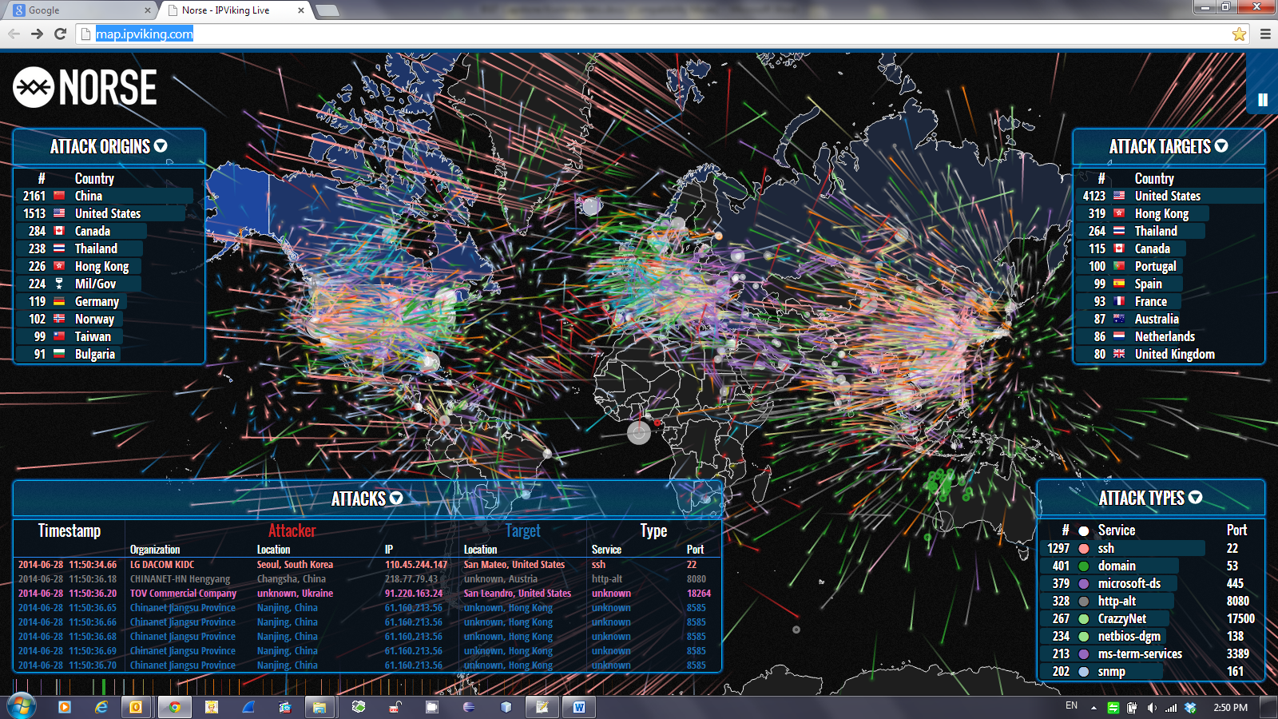

Figure 2: High hacking activity

Security appliances (such as firewalls), which are usually deployed at the network perimeter of an enterprise, filter inbound and outbound traffic based on statically configured rules and policies. Consequently, their preventive capabilities rely heavily upon the experience and competence of the security administrator. To that end, it is always a best practice to collect the log files, of such devices, in a syslog server for further (offline) analysis, by means of detective administrative safeguard. Nevertheless, the information stored in the security log files is not usually correlated with and evaluated against an external database of threats. Manual inspection of the log files is also a non-reliable process for offline incident detection. On the other hand, major IT Security Organizations and Institutions maintain lists of malicious IPs, which are collected from various sources, evaluated/validated and finally published on the Internet. A tool that will automatically parse the security appliances log files against these lists could be a trustworthy companion of the security administrators and/or security officers in their everyday task to protect the company perimeter.

One can find off-the-self software packages, implemented by major international security companies, which are capable of real-time security incident detection. However, such solutions are very expensive and require highly trained personnel to operate them. Therefore, the introduction of such system, by a company, is normally accompanied by the respective Managed Security Services, and a 24/7 SLA, which is also very expensive. Small–Medium Businesses (SMBs) or Small–Medium Enterprises (SMEs) cannot afford the overall cost of such solution. This capstone project has the aforementioned target group of companies in focus, with a view to propose a cost-effective but at the same time reliable solution for offline incident detection.

The overall objective of the capstone is to achieve a significant level of integration between the security appliances, which are used in the network perimeter of enterprises as preventive security controls, and the up-to-date information published by trusted IT Security Organizations/Institutions.

As far as the expected outcome of this project is concerned, the target is to create a proof of concept application that will analyze (by means of text parsing) syslog files retrieved from security appliances (i.e. Checkpoint, Cisco ASA etc.), based on info collected from various lists of malicious IPs (i.e. SANS list), and identify the potential attacks against the enterprise perimeter.

# Information Security Governance, Risk Management and Access Controls

Nowadays, enterprises have to deal with numerous compliance requirements (regulations) while they should operate in a hostile environment in terms of external attacks and malicious insiders (Majdalawieh, 2014). It is essential to identify the information risk profile of the organization. According to J. Pironti (2013), development of an information risk profile is an enterprise-wide process. Many stakeholders shall be involved, such as upper management, auditors, legal and compliance departments as well as various data and process owners. The information risk profile depicts the nature, the priority, the probability and the potential impact of all the risks the organization is exposed to (Pironti, 2013). In a second step senior management should decide which of these risks are acceptable and initiate remedy actions, through the risk mitigation process, for the rest of them (Pironti, 2013). The information risk profile should be developed and modeled in such a way it is easy to comprehend, covers the entire organization and adds value as it is a very useful tool for decision support on the senior management and stakeholders’ levels (Conrad, Misenar, & Feldman, 2012). The information risk profile provides guidance that supports the strategic and tactical objectives of the enterprise through alignment of the company’s goals with the means to achieve them (Harris, 2008). The guiding principles to establish an information risk management program include the following (Conrad, Misenar, & Feldman, 2012):

* Identify the regulations the organization shall comply with;
* Identify all the critical information assets and the corresponding business processes;
* Identify the data, application and system owners as well as the custodians, which are assigned with the operational responsibility;
* Categorize, classify and prioritize the assets according to their value for the organization;
* Ensure the availability of critical business processes and of related data;
* Identify and evaluate accurately the applicable threats, possible vulnerabilities and their associated risks. Thus, the senior management will be able to make appropriate decisions for risk management.
* Ensure that the right controls and safeguards are implemented. Moreover, monitor in a permanent basis these controls in terms of functionality so as to be sure they remain up to date and valid.
* Ensure that budget and resource allocation is done efficiently to maximize the Return-On-Investment (ROI).

Protection of information is based on ensuring the effectiveness of crucial security features. More particularly, Confidentiality, Integrity, and Availability (called the CIA triad) are considered as the cornerstones of information security (Conrad, Misenar, & Feldman, 2012). Confidentiality aims to prevent the unauthorized disclosure of information by means of unauthorized read access to data (Harris, 2008).

Integrity aims to prevent unauthorized modification of information by means of unauthorized write access to data (Harris, 2008). There are two distinguished variants of integrity: (a) data integrity and (b) system integrity (Harris, 2008). Data integrity seeks to protect information against unauthorized modification during data processing while system integrity seeks to protect a system that processes critical data (Harris, 2008). Availability ensures that both systems and information are available when needed and moreover in the form requested by the user for the latter case (Harris, 2008). Protecting the CIA triad has significant impact on the usability factor. Therefore, it is crucial to always balance the need to protect data and systems with the need to keep them accessible for the end users (proportionality). The opposite of the CIA triad is Disclosure, Alteration, and destruction (DAD) (Conrad, Misenar, & Feldman, 2012). Disclosure is the unauthorized disclosure of information, alteration is the unauthorized modification of data, and destruction refers to intentional or unintentional unavailability of data and/or systems (Conrad, Misenar, & Feldman, 2012).

Supplementary features applicable to information security are Authentication, Authorization, and Accountability (AAA). AAA features are applied in a strict sequential order (Conrad, Misenar, & Feldman, 2012). Authentication consists of a verified (that means authenticated) identity claim (Harris, 2008). Identity without proof is a very week – almost meaningless control. At a glance, there are three types of identity verification: (a) something you know (i.e. password), (b) something you have (i.e. smartcard or security token) and (c) something you are (biometrical characteristics) (Harris, 2008). Strong authentication consists of the combination of two or even more verification methods such as a smartcard that can be used after a valid password has been inserted (Harris, 2008). Authorization determines the actions one can perform on a system, and its data, once she has been identified and authenticated (Conrad, Misenar, & Feldman, 2012). Actions may include read, write, or execute rights on data files and system resources (Conrad, Misenar, & Feldman, 2012). Accountability keeps authenticated users accountable for their actions (either authorized or unauthorized and in some cases malicious) (Conrad, Misenar, & Feldman, 2012). This is typically done using system logs/traces and analyzing audit data (transaction logs) (Conrad, Misenar, & Feldman, 2012).  Nonrepudiation ensures that no user could possibly deny having performed an action (Conrad, Misenar, & Feldman, 2012).

Security concepts should by always applied in the context of security valid methods. For instance, least privilege ensures that users are granted the absolutely minimum access rights, which are necessary to perform efficiently their tasks (Harris, 2008). Need to know ensures that users have access only to the specific pieces of information they need to execute their tasks (according to their authorization level always) (Harris, 2008). Defense-in-Depth (also called layered security or bull’s-eye) applies multiple safeguards (also called controls: measures taken to reduce risk) to protect an organization (Harris, 2008). While any security control may fail under certain circumstances deploying multiple controls on various systems improve the confidentiality, integrity, and availability of the enterprise information (Conrad, Misenar, & Feldman, 2012).

“The average person does a poor job of accurately analyzing risk: if you fear the risk of dying while traveling, and drive from New York to Florida instead of flying to mitigate that risk, you have done a poor job of analyzing risk” (Conrad, Misenar, & Feldman, 2012). Travelling by car is much riskier than by airplane when taking into consideration the related accident statistics. Accurate Risk Analysis is a critical skill for every professional assigned with such responsibilities. Risk analysis decisions will dictate which safeguards should be deployed to protect the critical assets as well as the amount of money and resources to be spent (Conrad, Misenar, & Feldman, 2012). Quantitative and Qualitative Risk Analysis are two methods for analyzing risk (Scherling, 2011). Quantitative Risk Analysis uses hard metrics, such as money figures. Qualitative Risk Analysis uses simple describing values. While quantitative is more objective, qualitative is 100% subjective and relies on the experience and the background of the managers performing it (Scherling, 2011). Quantitative Risk Analysis is more difficult (Harris, 2008). Assets are valuable tangible and intangible enterprise property that shall be protected. Assets can be data, systems, people, buildings etc (Scherling, 2011). The value of an asset for the organization will finally determine which and how sophisticated safeguards should be deployed. People are a priori the most valuable asset (Harris 2008). A threat is defined as a potential negative (or even catastrophic) incident, like earthquakes, power or network outages (Conrad, Misenar, & Feldman, 2012). Vulnerability is a weakness that may lead to a threat realization (Conrad, Misenar, & Feldman, 2012). “Examples of vulnerabilities are data center without proper backup power, or a Microsoft Windows XP system that has not been patched in a few years” (Conrad, Misenar, & Feldman, 2012). Risk value occurs as the multiplication of a specific threat with the related vulnerability: “Risk = Threat × Vulnerability” (Harris, 2008). Usually, a number in the range 1-5, is assigned to both threats and vulnerabilities (Harris, 2008). While the range is a matter of definition it is essential to keep it consistent when comparing different risks (Conrad, Misenar, & Feldman, 2012). An additional parameter, called impact, can be also taken under consideration when calculating the risk as follows: “Risk = Threat × Vulnerability × Impact” (Harris, 2008). Impact depicts the severity of the damage when a specific risk is realized (Harris, 2008). “The Risk Analysis Matrix uses a quadrant to map the likelihood of a risk occurring against the consequences (or impact) that risk would have” (Conrad, Misenar, & Feldman, 2012). The Risk Analysis Matrix allows to perform Qualitative Risk Analysis based on likelihood (from "rare" to "almost certain") and consequences (or impact), from "insignificant" to "catastrophic" (Conrad, Misenar, & Feldman, 2012). The resulting indicators are Low (L), Medium (M), High (H), and Extreme Risk (E) (Conrad, Misenar, & Feldman, 2012). Low risks can be managed via the already available processes without escalation (Scherling, 2011). Moderate risk requires medium-level management involvement, while high risks require escalation to senior management (c-level) (Scherling, 2011). Extreme high risks require immediate action by senior management including a strict mitigation and follow up plan (Scherling, 2011). The goal of the matrix is to reveal high likelihood/high impact risks, and mitigate them to acceptable levels (Scherling, 2011). The Annualized Loss Expectancy (ALE) calculation helps to calculate the annual cost of a loss due to a risk realization (Harris, 2008). Therefore, ALE is primary parameter to be considered so as to make decisions to mitigate the risk (Scherling, 2011). ALE depends on the Asset Value (AV) and the so-called exposure factor (Harris, 2008). The Exposure Factor (EF) is defined as the percentage of the asset value that is lost due to an event (Harris, 2008). Accordingly, the Single Loss Expectancy (SLE) is the cost for a single occurrence as follows: SLE is the Asset Value (AV) times the Exposure Factor (EF) (Harris, 2008).  The Annual Rate of Occurrence (ARO) is the number of incidents occurring in yearly basis (Harris, 2008). The Annualized Loss Expectancy (ALE) is the yearly cost due to a certain risk (Conrad, Misenar, & Feldman, 2012). It is calculated by multiplying the Single Loss Expectancy (SLE) times the Annual Rate of Occurrence (ARO) (Conrad, Misenar, & Feldman, 2012). The Total Cost of Ownership (TCO) is the budget required to deploy a safeguard so as to mitigate a risk to acceptable levels (Conrad, Misenar, & Feldman, 2012). The Return on Investment (ROI) is the amount of money saved by deploying a safeguard. Consequently, if the annual Total Cost of Ownership (TCO), for maintaining a safeguard in operational state, is less than the Annualized Loss Expectancy (ALE), then ROI is positive (Conrad, Misenar, & Feldman, 2012). Otherwise, alternatives for the specific risk handling shall be considered.

As soon as the organization has assessed risk the next steps in the risk management process have to be decided. Valid options include accepting the risk, mitigating the risk, transferring the risk, and avoiding the risk (Harris, 2008). First of all, some risks may be accepted because it is cheaper to leave an asset unprotected rather than spending a ton of money to protect it. Upper management notification and approval is always needed in such cases. Low likelihood and low impact risks are good cases for risk acceptance (Conrad, Misenar, & Feldman, 2012). However, high and extreme risks can never be accepted as this is a recipe for disaster. Furthermore, risks related to regulations or safety should be confronted otherwise legal penalties are applied. Thus, accepting the risk is not really an available option in such cases. Mitigating the risk means lowering the risk to acceptable levels. Transferring the risk means to purchase insurance so as to deal with the results of the risk occurrence (Conrad, Misenar, & Feldman, 2012). What is necessary to bear in mind is that while risks may be transferred, responsibility remains always with the organization.

Access control is the cornerstone for all security disciplines (Conrad, Misenar, & Feldman, 2012). The purpose of access control is to allow authorized users access to appropriate data while denying access to unauthorized users (Conrad, Misenar, & Feldman, 2012). Access controls protect against threats such as unauthorized access, inappropriate modification of data, and loss of confidentiality (Conrad, Misenar, & Feldman, 2012). Access control is performed by implementing strong technical, physical, and administrative measures (Harris, 2008).

 A rule-based access control system uses a series of defined rules (filters) for accessing objects in a system (Conrad, Misenar, & Feldman, 2012). The rules are in the form access control list by means of "if/then" statements (Harris, 2008). In access control lists each entry describes the subjects that may access a specific object (Conrad, Misenar, & Feldman, 2012). Any access attempt by a subject to an object which does not have a matching entry on the ACL will be denied (Conrad, Misenar, & Feldman, 2012). Technologies like firewalls depend on access control lists.

In general, there are six access control types as follows:

1. Preventive controls

Preventive controls apply restrictions to what a potential user, either authorized or unauthorized, can do on the objects of a system (Conrad, Misenar, & Feldman, 2012).

1. Detective controls

[Detective controls](http://library.books24x7.com/assetviewer.aspx?bkid=40143&destid=2134#2134)  generate alerts during or after an identified attack (Conrad, Misenar, & Feldman, 2012).

1. Corrective controls

[Corrective controls](http://library.books24x7.com/assetviewer.aspx?bkid=40143&destid=2060#2060) attempt to repair a damaged system or process (Conrad, Misenar, & Feldman, 2012).

1. Recovery controls

In case of a security incident, recovery controls will try to restore functionality of the system (Conrad, Misenar, & Feldman, 2012).

1. Deterrent controls

Deterrent controls deter users from performing unauthorized actions on a system (Conrad, Misenar, & Feldman, 2012).

1. Compensating controls

A compensating control is a supplementary security control so as to compensate for weaknesses in other controls (Conrad, Misenar, & Feldman, 2012).

These access control types can fall into one of three categories: administrative, technical, or physical.

1. Administrative controls are implemented by creating and enforcing information security related policies or procedures (Conrad, Misenar, & Feldman, 2012).
2. Technical controls are implemented means restricting logical access on an information system (firewalls etc.) (Conrad, Misenar, & Feldman, 2012).
3. [Physical](http://library.books24x7.com/assetviewer.aspx?bkid=40143&destid=2723#2723) controls are deployed using measures, such as locks, fences, gates etc. (Conrad, Misenar, & Feldman, 2012). .

This capstone deals with the transformation of a detective – administrative control (that is the manual inspection of the firewall log files) to a detective – technical (via a software tool) with a view:

1. To automate the log file inspection process and thus increase the control efficiency, and
2. To increase the control reliability by taking advantage of the information published by trusted IT Security Institutions and Organizations, and thus enhancing its effectiveness.

Effective information security governance and risk management is a critical success factor for todays’ enterprises (Samuel and Sanchez, 2013). Establishment of the information management program should take place using the top-bottom approach in order to never question the senior management commitment to the necessity of always improving the security posture of the company. But to be successful it has to be embedded into the company’s culture and every employee has to understand she should identify the potential risk areas on the functions she works. Furthermore, senior management should ensure the appropriate controls and safeguards are in place to quickly identify risk areas and mitigate the risk findings.

# Commercial Security Information and Event Management (SIEM) Solutions

Analysis of the key characteristics of commercial SIEM solutions will be the basis for the identification of the High Level User Requirements (proportionaly) for the proposed solution.

## Gartner’s annual Magic Quadrant Report on SIEM

Gartner’s annual Magic Quadrant Reports are among the most trusted tools IT leaders use in evaluating and selecting solutions. This chapter is based on the 2013 report (Note: when this section has been written the up-to-date, for 2014, report was not yet been released), which focuses on critical capabilities for security information and event management (SIEM) software, such as real-time monitoring, threat intelligence, behavior profiling, and application monitoring. In more detail, SIEM technology delivers:

* SIM — log management, analytics and compliance reporting
* SEM — real-time monitoring and incident management for security-related events from networks, security devices, systems and applications

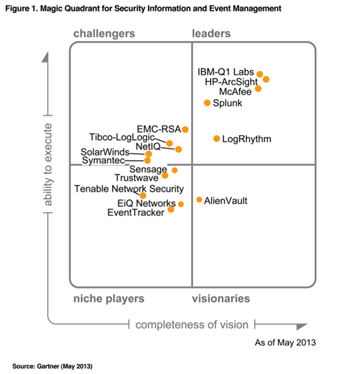

Figure 3: Gartner Magic Quadrant for SIEM in 2013

About the quadrant categorization:

* Leaders

The SIEM Leaders quadrant is composed of vendors that provide products that are a good functional match to general market requirements, have been the most successful in building an installed base and revenue stream within the SIEM market, and have a relatively high viability rating (due to SIEM revenue or SIEM revenue in combination with revenue from other sources).

* Challengers

The Challengers quadrant is composed of vendors that have a large revenue stream (typically because the vendor has multiple product and/or service lines), at least a modest-size SIEM customer base and products that meet a subset of the general market requirements.

* Visionaries

The Visionaries quadrant is composed of vendors that provide products that are a good functional match to general SIEM market requirements, but have a lower ability to execute rating than the Leaders.

* Niche Players

The Niche Players quadrant is composed primarily of smaller vendors that provide SIEM technology that is a good match to a specific SIEM use case, a subset of SIEM market requirements. Niche Players focus on a particular segment of the client base or a more limited product set.

## Inclusion Criteria

The following criteria had to be met for vendors to be included in the 2013 SIEM Magic Quadrant:

* The product must provide SIM and SEM capabilities.
* The product must support data capture from heterogeneous data sources, including network devices, security devices, security programs and servers.
* The vendor must appear on the SIEM product evaluation lists of end-user organizations.
* The solution must be delivered to the customer environment as a software- or appliance-based product (not a service).

## Major Evaluation Criteria

Gartner Report focuses mainly on the Ability to Execute of the SIEM vendors by assessing the following parameters:

* **Product/service** evaluates the vendor's ability and track record to provide product functions in areas such as log management, compliance reporting, SEM and deployment simplicity.
* **Overall viability** includes an assessment of the organization's financial health.
* **Sales execution/pricing** evaluates the technology provider's success in the SIEM market and its capabilities in presales activities.
* **Market responsiveness and track record** evaluates the match of the SIEM offering to the functional requirements stated by buyers at acquisition time, and the vendor's track record in delivering new functions when they are needed by the market.
* **Marketing execution** evaluates the SIEM marketing message against Gartner understanding of customer needs.
* **Customer experience** is an evaluation of product function or service within production environments. The evaluation includes ease of deployment, operation, administration, stability, scalability and vendor support capabilities.
* **Operation** is an evaluation of the organization's service, support and sales capabilities.

## Customer Requirements

As recorded on the Gartner Report 2013, SIEM solutions should:

* Support the real-time collection and analysis of events from host systems, security devices and network devices, combined with contextual information for users, assets and data.
* Provide long-term event and context data storage and analytics.
* Provide predefined functions that can be lightly customized to meet company-specific requirements.
* Be as easy as possible to deploy and maintain.

Scalability is a major consideration with SIEM deployments. Real-time monitoring and alerting, as well as log collection, query and reporting, are available as a service offering from MSSPs.

# The Business Case

At a glance, the scenario we are going to investigate focuses on the timely detection of external attacks against the perimeter of an SME. In the following paragraphs, the key components involved in the aforementioned scenario are further described for reader’s convenience and better understanding.

## The Small-Medium Enterprise Network

The following are some of the common external threats to enterprise environments:

* **Service disruption**—caused by botnets, worms, malware, adware, spyware, viruses, denial-of-service (DoS) attacks, and Layer 2 attacks.
* **Unauthorized access**—Intrusions, unauthorized users, escalation of privileges, IP spoofing, and unauthorized access to restricted resources
* **Data loss**—Loss or leakage of private data from servers and endpoints while in transit or as a result of spyware, malware, key-loggers, viruses, and so on

The first two threats are within the scope of the proposed solution.

A typical Small-Medium Enterprise network, realizing the Cisco SAFE (Secure Architecture For Enterprises) architecture is depicted in the following figure:

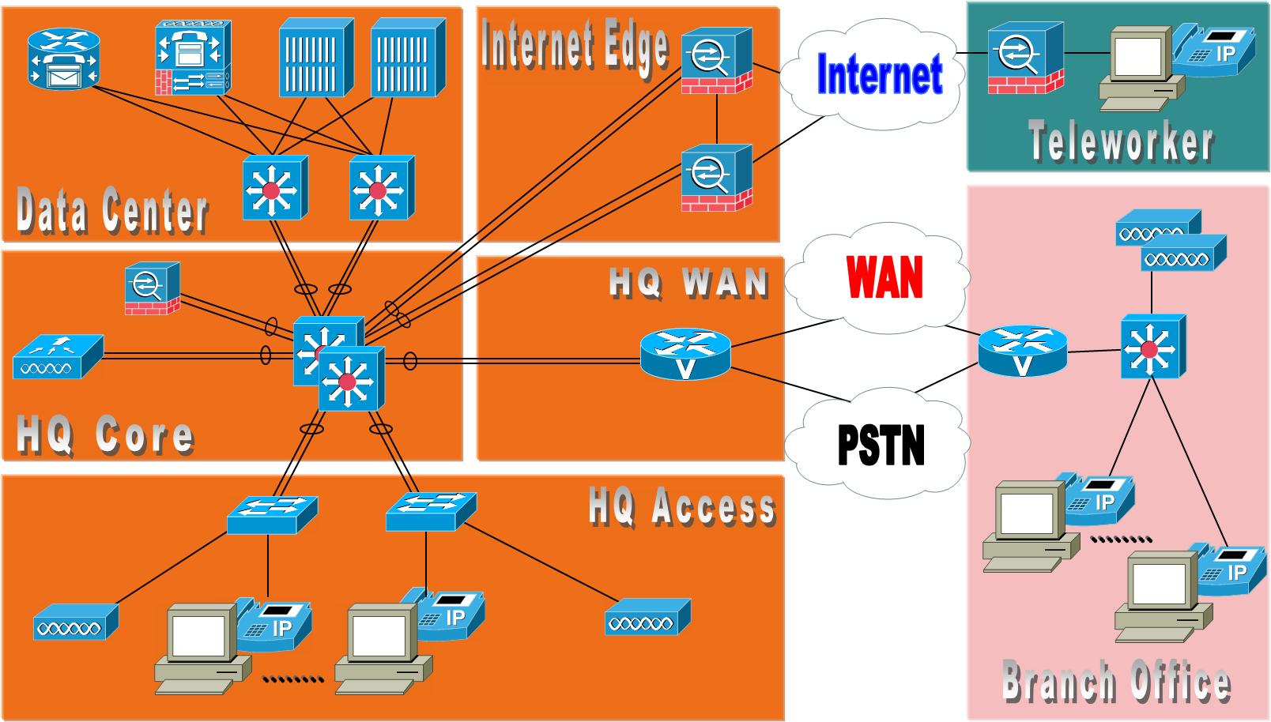

Figure 4: Typical SME network

The [Cisco SAFE Reference Architecture](http://www.cisco.com/c/en/us/td/docs/solutions/Enterprise/Security/SAFE_RG/SAFE_rg/chap1.html) consists of design blueprints based on the Cisco Validated Designs (CVDs) and proven security best practices that provide the design guidelines for building secure and reliable network infrastructures. The Cisco SAFE design blueprints were created mainly according to the following architecture principles:

* Defense in depth
* Service availability and resiliency
* Modularity and flexibility

The following is a brief description of the design modules:

### Enterprise Core

The core is a high-speed infrastructure whose objective is to provide a reliable and scalable Layer-2/Layer-3 transport. The core is typically implemented with redundant switches that aggregate the connections to the campuses, data centers, WAN edge, and Internet edge.

### Intranet Data Centre

Cisco SAFE includes an Intranet data center design capable of hosting a large number of systems for serving applications and storing significant volumes of data. The data center design also hosts the network infrastructure that supports the applications, including routers, switches, load balancers, application acceleration devices to name some. The intranet data center is designed to serve internal users and applications, and that are not directly accessible from the Internet to the general public.

### Enterprise Campus

The enterprise campus provides network access to end users and devices located at the same geographical location.

### Enterprise Internet Edge

The Internet edge is the network infrastructure that provides connectivity to the Internet, and that acts as the gateway for the enterprise to the rest of the cyberspace. The Internet edge services include public services DMZ, corporate Internet access and remote access VPN.

### Enterprise WAN Edge

The WAN edge is the portion of the network infrastructure that aggregates the WAN links that connect geographically distant branch offices to a central site or regional hub site. The WAN can be either owned by the same enterprise or provided by a service provider, the latter being the most common option. **Enterprise Branch**

Branches provide connectivity to users and devices at the remote location. They typically implement one or more LANs, and connect to the central sites via a private WAN or an Internet connection.

## Internet Firewall Configuration Guidelines

A firewall should be deployed at the Internet perimeter to protect the enterprise internal resources and data from external threats, and is responsible for the following:

* Preventing incoming access from the Internet
* Protecting public resources deployed in the DMZ by restricting incoming access to the public services and by limiting outbound access from DMZ resources out to the Internet
* Controlling user Internet-bound traffic
* Monitoring network ports for rogue activity and preventing infected internal endpoints from communicating with botnet masters or command and control hosts on the Internet

The security appliances should be configured to enforce access policies, keep track of connection status, and inspect packet payloads.

## Commercial Firewall Solutions

Gartner Magic Quadrant 2014 for Enterprise grade Firewalls is depicted in the figure below:

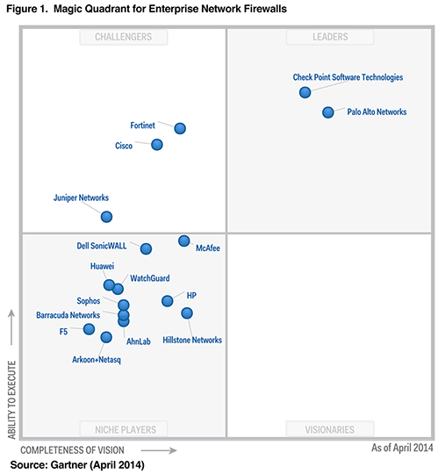

Figure 5: Gartner Magic Quadrant for Firewalls in 2014

The enterprise network firewall market represented by this Magic Quadrant is composed primarily of purpose-built appliances and virtualized models for securing corporate networks. Products must be able to support single-enterprise firewall deployments and large global deployments, including branch offices. Please note that based on this report, log files generated from a firewall of one the leader vendors shall be used in our proof of concept (POC).

## Open Source and Freeware Firewall Solutions

Although open source or commercial with free version firewalls are widely used by Small and Medium Business around the globe, no officially released evaluation report from a highly regarded organization or a vendor neutral firm exists. The following list of firewalls - in alphabetical order - is provided for completeness purposes and is by no means exhaustive or indicative:

1. [**ClearOS**](http://www.clearfoundation.com/Software/overview.html)
2. [**Endian**](http://www.endian.com/en/community/overview/)
3. [**IPCop**](http://ipcop.org/)
4. [**IPFire**](http://www.ipfire.org/)
5. [**PFSense**](http://pfsense.org/)
6. [**Smoothwall**](http://www.smoothwall.org/)
7. [**Sophos UTM**](http://www.sophos.com/)
8. [**Sphirewall**](http://sphirewall.net/)
9. [**Untangle**](http://www.untangle.com/)
10. [**Vyatta**](http://www.vyatta.org/)
11. [**Zentyal**](http://www.zentyal.org/)
12. [**Zero Shell**](http://zeroshell.org/)

## SysLog

Syslog is a way for network devices to send event messages to a logging server – the Syslog server. Network equipment, like routers, switches and firewalls can send Syslog messages.. Typically, most Syslog servers have a predefined set of components that make this possible.

* A **Syslog listener**: A Syslog server needs to receive messages sent over the network. A listener process gathers syslog data sent over UDP port 514. UDP messages aren’t acknowledged. Therefore, some network devices will send Syslog data via TCP 1468 to ensure message delivery.
* A **database**: Large networks can generate a huge amount of Syslog data.
* **Management and filtering software**: due to the need to deal with large amounts of data.

Syslog messages usually include information to help identify basic information about where, when, and why the log was sent: IP address, timestamp, and the actual log message. The Syslog protocol doesn’t define a standard way for message content to be formatted – and there as many ways to format a message. Consequently, in the context of this capstone, it is not productive to pay much attention on the setup and configuration of a Syslog server but rather to collect and concentrate on already existing Syslog files that are publicly available on the internet.

# Requirements Engineering

A far as requirements definition is concerned the industry standard process of Requirements Engineering has been followed.

## Stakeholders Identification

The key stakeholder (primary actor) of such solution would be the person assigned with the responsibility to protect the network perimeter of the company. Depending on the actual size and the organizational structure of the SME this role may be undertaken either by the Network/Security Administrator, in case of small constellations, or by an Information Security Officer and even the Chief Information Security Officer (CISO) in case of larger companies.

Additional stakeholders (secondary actors) may be:

* + 1. Roles assigned with the responsibility to collect and monitor system generated reports for quality purposes (i.e. as input for the management review meetings);
    2. Internal and or external auditors that evaluate the regulatory compliance of the company (i.e. according to ISO/IEC 27k).

## High Level User Requirements Elicitation

### Naming Conventions for the User Requirements

The following naming convention is used so as to define the high level stakeholders’ requirements:

**AM-UR-zz**

AM stands for the “Attack Monitor”, UR for “User Requirement: and zz for the identification number (01…99).

The identified -by the analysis phase- user requirements are described, in the following sub-paragraphs, using the “natural language” method. Although requirements can be documented in various forms the best practice is to define them in short sentences describing non-overlapping functions and then take advantage of the UML 2.x modelling tools so as to reflect them to sets of use cases per system actor.

### AM-UR-01: Solution shall Use Open Source and License Free Technologies

As long as the proposed solution has as main focus SMEs with limited resources and reserved budget, for information security related investments, it is essential to take full advantage of the available open source tools (i.e. Eclipse SDK), software libraries (such as the RestKit Framework) and technologies (i.e. Java).

### AM-UR-02: Solution shall Use Publicly Available Information from Trusted Sources

Effectiveness of the proposed solution relies heavily on quality of the input data, according to the so called “garbage in – garbage out” principle of the Information Management Systems. Therefore, selection of input data sources plays a crucial role in the overall success of the new system. It is essential to insert up-to-date data retrieved from globally accepted institutions and/or organizations. The latter shall have a long and proved record of being vendor neutral, with a view to avoid obstacles set and misleading information released by the various players of the extremely competitive InfoSec market arena.

### AM-UR-03: Solution shall introduce Intelligence on External Attacks Identification

The proposed solution aims to transform an administrative detective safeguard to a logical (technical) one so as increase efficiency. Therefore, human intervention on the data processing shall be eliminated so as avoid misinterpretations on the given results. Collection of input data from various reliable sources, regarding the existing attack vectors, as well as cross checking against the information stored inside the firewall log files depict the minimum setup so as to automate the incident identification process and alert the corresponding response team/personnel. As more sophisticated is the aforementioned mechanism the value, and consequently the Return on Security Investment (ROSI) for the company, of the system increases. The external attack detection mechanism should be fine-tuned so as keep both the False Negative and False Positive Detection Rates to acceptable levels.

### AM-UR-04: Solution shall Identify External Attacks in a Timely Fashion

Early detection is a decisive factor in the success of a detective control, therefore fine tuning is necessary on the log files/entries analysis period by the system.

### AM-UR-05: External Attacks shall be displayed on Smart Devices

Taking into account the fact that SMEs’ IT personnel usually “wear many hats” becomes clear that user mobility needs are increased. Consequently, it is not expected to have dedicated resources for the tactical (operational) needs of the proposed system by means of operators supervising the console output for identified attacks. In combination with the “bring your own device” reality in the vast majority of enterprises today it is clear that new system should be accompanied by the corresponding apps.

### AM-UR-06: Solution shall alert the End Users in case of External Attacks

To increase usability of the proposed solution it is absolutely necessary to minimize user intervention by means of an always activated alerting-notification mechanism.

### AM-UR-07: Solution shall be based on Cutting-Edge Web Technologies

Attackers do not work from 9:00AM until 5:00PM. Actually in many cases they don’t belong into the same time zone as their targets. Therefore, a mechanism shall be implemented supporting system alerts to be delivered outside the company’s physical borders.

### AM-UR-08: Solution operation shall be fully automated

As aforementioned, user intervention will significantly decrease the effectiveness and efficiency of the implemented safeguard as it will become prone to mishandling and misinterpretations.

### AM-UR-09: Solution shall be Reliable

As always with security related issues, apart from the measurable parameters (Security KPIs) the feeling of “being secured” is totally subjective. As a result, reliability of implemented controls plays a significant role in the attempt to establish and maintain a security feeling in the company.

### AM-UR-10: Solution shall be Modular

System modularity will increase flexibility on introducing new input data sources (by means of lists of malicious IPs and firewall log files of various vendors). In addition, system installation and setup will be easier to be tailored with each company specific needs.

### AM-UR-11: Solution shall be Scalable

System horizontal and vertical scalability will permit to serve companies with greater attack surface, than usual, on the internet and consequently with increased processing needs. Furthermore, meeting the scalability related requirements will allow solution to be hosted on the cloud (either public or private) and delivered as Software as a Service (SaaS) on a subscription base.

### AM-UR-12: Solution shall be Secure

System will deal with critical information assets of the company. Therefore, secure SDLC best practices shall be followed. In a second step, this process can be the cornerstone for the security Accreditation and Certification of the solution.

### AM-UR-13: Solution shall be User Friendly

System output should be filtered so as to lead to concrete conclusion about the security posture of the company’s network perimeter.

### AM-UR-14: Solution shall support Regulatory Compliance

System shall have enhanced reporting capabilities supporting both management review and auditing by internal or external authorities.

## User Requirements Prioritization Concept

The prioritization rules to be applied is:

|  |  |
| --- | --- |
| Priority | Description |
| **High** | Mission critical requirement. Functionality must be released as planned. Failure to satisfy such requirement(s) poses blocking points. |
| **Medium** | Supports necessary system operations. However, functionality might be released in a later step. |
| **Low** | Related to functional or quality enhancements. Would be nice to have at a point if resources availability and/or planned budget permit. |

Table 1: Requirements Prioritization Scale

## User Requirements Prioritization

|  |  |  |  |
| --- | --- | --- | --- |
| No | Requirement ID | Description | Priority |
| 1 | AM-UR-01 | Solution shall Use Open Source and License Free Technologies | High |
| 2 | AM-UR-02 | Solution shall Use Publicly Available Information from Trusted Sources | High |
| 3 | AM-UR-03 | Solution shall introduce Intelligence on External Attacks Identification | High |
| 4 | AM-UR-04 | Solution shall Identify External Attacks in a Timely Fashion | High |
| 5 | AM-UR-05 | External Attacks shall be displayed on Smart Devices | Low |
| 6 | AM-UR-06 | Solution shall alert the End Users in case of External Attacks | Medium |
| 7 | AM-UR-07 | Solution shall be based on Cutting-Edge Web Technologies | Medium |
| 8 | AM-UR-08 | Solution operation shall be fully automated | Medium |
| 9 | AM-UR-09 | Solution shall be Reliable | High |
| 10 | AM-UR-10 | Solution shall be Modular | Medium |
| 11 | AM-UR-11 | Solution shall be Scalable | Low |
| 12 | AM-UR-12 | Solution shall be Secure | High |
| 13 | AM-UR-13 | Solution shall be User Friendly | Low |
| 14 | AM-UR-14 | Solution shall support Regulatory Compliance | High |

Table 2: User Requirements Prioritization Matrix

## User Requirements included in the Proof of Concept

A proof of concept (POC) is defined as a limited in extend and depth realization of a certain concept to demonstrate its feasibility. Consequently, a proof of concept is a priori incomplete. To that end, the decision on whether or not to exclude a user requirement from the POC implementation was primarily based on the existing time constraints that jeopardised the objective to present a functional end-to-end scenario.

|  |  |  |  |  |
| --- | --- | --- | --- | --- |
| No | Requirement ID | Description | Priority | Included in the POC? |
| 1 | AM-UR-01 | Solution shall Use Open Source and License Free Technologies | High |  |
| 2 | AM-UR-02 | Solution shall Use Publicly Available Information from Trusted Sources | High |  |
| 3 | AM-UR-03 | Solution shall introduce Intelligence on External Attacks Identification | High |  |
| 4 | AM-UR-04 | Solution shall Identify External Attacks in a Timely Fashion | High |  |
| 5 | AM-UR-05 | External Attacks shall be displayed on Smart Devices | Low |  |
| 6 | AM-UR-06 | Solution shall alert the End Users in case of External Attacks | Medium |  |
| 7 | AM-UR-07 | Solution shall be based on Cutting-Edge Web Technologies | Medium |  |
| 8 | AM-UR-08 | Solution operation shall be fully automated | Medium |  |
| 9 | AM-UR-09 | Solution shall be Reliable | High |  |
| 10 | AM-UR-10 | Solution shall be Modular | Medium |  |
| 11 | AM-UR-11 | Solution shall be Scalable | Low |  |
| 12 | AM-UR-12 | Solution shall be Secure | High |  |
| 13 | AM-UR-13 | Solution shall be User Friendly | Low |  |
| 14 | AM-UR-14 | Solution shall support Regulatory Compliance | High |  |

Table 3: User Requirements included in the POC

# Functional and Non-Functional Specification

## The Internet Storm Center / DShield API

The Internet Storm Center of SANS Institute provides a simple REST API (called DShield). The following API calls (functions) are available as recorded on the related web page:

* [*Backscatter*](https://isc.sans.edu/api/#backscatter) *-* Returns possible backscatter data. This report only includes "syn ack" data and is summarized by source port.
* [*Handler*](https://isc.sans.edu/api/#handler) *-* Returns the name of the handler of the day.
* [*Infocon*](https://isc.sans.edu/api/#infocon) *-* Returns the current infocon level (green, yellow, orange, red).
* [*IP*](https://isc.sans.edu/api/#ip) *-* Returns a summary of the information our database holds for a particular IP address (similar to /ipinfo.html).
* [*Port*](https://isc.sans.edu/api/#port) *-* Summary information about a particular port.
* [*PortDate*](https://isc.sans.edu/api/#portdate) *-* Information about a particular port at a particular date.
* [*TopPorts*](https://isc.sans.edu/api/#topports) *-* Information about top ports for a particular date with return limit.
* [*TopIPs*](https://isc.sans.edu/api/#topips) *-* Information about top IPs for a particular date with return limit.
* [***Source IPs***](https://isc.sans.edu/api/#sources)**- Information summary from the last 30 days about source IPs with return limit.**

**Note:** This is the API call that will be used for the purposes of our prototype.

* [*PortHistory*](https://isc.sans.edu/api/#porthistory) *-* Returns port data for a range of dates
* [*ASNUM*](https://isc.sans.edu/api/#asnum) *-* Returns a summary of the information our database holds for a particular ASNUM (similar to /asdetailsascii.html) with return limit.
* [*Daily Summary*](https://isc.sans.edu/api/#dailysummary) *-* Returns daily summary totals of targets, attacks and sources. Limit to 30 days at a time.
* [*404 Project Summary*](https://isc.sans.edu/api/#daily404summary) *-* Returns daily summary information of submitted 404 Error Page Information
* [*404 Project Details*](https://isc.sans.edu/api/#daily404detail) *-* Returns detail information of submitted 404 Error Page Information.
* [*Glossary*](https://isc.sans.edu/api/#glossary)- List of glossary terms and definitions
* [*WebhoneypotSummary*](https://isc.sans.edu/api/#webhoneypotsummary) *-* API data for [Webhoneypot: Web Server Log Project](https://isc.sans.edu/webhoneypot/index.html).
* [*WebhoneypotByType*](https://isc.sans.edu/api/#webhoneypotbytype) *-* API data for [Webhoneypot: Attack By Type](https://isc.sans.edu/webhoneypot/types.html).

## Attack Monitor Hardware Specifications

Not applicable for the POC case. As soon as the exhaustive list of functional and especially non-functional requirements is finalized, solution deployment environment characteristics should be defined.

## System Actors

The following actors have been defined in the scope of the project taking into account the security principles of “least privileges” and “need to know”:

  

**Security Administrator Information Security Officer Security Auditor**

Figure 6: System Actors

### Security Administrator

|  |  |  |
| --- | --- | --- |
| **Actor Details** | | |
| **Actor ID** | Actor-1 |  |
| **Actor Name** | **Security Administrator** |
|  |  |
| **Brief Description** | This actor represents a user that has administrative access on the Attack Monitor and interacts with the system only via a Web GUI |
| **Responsibilities** | Security Administrator is responsible for the overall configuration and administration of the Attack Monitor and its Users. Users Assuming this role supervise and monitor the healthy operation of the system and its interfaces. | |

### Information Security Officer

|  |  |  |
| --- | --- | --- |
| **Actor Details** | | |
| **Actor ID** | Actor-2 |  |
| **Actor Name** | **Information Security Officer** |
|  |  |
| **Brief Description** | This actor represents a user or a group of users that has read only access on the Attack Monitor and interacts with the system either via the Web GUI or via the Smart Device App |
| **Responsibilities** | This role is responsible for the tactical operation of the Attack Monitor. Users assuming this role shall initiate the incident response process as soon as Attack Monitor detects an external attack and raises an alarm. In general, this group shall take full advantage of the reporting function capabilities of the Attack Monitor.  Note: Although Information Security Officer can assume the role of Security Administrator it is recommended to enforce the security principle of “segragation of duties” | |

### Security Auditor

|  |  |  |
| --- | --- | --- |
| **Actor Details** | | |
| **Actor ID** | Actor-3 |  |
| **Actor Name** | **Security Auditor** |
|  |  |
| **Brief Description** | This actor represents a user or a group of users that has read only access on the Attack Monitor and interacts with the system only via the Web GUI |
| **Responsibilities** | This role is responsible for the evaluation of the audit data stored in the Attack Monitor Database for compliance purposes. | |

## Use Cases

The aim of this section is to become the basis of future work (next iterations).

The following naming convention will be used for the use cases: **UC-AM-zzz-nn** where:

**UC** stands for use case;

**AM** refers to the target system (fixed value referring to Attack Monitor);

**zzz** refers to the target subsystem;

**nn** refers to the ascending use case number.

For the applied use case template as well as for the description of each field please refer to the **IBM® Rational® Modeler** template:

**Purpose**

*[This section aims at presenting the purpose of the use case and what this functionality does briefly.]*

**Subsystem**

*[The Subsystem section defines the subsystem where the use case belongs to.]*

**Primary Actor(s)**

*[The actor(s) executing the actions specified in the use case specification.]*

**Precondition(s)**

*[A precondition (of a use case) is the state of the excise operation that must be present prior to a use case being performed.]*

**Post-condition(s)**

*[A post-condition (of a use case) is a list of possible states the excise operation can be in immediately after a use case has finished.]*

**Associated Use Case(s)**

*[Use cases to which the current use case is associated. In this paragraph also the use cases that need to be executed prior to the current use case are listed]*

**Basic Flow**

*[The detailed steps followed during the execution of the use case.]*

Step 1 Format: Step [The number of the Basic Flow]

*[This use case starts when the actor performs an action. The use case describes what the actor does and what the system does in response.]*

[Alternative Flow – name] optional

[Exception Flow – name] optional

[Extension Point – name] optional

Step 2

**Alternative Flow – name**

Step 1 Format Step n.[The number refers to the nth step in this alternative flow]

*[This part of the use case describes an alternative system behavior referred by a specific step of the Basic Flow]*

**Exception Flow - name**

Step 1 Format Step n. [The number refers to the nth step in this exception flow]

*[This part of the use case describes an exception system behavior referred by a specific step of the Basic Flow and/or alternative flows]*

**Extension Point – name**

*[This part of the use case describes an extension system behavior referred by a specific step of the Basic Flow and/or alternative flows]*

**Special Requirements**

*[Supplementary requirements the current use-case is associated with.]*

**Activity Diagram (optional)**

*[Activity diagram are used to support the documented Primary and Alterative flows. The textual description takes precedence over the diagram.]*

**Additional Info**

*[Additional information is used to support the use case, e.g. screenshots]*

## Functional and No-Functional Requirement’s Naming Conventions

The following naming scheme is proposed to be used, in the future, so as to define the system requirements:

**AM-x-yyy-zz**

AM stands for the “Attack Monitor”, x for the requirement type, yyy for the underlying functionality and zz for the identification number (01…99).

As far as the requirement types is concerned,

1. **F** stands for functional requirements and
2. **N** for non-functional requirements

As far as the system functions are concerned the categories/subsystems below are foreseen:

1. **MIP**: **M**alicious **I**P lists **P**arsing functions of the Attack Monitor
2. **FLP**: **F**irewall **L**og file **P**arsing of the Attack Monitor
3. **RWS**: **R**estful **W**eb **S**ervice of the Attack Monitor
4. **APP**: Smart Device **App**lication for the Attack Monitor actors
5. **GUI**: Attack Monitor Web **GUI**

**Note 1**: It is a common practice but not a strict rule that use cases inherit the priority of the associate requirement. Nevertheless, at least one of the created use cases, corresponding to a specific requirement, shall have priority as high as this requirement. It is not rational to assign higher priority to a use case than the one assigned to the corresponding user requirement. The same approach shall be followed in a second step when use cases will be tailored with test cases and in a third step when a fault report is opened against a test case and its severity has to be evaluated by the test team.

**Note 2**: Supplementary requirements cannot be analyzed to use cases. An exception to this rule is the “login” and “logout” use cases, which actually correspond to user interaction with the system.

## Requirements Forward Traceability Matrix

The document structure has been chosen with the aim to support the reader to gradually understand the target system, as the iterations counter increases, to enhance reader awareness about the cause-decision path and to facilitate forward and backward traceability between the user requirements and the associated use cases. The same approach will be followed on the design and test specifications in order to be able to finally trace the path between a user requirement and the related test cases and vice versa. Consequently, the quality of the project deliverables, for the specific work package, will be measurable as the percentage of the successfully passed test cases will reflect to the part of the system that has been implemented according to the specifications. In addition, this approach facilitates the risk management process, of the project, as it is straightforward to identify possible risk factors, evaluate their impact on the work package deliverables and initiate the appropriate mitigation actions in a timely fashion.

# System Architecture

The overview of the system architecture and deployment is depicted in the following figure:

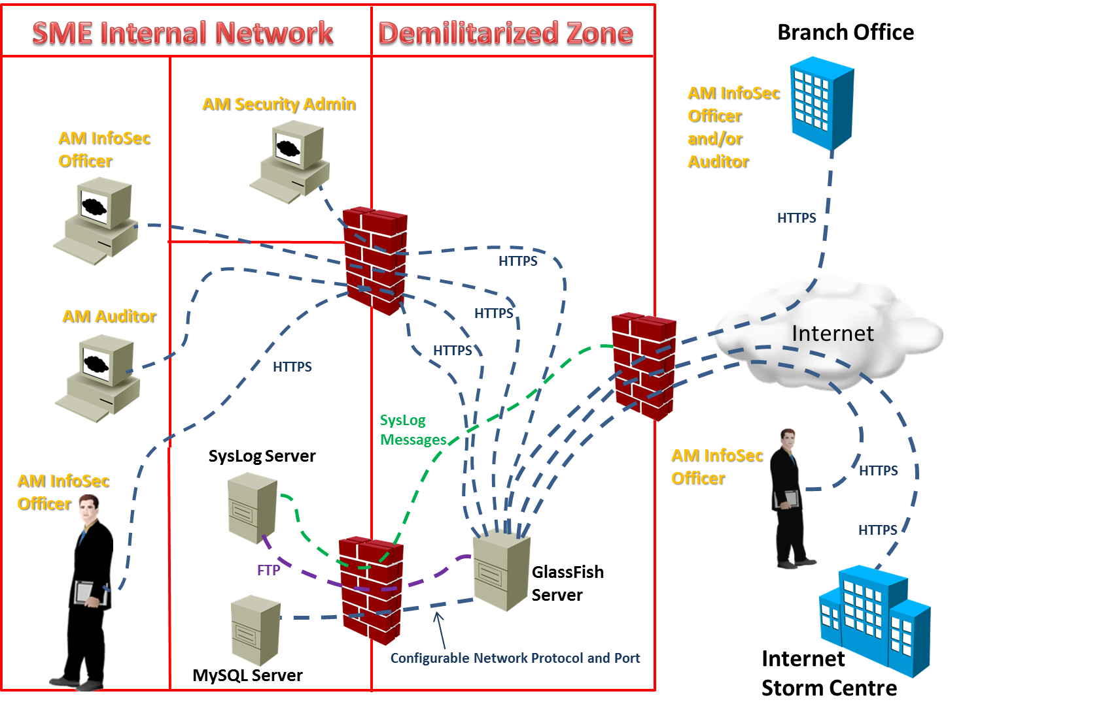

Figure 7: Solution Architecture

# Design Specification

This capstone will focus mainly on the POC implementation that corresponds to the first iteration of the Attack Monitor project execution or product implementation. The remaining iterations are considered as part of the future work (pl. refer to the respective chapter).

## The Proof-Of-Concept Scenario

The scenario to be implemented in the context of the proof-of-concept (POC) is depicted in the following sub-sections using the storyboard method. In system design, storyboards are documents created by business or system analysts to help the development team discover requirements that may otherwise be overlooked. The storyboards depict users' interactions with the system to be developed or enhanced. The process of creating storyboards allows the team to understand not only the users' interaction with the system, but also system-subcomponent interaction. The storyboards should contain just enough detail to capture nothing more than the essential information.

### POC design – Step 1

In the first step the daily list of malicious IPs should be retrieved from the Internet Storm Centre:

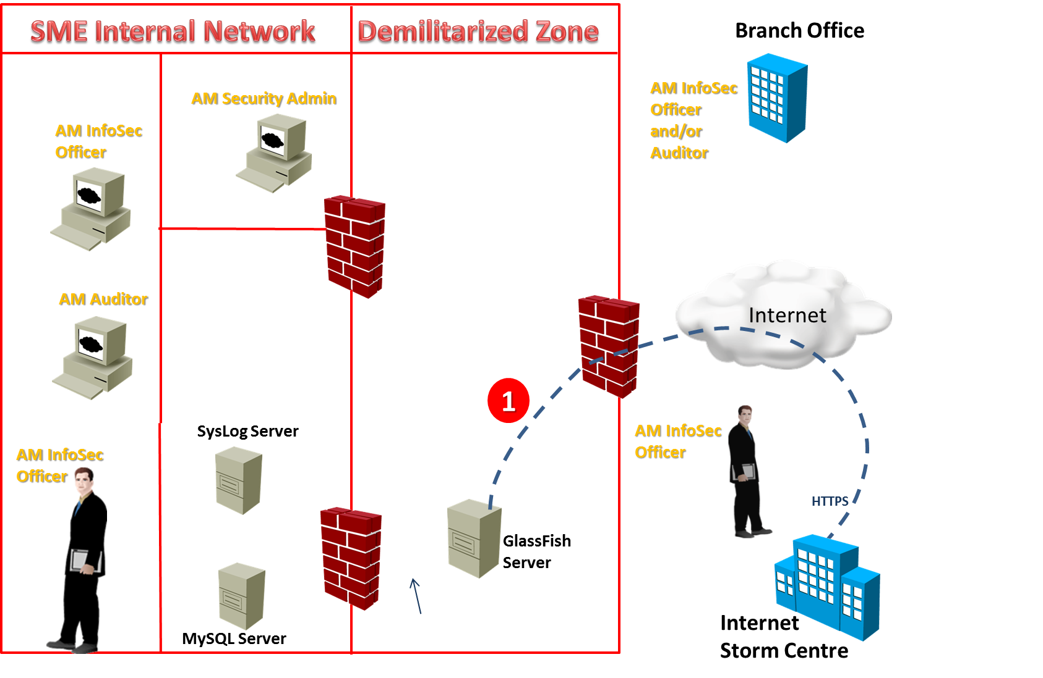

Figure 8: POC – Step 1

**POC design – Step 2**

In the second step, data retrieved from the Internet Storm Centre should be stored on the Relational Database for later use:

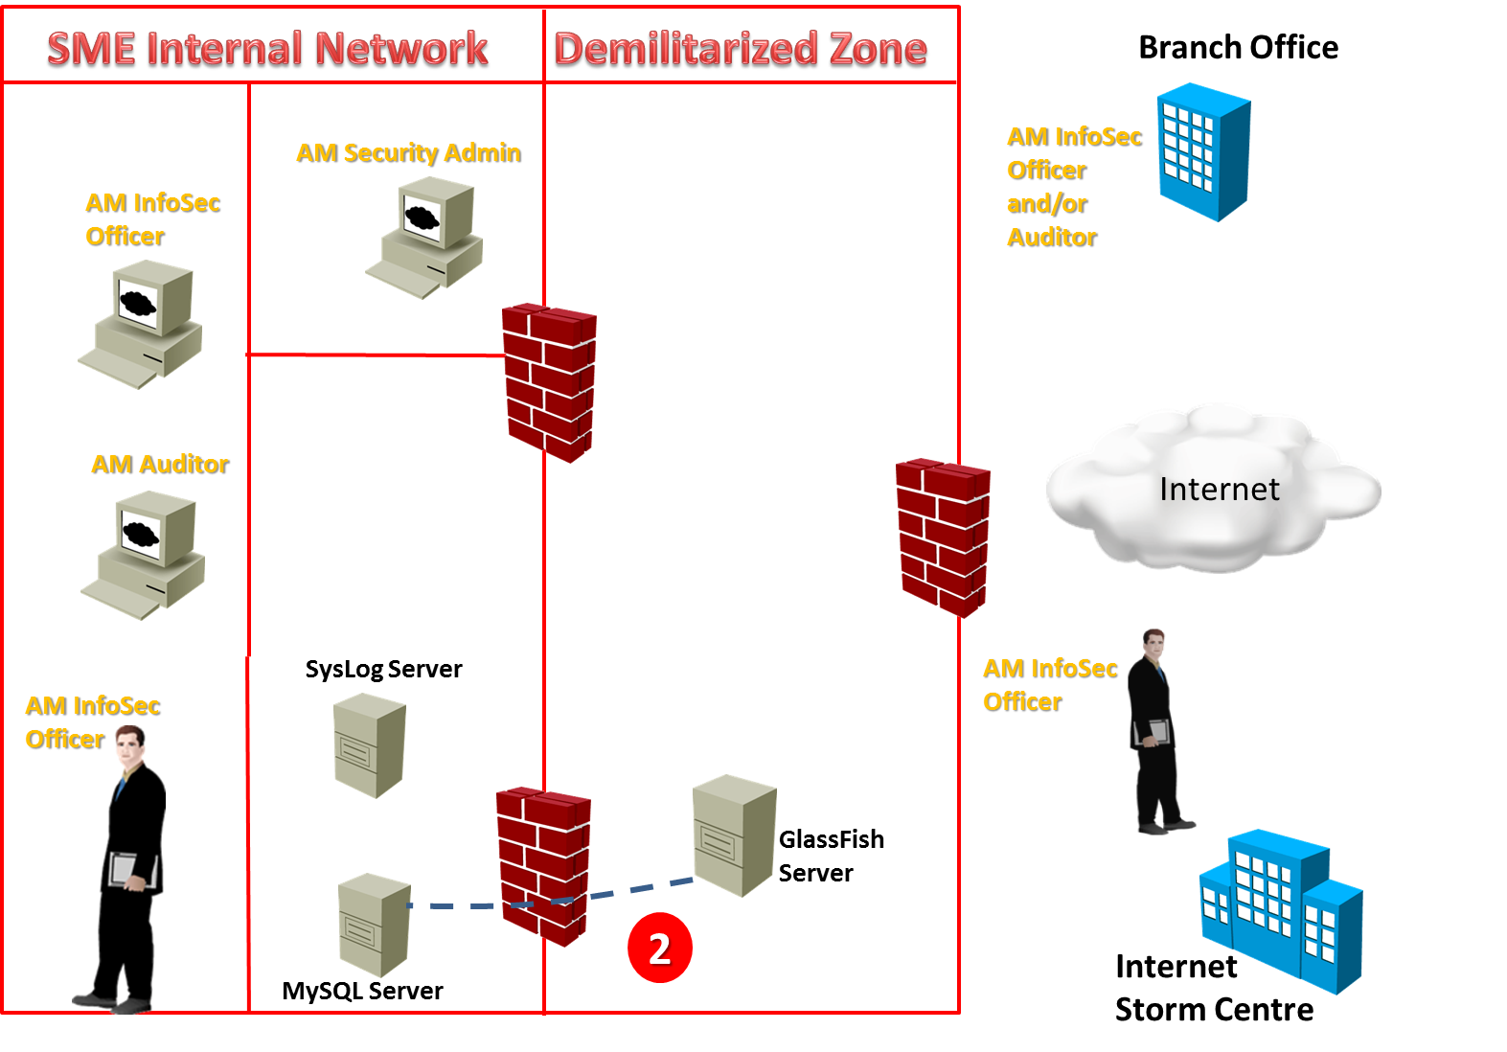

Figure 9: POC – Step 2

### POC design – Step 3

Log messages from the Edge Firewall of the SME should be stored on the company’s Syslog server. This step, as well as the next one, will be simulated as they don’t really add any value on the POC.

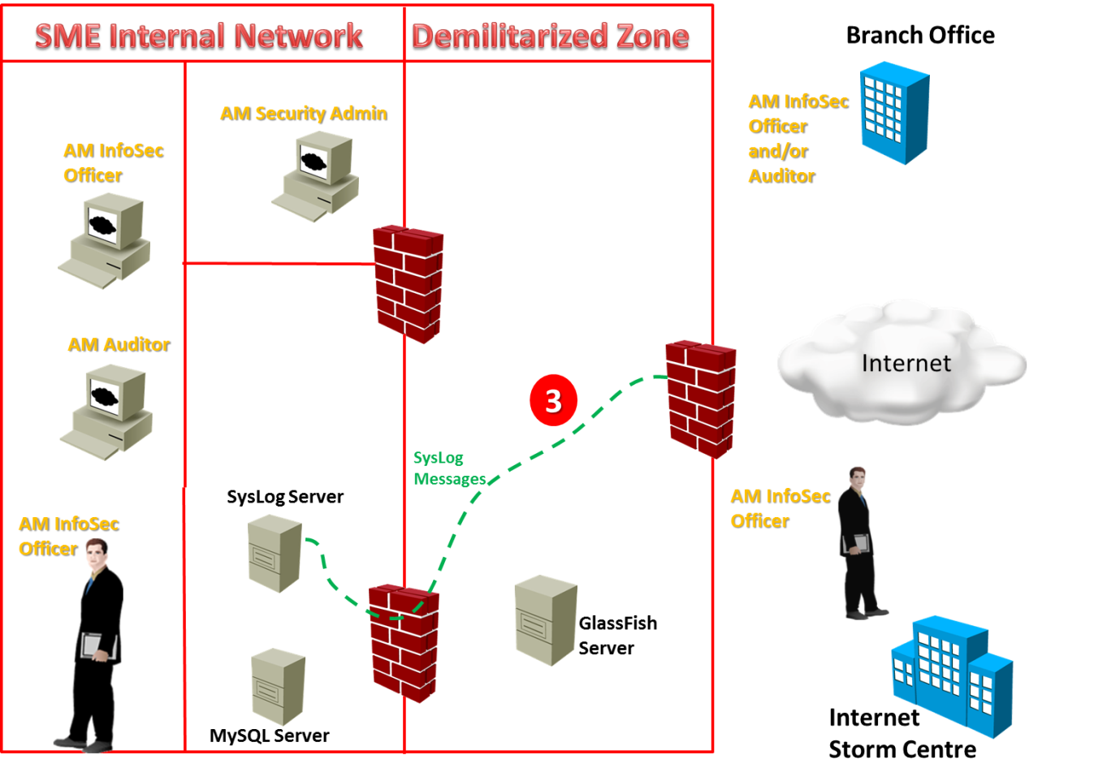

Figure 10: POC – Step 3

### POC design – Step 4

Log files created from messages of the Edge Firewall on the Syslog server should be periodically transmitted (via FTP) on a shared folder, which is accessible by the Attack Monitor solution (by means of a staging area). This step, same as the previous one, will be simulated as they don’t really add any value on the POC.

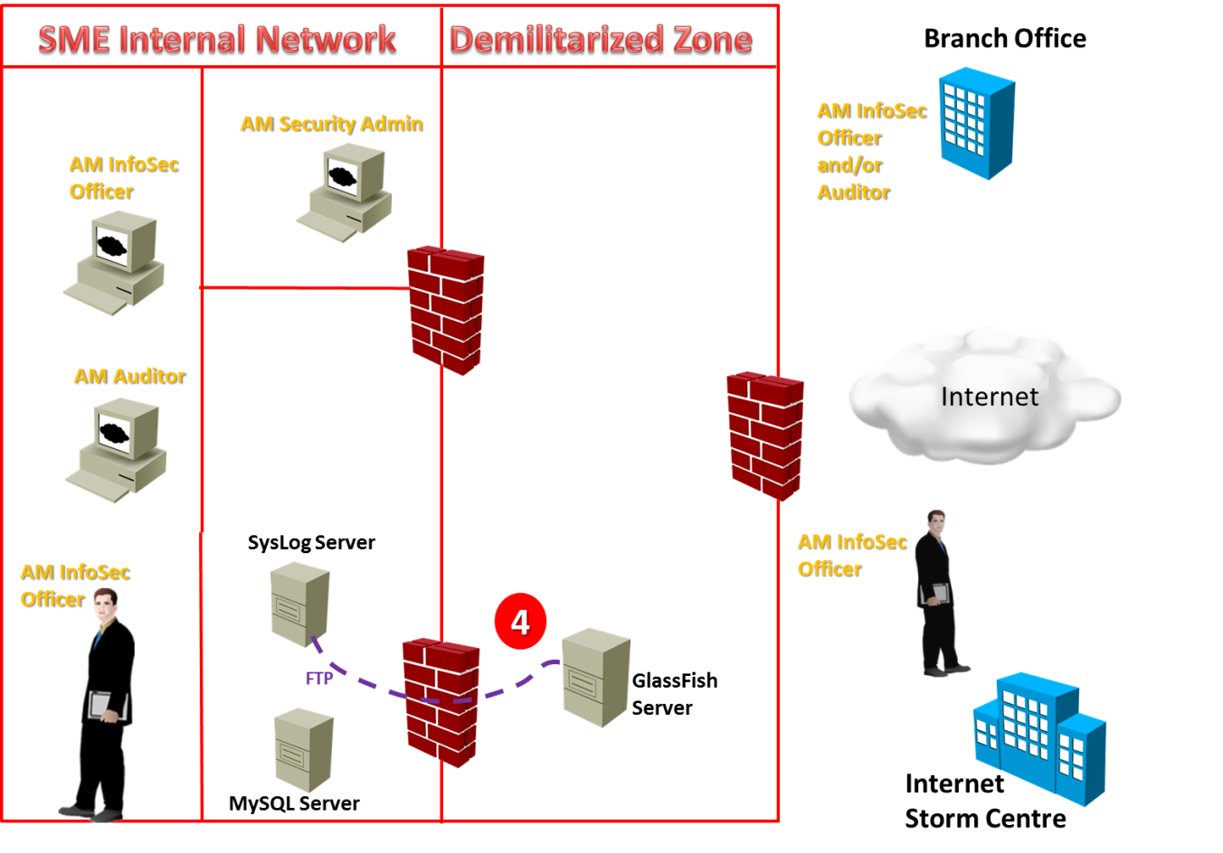

Figure 11: POC – Step 4

### POC design – Step 5

Attack Monitor performs a cross check of the IPs logged by the edge firewall against those retrieved from the Internet Storm Centre. In case a match is found, the attack agent’s IP is stored on the Relational Database on a separate table:

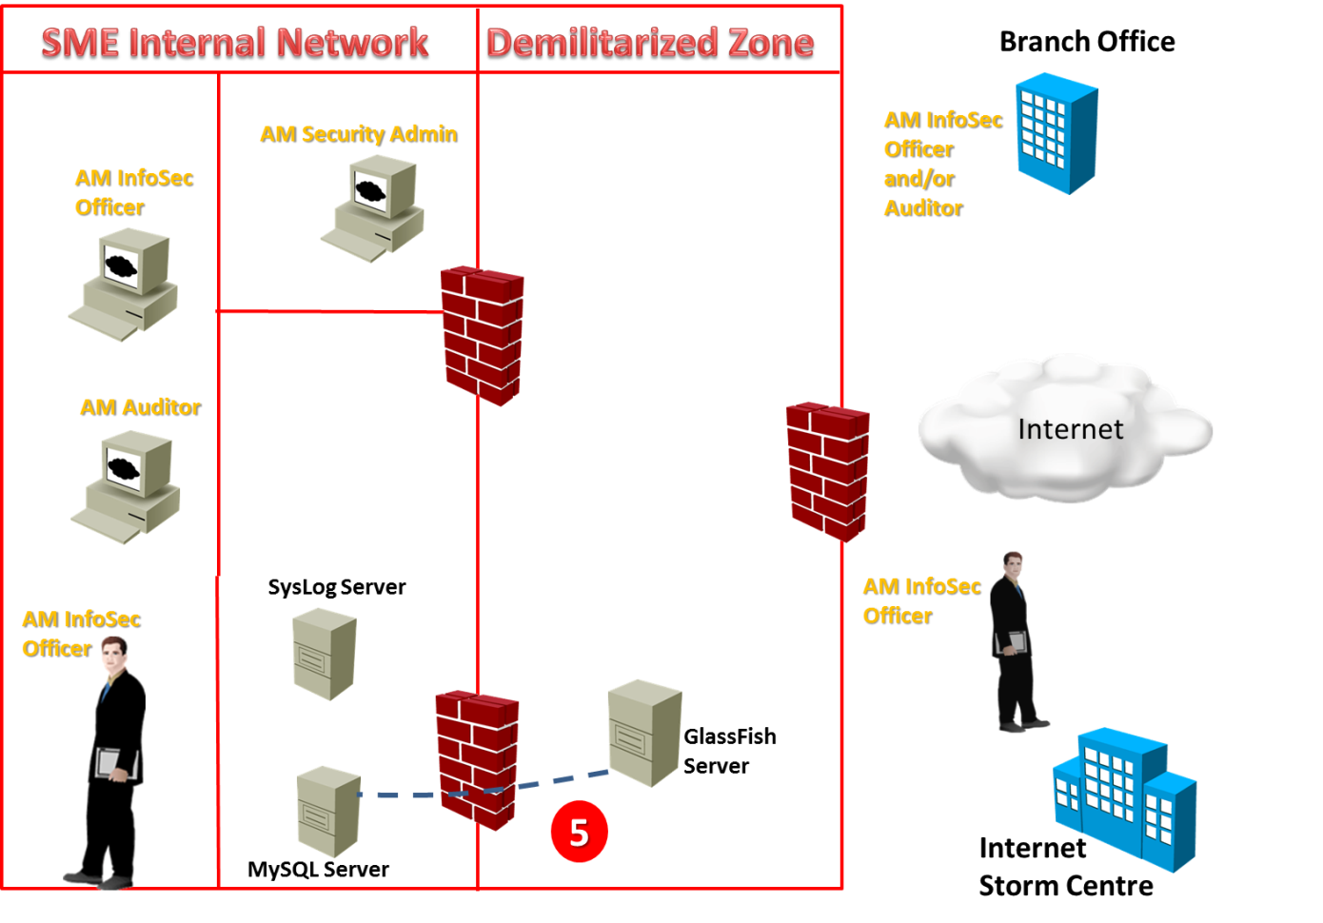

Figure 12: POC – Step 5

### POC design – Step 6

Finally the Information Security Officer starts the Attack Monitor App on her/his iPhone and gets the updated list of IPs that most likely attack the SME’s network perimeter:

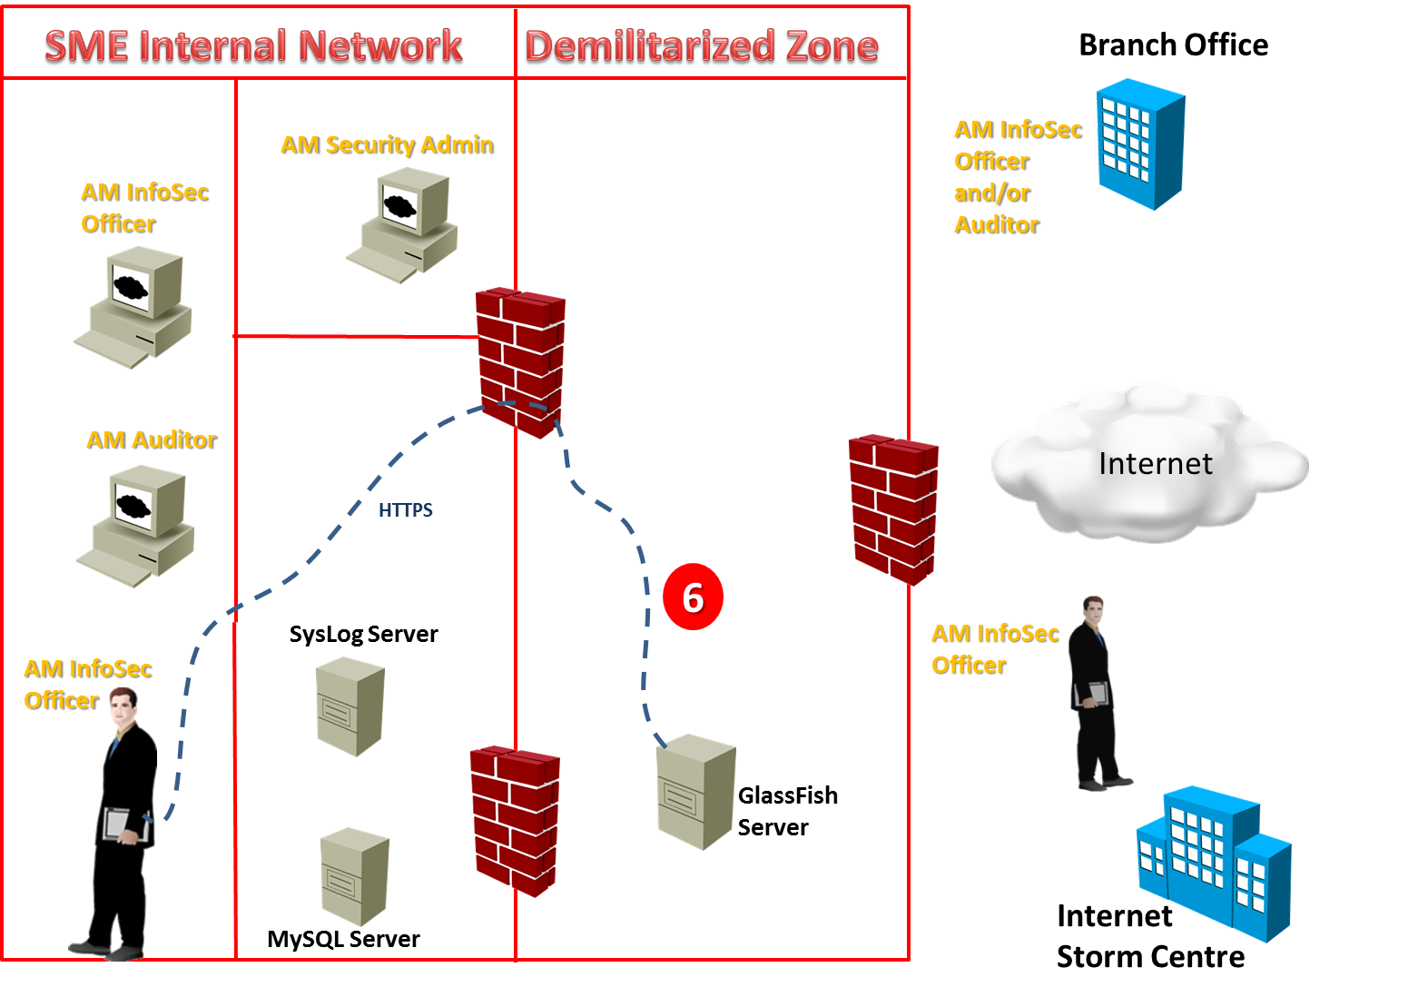

Figure 13: POC – Step 6

## Selection of High Level Programming Languages

Four subsystems are foreseen for the POC implementation so as to satisfy also the modularity requirement:

* **MIP** Subsystem (**M**alicious **I**P lists **P**arsing functions of the Attack Monitor) will be implemented in Java Platform Standard Edition (Java SE) 7 using Java SE Development Kit (JDK) 7 and Java SE Runtime Environment (JRE) 7.
* **FLP** Subsystem (**F**irewall **L**og file **P**arsing of the Attack Monitor) will be implemented in Java Platform Standard Edition (Java SE) 7 using Java SE Development Kit (JDK) 7 and Java SE Runtime Environment (JRE) 7.
* **RWS** Subsystem (**R**estful **W**eb **S**ervice of the Attack Monitor) will be implemented in Java Platform, Enterprise Edition (Java EE) using the  [**Java EE SDK**](http://www.oracle.com/technetwork/java/javaee/downloads/index.html), featuring GlassFish Application Server.
* **APP** Subsystem (Smart Device **App**lication for the Attack Monitor actors) will be implemented in iOS 7 using the related SDK and RestTkit Framework (for consuming the provided by RWS sybsystem web service).

**Note**: Implementation of the GUI subsystem is left for future work (next iterations).

## Accessing the Internet Storm Center / DShield API

The Internet Storm Center of SANS Institute provides a simple REST API (called DShield). The following API call (function) will be accessed:

[*Source IPs*](https://isc.sans.edu/api/#sources)- Information summary from the last 30 days about source IPs with return limit. Parameters: column to sort by (options: ip, count, attacks, firstseen, lastseen), number of records to be returned (max:10000) and date (limits to firstseen/lastseen if sorted by these).

[http://isc.sans.edu/api/sources/attacks/100/2012-03-08](https://isc.sans.edu/api/sources/attacks/100/2012-03-08)

<?xml version="1.0" encoding="UTF-8"?>

<sources>

<data>

<ip> 202.121.166.203 </ip>

<attacks> 109314 </attacks>

<count> 199219 </count>

<firstseen> 2011-11-04 </firstseen>

<lastseen> 2012-03-09 </lastseen>

</data>

...

<sources>

Important Note: Output formats include **xml** (default), **json**, **text** and **php**. Just add on to the url as a parameter such as [*http://isc.sans.edu/api/handler?text*](https://isc.sans.edu/api/handler?text)

For instance, the API call [*https://isc.sans.edu/api/sources/attacks/10/2014-06-21?json*](https://isc.sans.edu/api/sources/attacks/10/2014-06-21?json) returns:

{"0":{"ip":"150.164.102.070","attacks":"352368","count":"447121","firstseen":"2014-05-03","lastseen":"2014-06-03"},"1":{"ip":"184.105.139.067","attacks":"138761","count":"3040055","firstseen":"2014-02-23","lastseen":"2014-06-21"},"2":{"ip":"218.077.079.034","attacks":"128413","count":"13789529","firstseen":"2013-12-26","lastseen":"2014-06-15"},"3":{"ip":"218.077.079.043","attacks":"116759","count":"3534311","firstseen":"2014-06-12","lastseen":"2014-06-21"},"4":{"ip":"185.056.080.133","attacks":"109549","count":"807512","firstseen":"2014-06-05","lastseen":"2014-06-21"},"5":{"ip":"065.111.161.035","attacks":"98903","count":"333225","firstseen":"2014-05-15","lastseen":"2014-06-21"},"6":{"ip":"066.240.236.119","attacks":"98053","count":"2868534","firstseen":"2014-04-26","lastseen":"2014-06-21"},"7":{"ip":"071.006.135.131","attacks":"97337","count":"2765879","firstseen":"2013-12-16","lastseen":"2014-06-21"},"8":{"ip":"071.006.165.200","attacks":"97288","count":"2548097","firstseen":"2014-01-12","lastseen":"2014-06-21"},"9":{"ip":"066.240.192.138","attacks":"96802","count":"2759986","firstseen":"2014-01-03","lastseen":"2014-06-21"},"METAKEYINFO":"data"}

In the context of this capstone project we are going to take advantage of the xml (default) output format of DShield API.

### XML Validation

The delivered xml based web service will be validated on: <http://www.w3schools.com/xml/xml_validator.asp>

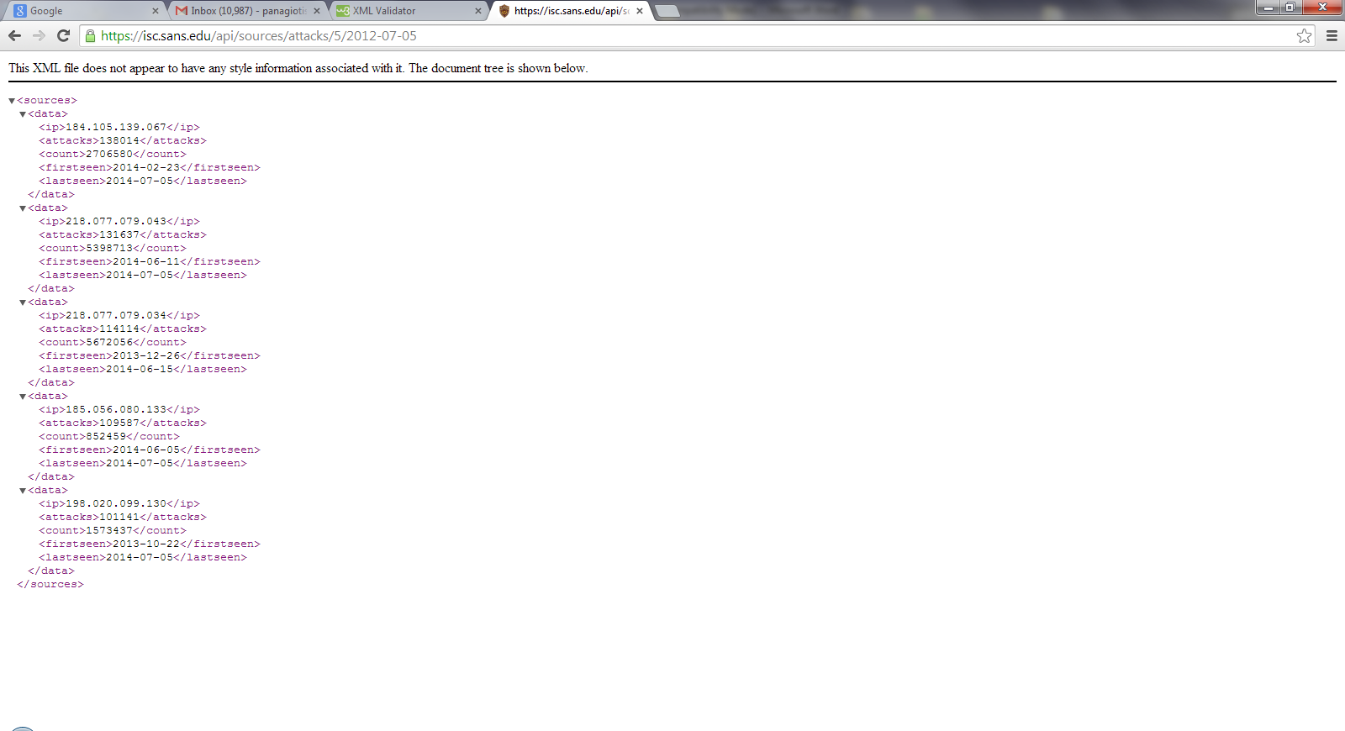

Figure 14: XML Input

The actual sample that has been tested is:

<sources>

<data>

<ip>184.105.139.067</ip>

<attacks>138014</attacks>

<count>2706580</count>

<firstseen>2014-02-23</firstseen>

<lastseen>2014-07-05</lastseen>

</data>

<data>

<ip>218.077.079.043</ip>

<attacks>131637</attacks>

<count>5398713</count>

<firstseen>2014-06-11</firstseen>

<lastseen>2014-07-05</lastseen>

</data>

<data>

<ip>218.077.079.034</ip>

<attacks>114114</attacks>

<count>5672056</count>

<firstseen>2013-12-26</firstseen>

<lastseen>2014-06-15</lastseen>

</data>

<data>

<ip>185.056.080.133</ip>

<attacks>109587</attacks>

<count>852459</count>

<firstseen>2014-06-05</firstseen>

<lastseen>2014-07-05</lastseen>

</data>

<data>

<ip>198.020.099.130</ip>

<attacks>101141</attacks>

<count>1573437</count>

<firstseen>2013-10-22</firstseen>

<lastseen>2014-07-05</lastseen>

</data>

</sources>

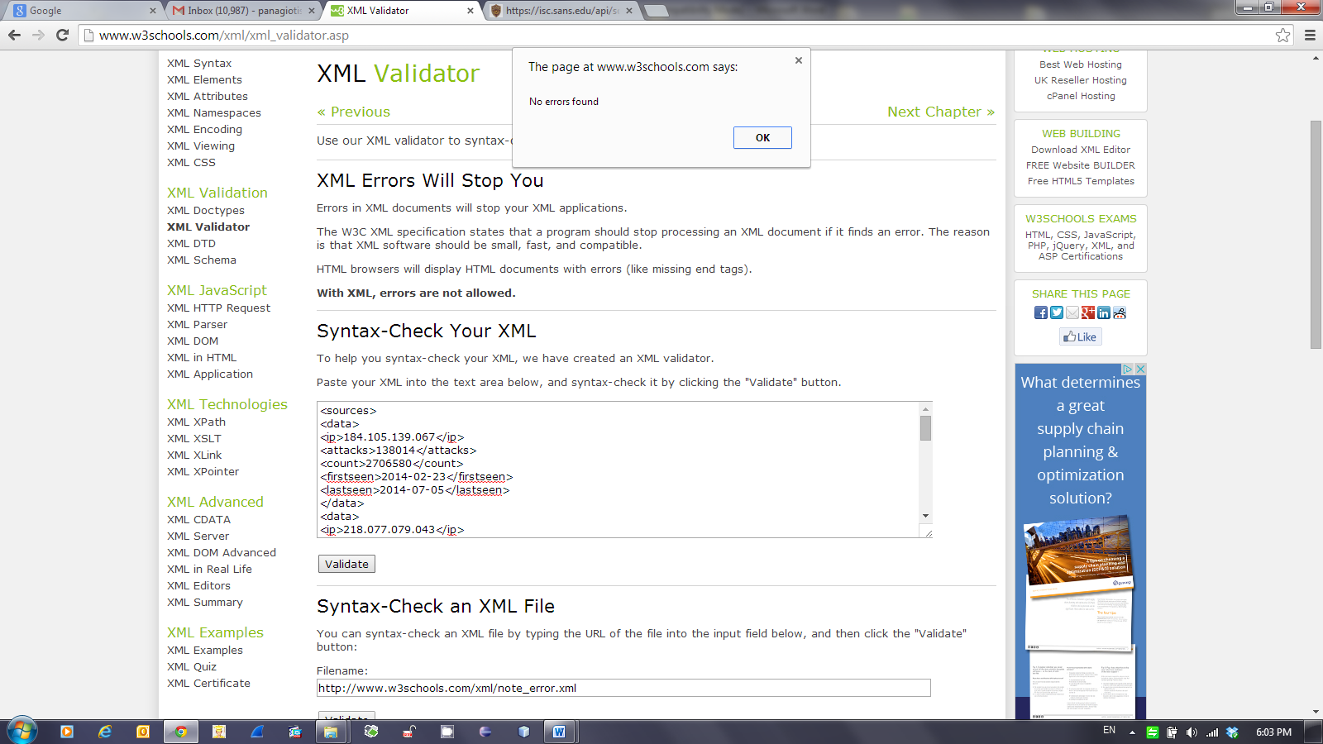

Figure 14: XML Validation Result

### Reading XML Data into a DOM

DOM is an Object representation of an XML, HTML or XHTML document. The Java API for XML (JAXP) provides an API for DOM implementation in Java. It also provides parsing interface which can be used to plug in different parsers (JAXP provides a default implementation).

## The Relational Database

The free Community Edition of MySQL will be used as the Relational Database Management System (RDBMS). According to Oracle, MySQL is the world’s most popular open source database software. MySQL provides JDBC, ODBC, .NET drivers for Java and .NET development, as well as other languages. MySQL is supported by many popular IDE’s, including MySQL’s own RDBMS IDE, MySQL Workbench. MySQL is accompanied by extensive documentation, tutorials, and even sample databases.

## Log File (text) Parsing

Parsing of the retrieved log files will be based on Scanner class functionality. In particular, The Scanner class is a class in java.util, which allows the user to read values of various types.

## The RESTful Web Service

For the development of the Java RESTful Web Service, MySQL Server and EclipseLink (JPA) will be used. Regarding Restful Web Services the following paragraph has been retrieved from the Java EE tutorials:

“RESTful web services are built to work best on the Web. Representational State Transfer (REST) is an architectural style that specifies constraints, such as the uniform interface, that if applied to a web service induces desirable properties, such as performance, scalability, and modifiability, which enable services to work best on the Web. In the REST architectural style, data and functionality are considered resources and are accessed using Uniform Resource Identifiers (URIs), typically links on the Web. The resources are acted upon by using a set of simple, well-defined operations. The REST architectural style constrains architecture to client/server architecture and is designed to use a stateless communication protocol, typically HTTP. In the REST architecture style, clients and servers exchange representations of resources by using a standardized interface and protocol.

The following principles encourage RESTful applications to be simple, lightweight, and fast:

* Resource identification through URI: A RESTful web service exposes a set of resources that identify the targets of the interaction with its clients. Resources are identified by URIs, which provide a global addressing space for resource and service discovery.
* Uniform interface: Resources are manipulated using a fixed set of four create, read, update, delete operations: PUT, GET, POST, and DELETE. PUT creates a new resource, which can be then deleted by using DELETE. GET retrieves the current state of a resource in some representation. POST transfers a new state onto a resource.
* Self-descriptive messages: Resources are decoupled from their representation so that their content can be accessed in a variety of formats, such as HTML, XML, plain text, PDF, JPEG, JSON, and others. Metadata about the resource is available and used, for example, to control caching, detect transmission errors, negotiate the appropriate representation format, and perform authentication or access control. See [Responding to HTTP Methods and Requests](http://docs.oracle.com/javaee/6/tutorial/doc/gilik.html#gipys) and [Using Entity Providers to Map HTTP Response and Request Entity Bodies](http://docs.oracle.com/javaee/6/tutorial/doc/gilik.html#gipze) for more information.
* Stateful interactions through hyperlinks: Every interaction with a resource is stateless; that is, request messages are self-contained. Stateful interactions are based on the concept of explicit state transfer. Several techniques exist to exchange state, such as URI rewriting, cookies, and hidden form fields. State can be embedded in response messages to point to valid future states of the interaction. See [Using Entity Providers to Map HTTP Response and Request Entity Bodies](http://docs.oracle.com/javaee/6/tutorial/doc/gilik.html#gipze) and “Building URIs” in the JAX-RS Overview document for more information.”

## The Database Connector and the Application Server

We will use JDBC to map JPA entity classes to tables and views within a MySQL database. We will then build RESTful web services, EJB classes, which communicate with MySQL through the entities. We will separate the JPA entities into a Java Class Library. The class library will be referenced by the RESTful web service. The RESTful web service, part of a Java Web Application, will be deployed to GlassFish server, in order to be accessed with HTTP(S) methods and test it.

## The RestKit Framework

RestKit GitHub project describes RestKit as “a modern Objective-C framework for implementing RESTful web services clients on iOS and Mac OS X. It provides a powerful object mapping engine that seamlessly integrates with Core Data and a simple set of networking primitives for mapping HTTP requests and responses built on top of AFNetworking. It has an elegant, carefully designed set of APIs that make accessing and modeling RESTful resources feel almost magical.”

RestKit has three main components:

1. Network – RestKit uses AFNetworking v1.3.3 for the network layer.
2. Object Mapping – Provides a simple API for turning remote JSON/XML responses into local objects.
3. Core Data – Provides additional support on top of the object mapper for mapping remote resources to persisted local objects (no Core Data will be used in the context of our prototype implementation).

# Prototype (POC) Implementation

In order to fulfil the requirement of using cutting-edge web technologies for the POC implementation -with a view to present a real world and not a primitive solution- author made extensive use of third party libraries and frameworks that significantly decreased the development but unfortunately increased dramatically the debugging and troubleshooting effort. In addition, in order to complete the complex puzzle of the end to end scenario he took advantage of the technology suppliers’ tutorials, tutorials found on development related blogs and of programming practices suggested on the <http://stackoverflow.com/> site so as to overcome the numerous but specific implementation problems.

## Implementation and Release Notes

In the following paragraphs of this section, essential information about the implementation and troubleshooting process of the Attack Monitor is presented.

**Configuration and Change Management System**

Neither configuration nor change management system will be used for the prototype implementation. In case the capstone project deliverables are considered valuable by the Review Committee, it might be useful to upload the source code at “GitHub” in order to be freely available and at the disposal of the worlwide community of software engineers.

## The MySQL Database

A new database instance, named “threat”, has been created using the “MySQL Workbench” as depicted below:

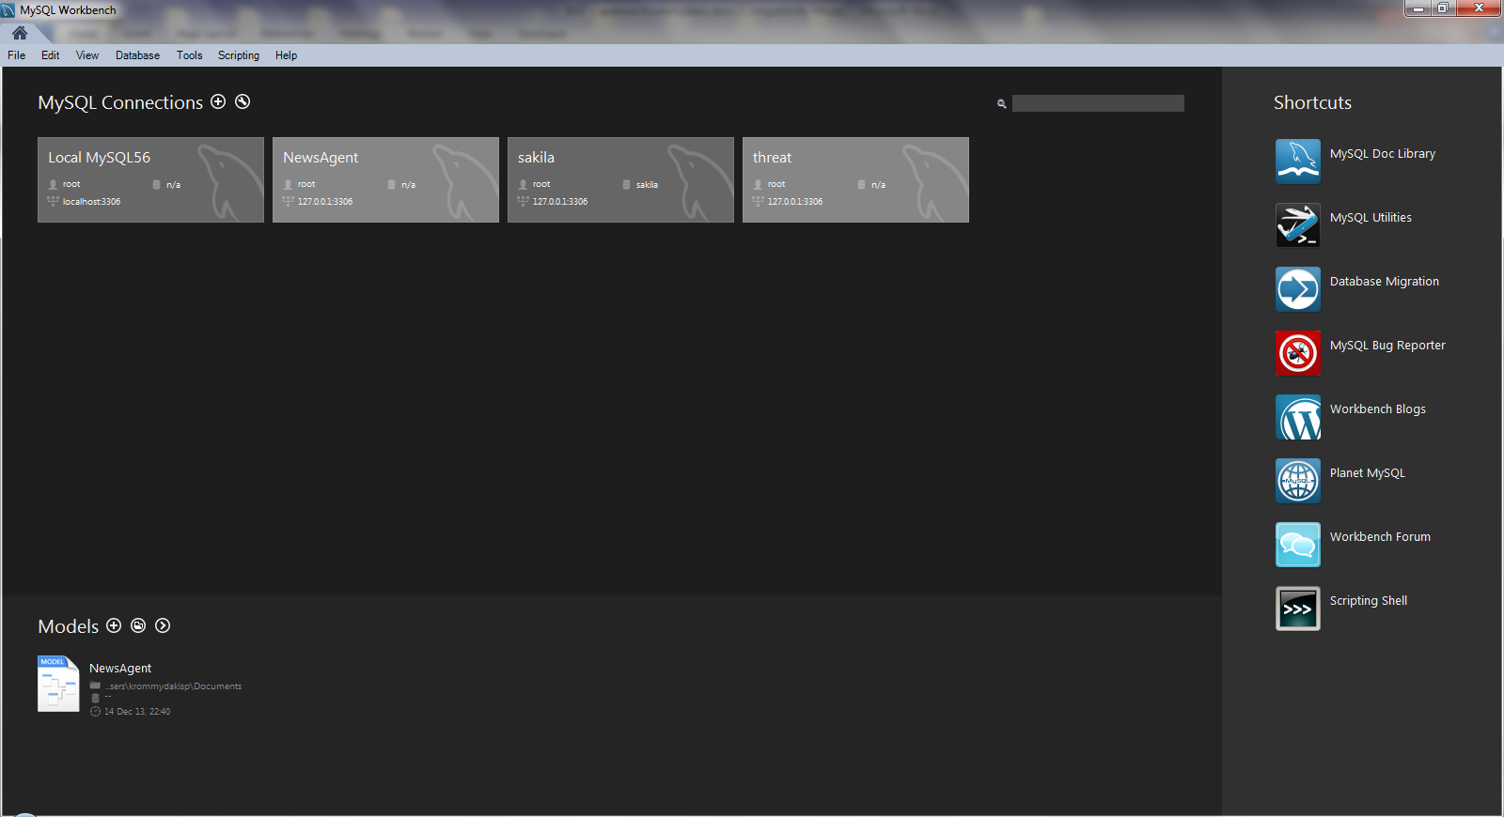

Figure 16: MySQL Workbench – The new database

The newly created database contains two simple tables. The first one, which is called “sans” will be populated with the data retrieved by the SANS’ Internet Storm Center as follows:

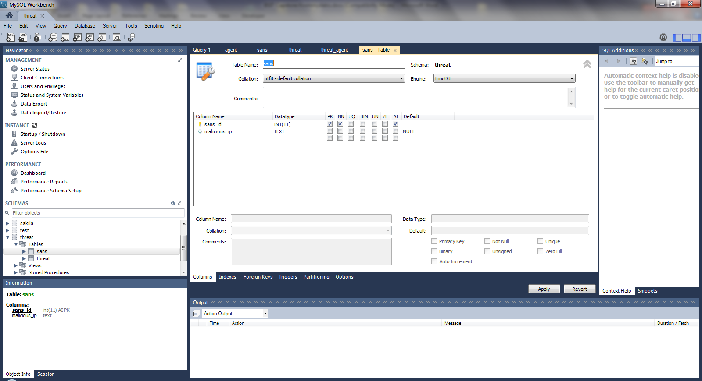

Figure 17: MySQL Workbench – The “sans” table

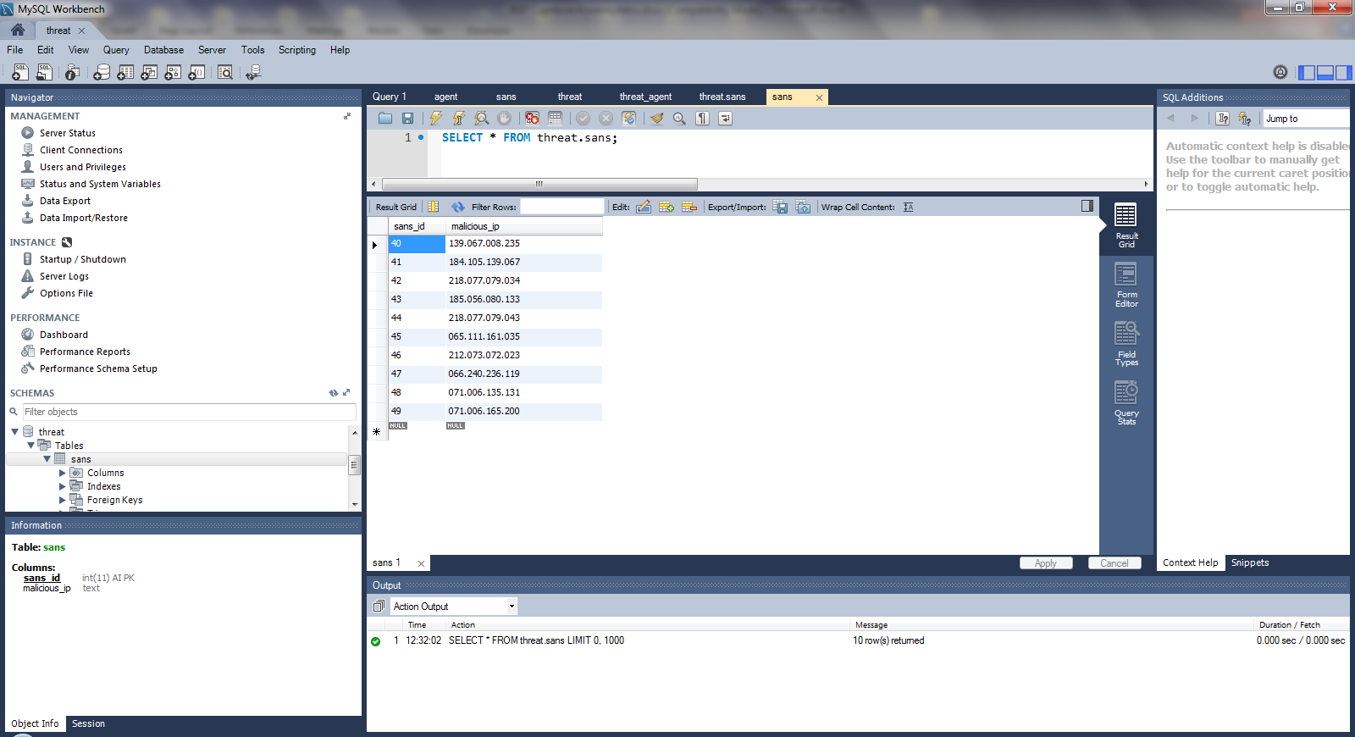

Figure 18: MySQL Workbench – Records of he “sans” table

The second database table has been named “threat” and will store the malicious IPs found in the firewall log files:

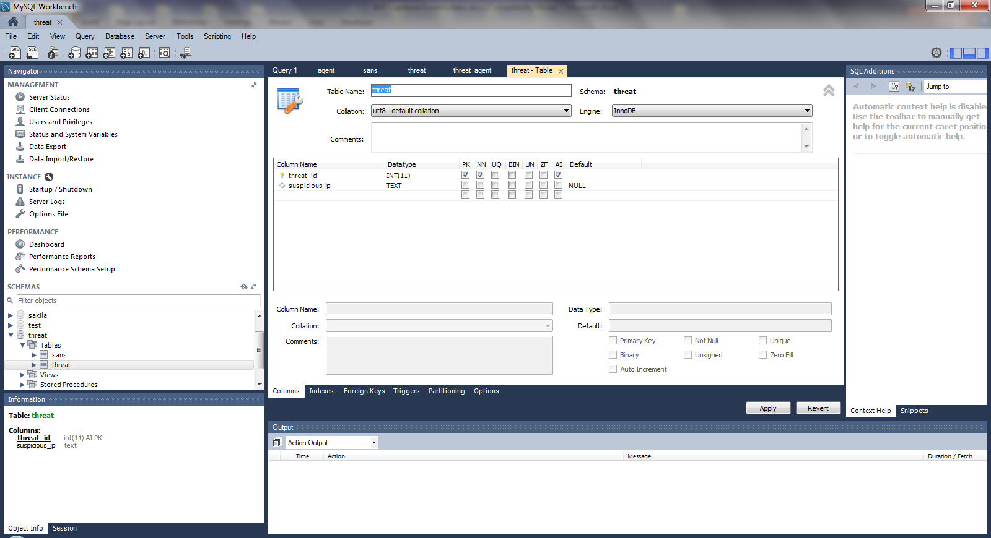

Figure 19: MySQL Workbench – The “threat” table

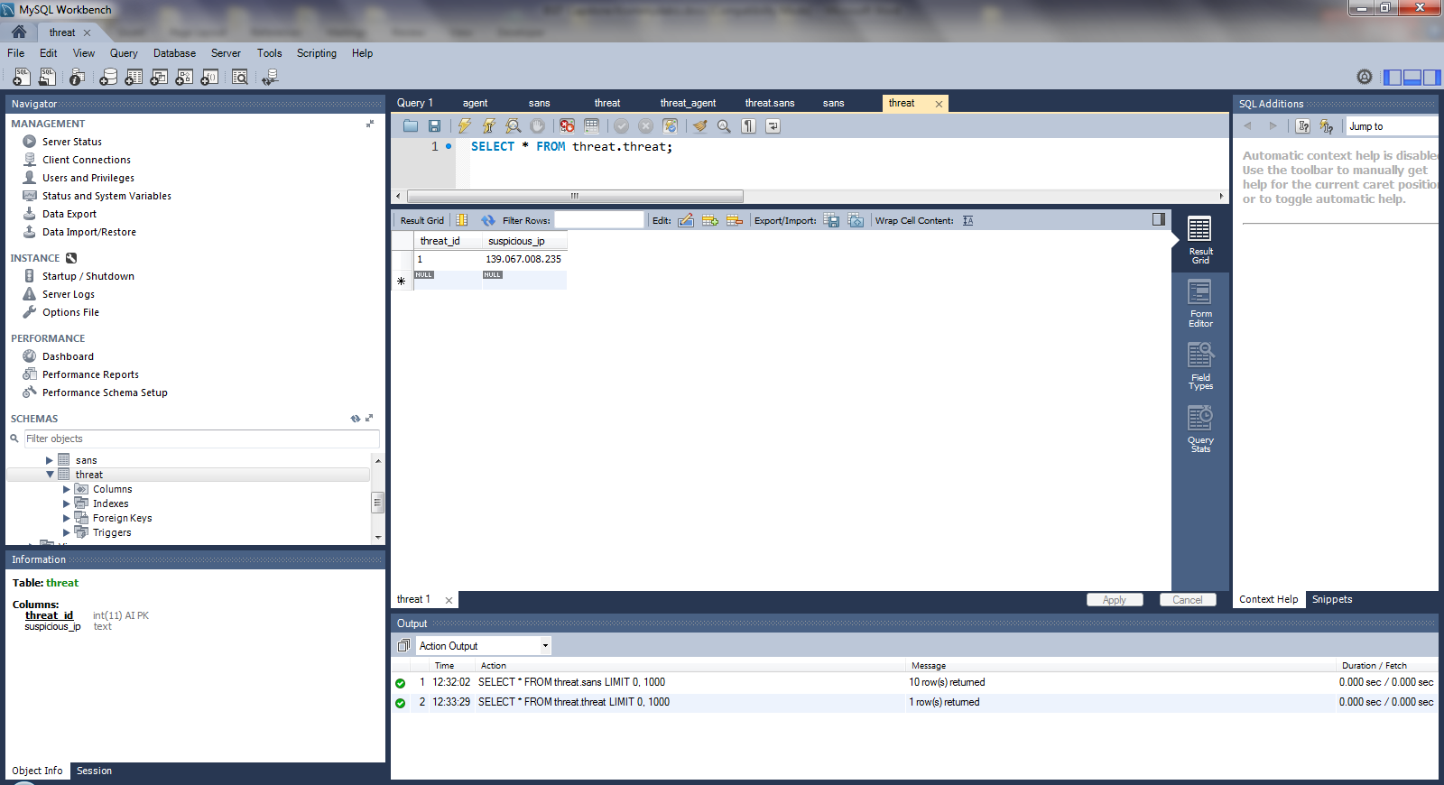

Figure 20: MySQL Workbench – Records of the “threat” table

## The XML Parser

**Note**: Implementation is mainly based on the vendor tutorial found in:

<http://docs.oracle.com/javase/tutorial/jaxp/dom/readingXML.html>

Additional resource used: <http://www.studytrails.com/java/xml/jaxp/java-api-for-xml-DOM.jsp>

The respective Eclipse IDE project is depicted in the following screenshot:

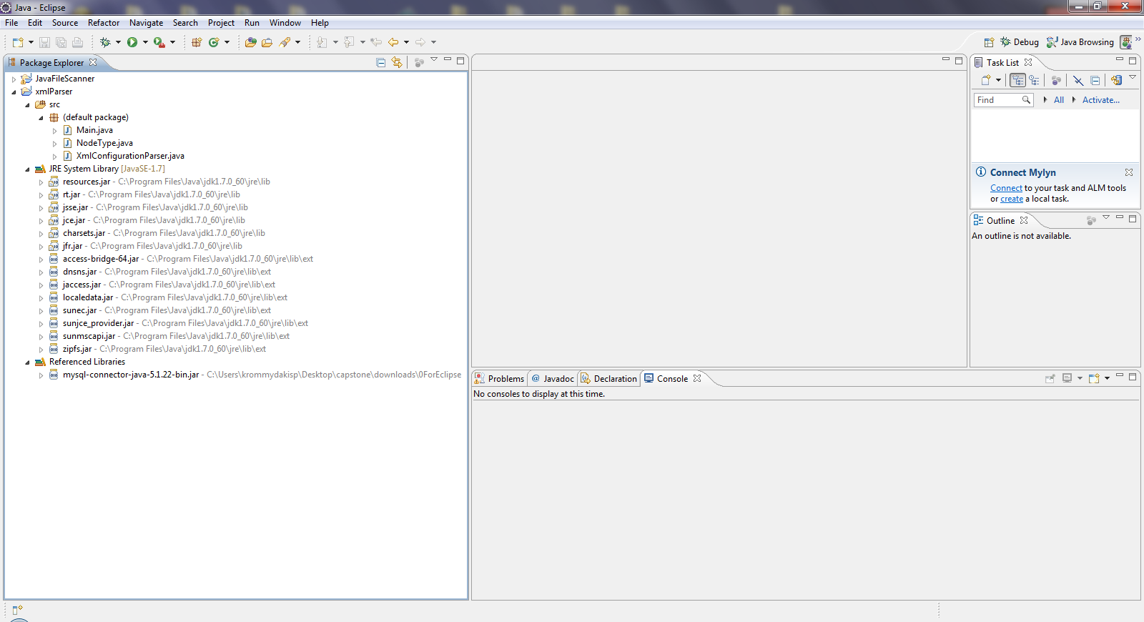

Figure 21: The XML Parser Eclipse project

### The Main.java Class

**import** java.io.IOException;

**import** java.sql.Connection;

**import** java.sql.DriverManager;

**import** java.sql.PreparedStatement;

**import** java.sql.SQLException;

**import** java.util.ArrayList;

**import** java.util.Iterator;

**import** java.util.List;

**import** javax.xml.parsers.ParserConfigurationException;

**import** org.w3c.dom.Document;

**import** org.w3c.dom.Element;

**import** org.w3c.dom.Node;

**import** org.w3c.dom.NodeList;

**import** org.xml.sax.SAXException;

**public** **class** Main {

**private** **static** String *tableName* = "sans";

**public** **static** **void** main(String[] args) **throws** ParserConfigurationException, IOException, SAXException {

XmlConfigurationParser xmlConfigurationParser=**new** XmlConfigurationParser();

Document document=xmlConfigurationParser.loadFile("https://isc.sans.edu/api/sources/attacks/10/2014-06-18?xml");

Element element=xmlConfigurationParser.getRootElement(document);

List<Node> dataNodes=xmlConfigurationParser.getChildNodesByTagName(element, "data", NodeType.*ELEMENT_NODE*);

List<String> ips=**new** ArrayList<>();

**for** (Node datanode:dataNodes){

List<Node> ipNodes=xmlConfigurationParser.getChildNodesByTagName(datanode, "ip", NodeType.*ELEMENT_NODE*);

**for** (Node ipNode:ipNodes){

NodeList nodeLst=ipNode.getChildNodes();

**if** (nodeLst.getLength()==1){

Node node=nodeLst.item(0);

ips.add(node.getNodeValue());

}

}

}

**for** (String ip:ips){

System.*out*.println("Retrieve Malicious IP from Internet Storm Centre: " + ip);

}

Connection con = **null**;

String url = "jdbc:mysql://localhost:3306/";

String db = "threat";

String driver = "com.mysql.jdbc.Driver";

String user = "root";

String pass = "a11111111!";

**try** {

Class.*forName*(driver);

con = DriverManager.*getConnection*(url + db, user, pass);

**if** (con!=**null**)

System.*out*.println("Database Connection Opened...");

} **catch** (ClassNotFoundException e) {

e.printStackTrace();

} **catch** (SQLException e) {

e.printStackTrace();

}

StringBuffer sb = **new** StringBuffer("INSERT INTO " + *tableName* + " (malicious_ip)");

sb.append(" VALUES");

**int** size = ips.size();

**int** count = 0;

Iterator<String> iterator = ips.iterator();

**while** (iterator.hasNext()) {

**if** (count < (size - 1))

sb.append("(\"" +iterator.next() + "\"),");

**else**

sb.append("(\"" + iterator.next() + "\");");

count++;

}

System.*out*.println(sb.toString());

**try** {

PreparedStatement pstmt = con.prepareStatement(sb.toString());

pstmt.executeUpdate();

} **catch** (SQLException e) {

e.printStackTrace();

}

**try**{

con.close();

**if** (con.isClosed())

System.*out*.println("...Database Connection Closed");

System.*out*.println("Local Threat Agents database has been updated with the list of Malicious IPs from Internet Storm Centre (SANS Institute) !!!");

} **catch** (SQLException e) {

System.*err*.println("SQLException: " +e.getMessage());

}

}

}

### The NodeType.java Class

**import** java.util.HashMap;

**import** java.util.Map;

**public** **enum** NodeType {

*ELEMENT_NODE* (1,"ELEMENT"),

*ATTRIBUTE_NODE* (2,"ATTRIBUTE"),

*TEXT_NODE* (3,"TEXT"),

*CDATA_SECTION_NODE* (4,"CDATA_SECTION"),

*ENTITY_REFERENCE_NODE* (5,"ENTITY_REFERENCE"),

*ENTITY_NODE* (6,"ENTITY"),

*PROCESSING_INSTRUCTION_NODE* (7,"PROCESSING_INSTRUCTION"),

*COMMENT_NODE* (8,"COMMENT"),

*DOCUMENT_NODE* (9,"DOCUMENT"),

*DOCUMENT_TYPE_NODE* (10,"DOCUMENT_TYPE"),

*DOCUMENT_FRAGMENT_NODE* (11,"DOCUMENT_FRAGMENT"),

*NOTATION_NODE* (12,"NOTATION");

**private** **int** id;

**private** String name;

**private** **static** **final** Map<String, NodeType> *_NodeTypeMap*;

**static** {

*_NodeTypeMap* = **new** HashMap<>();

**for** (NodeType v : *values*()) {

*_NodeTypeMap*.put(v.getName(), v);

*_NodeTypeMap*.put(String.*valueOf*(v.id), v);

}

}

**private** NodeType(**int** id, String name) {

**this**.id=id;

**this**.name=name;

}

**public** **int** getId() {

**return** id;

}

**public** **void** setId(**int** id) {

**this**.id = id;

}

**public** String getName() {

**return** name;

}

**public** **void** setName(String name) {

**this**.name = name;

}

**public** **static** NodeType valueOfName(String type) {

**return** *_NodeTypeMap*.get(type);

}

**public** **static** NodeType valueOfInt(**int** type) {

**return** *_NodeTypeMap*.get(String.*valueOf*(type));

}

}

### The XmlConfigurationParser.java Class

**import** org.w3c.dom.Document;

**import** org.w3c.dom.Element;

**import** org.w3c.dom.NamedNodeMap;

**import** org.w3c.dom.Node;

**import** org.w3c.dom.NodeList;

**import** org.xml.sax.SAXException;

**import** javax.xml.parsers.DocumentBuilder;

**import** javax.xml.parsers.DocumentBuilderFactory;

**import** javax.xml.parsers.ParserConfigurationException;

**import** java.io.IOException;

**import** java.net.URL;

**import** java.util.ArrayList;

**import** java.util.List;

**public** **class** XmlConfigurationParser {

**public** Document loadFile(String url) **throws** ParserConfigurationException, IOException, SAXException {

DocumentBuilderFactory dbFactory = DocumentBuilderFactory.*newInstance*();

DocumentBuilder dBuilder = dbFactory.newDocumentBuilder();

Document document = dBuilder.parse(**new** URL(url).openStream());

document.getDocumentElement().normalize();

**return** document;

}

**public** Element getRootElement(Document document) {

**return** document.getDocumentElement();

}

**public** NodeList getNodeListByTagName(Element document, String tag) {

**return** document.getElementsByTagName(tag);

}

**public** List<Node> getNodesByTagName(Element document, String tag, NodeType nodeType) {

NodeList nodeList = getNodeListByTagName(document, tag);

List<Node> nodes = **new** ArrayList<>();

**for** (**int** index = 0; index < nodeList.getLength(); index++) {

Node node = nodeList.item(index);

**if** (getNodeType(node) == nodeType) {

nodes.add(node);

}

}

**return** nodes;

}

**public** NodeList getNodeListByTagName(Document document, String tag) {

**return** document.getElementsByTagName(tag);

}

**public** List<Node> getNodesByTagName(Document document, String tag, NodeType nodeType) {

NodeList nodeList = getNodeListByTagName(document, tag);

List<Node> nodes = **new** ArrayList<>();

**for** (**int** index = 0; index < nodeList.getLength(); index++) {

Node node = nodeList.item(index);

**if** (getNodeType(node) == nodeType) {

nodes.add(node);

}

}

**return** nodes;

}

**public** NamedNodeMap getElementAttributesNamedNodeMap(Element element) {

**return** element.getAttributes();

}

**public** String getElementAttributeByName(Element element, String attributeName) {

**return** element.getAttribute(attributeName);

}

**public** String getTagName(Element element) {

**return** element.getTagName();

}

**public** String getNodeName(Node node) {

**return** node.getNodeName();

}

**public** NodeType getNodeType(Node node) {

**return** NodeType.*valueOfInt*(node.getNodeType());

}

**public** List<Node> getChildNodes(Node menu, NodeType nodeType) {

NodeList nodeList = menu.getChildNodes();

List<Node> nodes = **new** ArrayList<>();

**for** (**int** index = 0; index < nodeList.getLength(); index++) {

Node node = nodeList.item(index);

**if** (getNodeType(node) == nodeType) {

nodes.add(node);

}

}

**return** nodes;

}

**public** List<Node> getChildNodesByTagName(Node parentNode,String tag, NodeType nodeType) {

NodeList nodeList = parentNode.getChildNodes();

List<Node> nodes = **new** ArrayList<>();

**for** (**int** index = 0; index < nodeList.getLength(); index++) {

Node node = nodeList.item(index);

**if** (getNodeType(node) == nodeType && tag.equals(getNodeName(node))) {

nodes.add(node);

}

}

**return** nodes;

}

**public** String getCData(Node parentNode) {

StringBuilder cData=**new** StringBuilder();

NodeList nodeList = parentNode.getChildNodes();

**for** (**int** index = 0; index < nodeList.getLength(); index++) {

Node node = nodeList.item(index);

**if** (getNodeType(node) == NodeType.*CDATA_SECTION_NODE*) {

cData=cData.append(node.getNodeValue()).append("\n");

}

}

**return** cData.toString().trim();

}

}

## The Firewall Log File Text Parser

The respective Eclipse IDE project is depicted in the following screenshot:

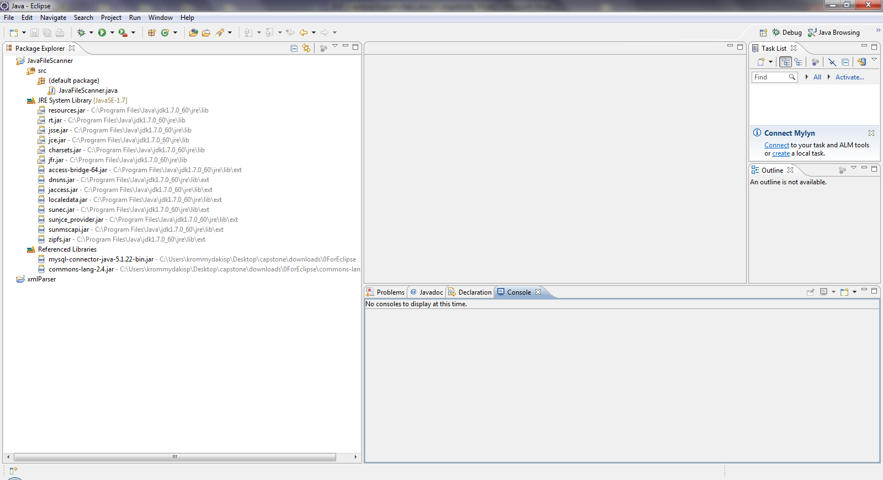

Figure 22: The Java File Scanner Eclipse project

### The JavaFileScanner.java Class

import java.io.IOException;

import java.net.InetAddress;

import java.net.UnknownHostException;

import java.nio.file.Path;

import java.nio.file.Paths;

import java.util.Scanner;

import java.sql.Connection;

import java.sql.DriverManager;

import java.sql.PreparedStatement;

import java.sql.ResultSet;

import java.sql.SQLException;

public class JavaFileScanner {

public static void main(String[] args) throws IOException {

try {

String fileName = "C:\\Users\\krommydakisp\\Desktop\\capstone\\fw_logs\\CheckPoint-FW.txt";

Path path = Paths.get(fileName);

Scanner scanner = new Scanner(path);

//read file line by line

scanner.useDelimiter(System.getProperty("line.separator"));

while(scanner.hasNext()){

System.out.println("Lines: "+scanner.next());

}

scanner.close();

//read Log File and parse it to object array

scanner = new Scanner(Paths.get("C:\\Users\\krommydakisp\\Desktop\\capstone\\fw_logs\\CheckPoint-FW.txt"));

scanner.useDelimiter(System.getProperty("line.separator"));

while(scanner.hasNext()){

//parse line to get Source IP Object

SuspiciousEvent event = parseLogLine(scanner.next());

System.out.println(event.toString());

}

scanner.close();

} catch (Exception e) {

e.printStackTrace();

}

}

private static SuspiciousEvent parseLogLine(String line) throws UnknownHostException {

Scanner scanner = new Scanner(line);

scanner.useDelimiter("\\s*,\\s*");

String date = scanner.next();

String time = scanner.next();

String action = scanner.next();

String fw_name = scanner.next();

String direction = scanner.next();

String srcIP = scanner.next();

String destIP = scanner.next();

String numberOfBytes = scanner.next();

String ruleNumber = scanner.next();

String protocol = scanner.next();

JavaFileScanner jfs = new JavaFileScanner();

srcIP = srcIP.replace("src=", "" );

srcIP = srcIP.replaceAll("^\"|\"$", "");

String [] ipv4_parts = srcIP.split ("\\.");

String new_srcIP = "";

for (String s : ipv4_parts)

{

//System.out.println(s);

String new_s = org.apache.commons.lang.StringUtils.leftPad(s, 3, "0");

//System.out.println(new_s);

new_srcIP = new_srcIP +"." + new_s;

//System.out.println(new_srcIP);

}

srcIP = new_srcIP.substring(1);

//System.out.println(srcIP);

return jfs.new SuspiciousEvent(srcIP);

}

public class SuspiciousEvent{

private String srcIP;

public SuspiciousEvent(String n){

this.srcIP = n;

}

@Override

public String toString(){

System.out.println("Suspicious IP="+this.srcIP);

Connection con = null;

String url = "jdbc:mysql://localhost:3306/";

String db = "threat";

String driver = "com.mysql.jdbc.Driver";

String user = "root";

String pass = "a11111111!";

try {

Class.forName(driver);

con = DriverManager.getConnection(url + db, user, pass);

if (con!=null)

System.out.println("Database Connection Opened...");

} catch (ClassNotFoundException e) {

e.printStackTrace();

} catch (SQLException e) {

e.printStackTrace();

}

try {

databaseQuery(con, this.srcIP);

} catch (SQLException e) {

// TODO Auto-generated catch block

e.printStackTrace();

}

try{

con.close();

if (con.isClosed())

System.out.println("...Database Connection Closed");

} catch (SQLException e) {

System.err.println("SQLException: " +e.getMessage());

}

return "Cross-check has been concluded for suspicious IP="+this.srcIP + "\n\n";

}

private void databaseQuery(Connection con, String srcIP) throws SQLException {

String srcTableName = "sans";

String dstTableName = "threat";

StringBuffer sb = new StringBuffer("SELECT * FROM " + srcTableName + " WHERE malicious_ip= ?" );

//System.out.println("Prepared SQL statement:" + sb.toString());

try {

PreparedStatement pstmt = null;

pstmt = con.prepareStatement(sb.toString());

pstmt.setString(1, srcIP);

//System.out.println("Prepared SQL statement:" + pstmt.toString());

ResultSet rs= pstmt.executeQuery();

if (rs.next()) {

System.out.println("WARNING!!! Potential attack identified from source IP address: " + srcIP);

StringBuffer db = new StringBuffer("INSERT INTO " + dstTableName + " (suspicious_ip) VALUES(?)" );

//System.out.println("Prepared SQL statement:" + db.toString());

PreparedStatement stmt = null;

stmt = con.prepareStatement(db.toString());

stmt.setString(1, srcIP);

stmt.executeUpdate();

}

} catch (SQLException e) {

e.printStackTrace();

}

}

}

}

## The RESTFul Web Service

**Note**: Implementation is based on

[http://programmaticponderings.wordpress.com/2013/04/12/restful-web-services-using-java-and-mysql/](%20http:/programmaticponderings.wordpress.com/2013/04/12/restful-web-services-using-java-and-mysql/)

The necessary two NETBeans IDE projects are depicted in the following screenshot:

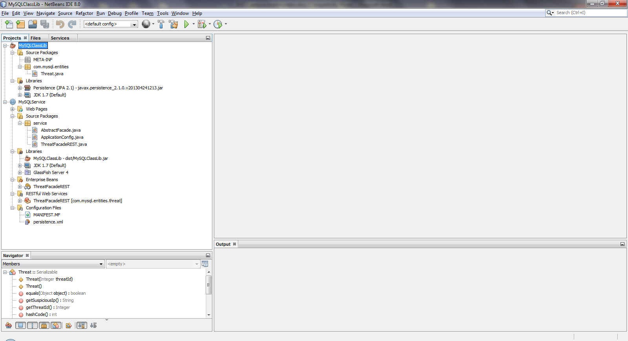

Figure 23: The two NetBeans projects

### NETBeans IDE Configuration

To begin development in NetBeans, first create a new JDBC database connection to the MySQL threat database. In the Services tab, right-click on the Databases item and select New Connection…:

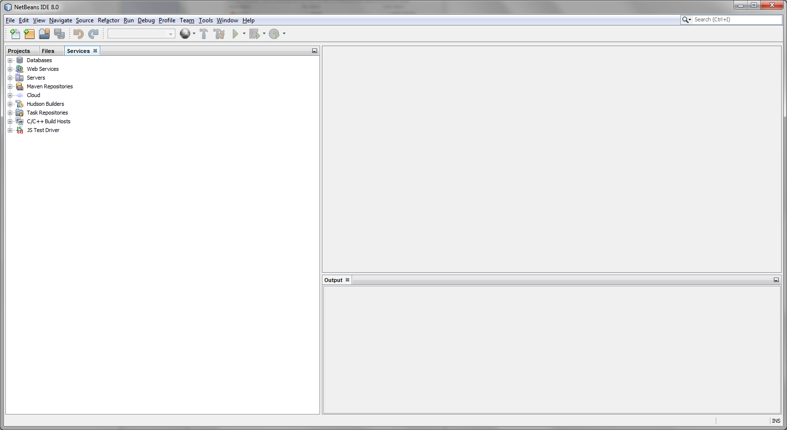

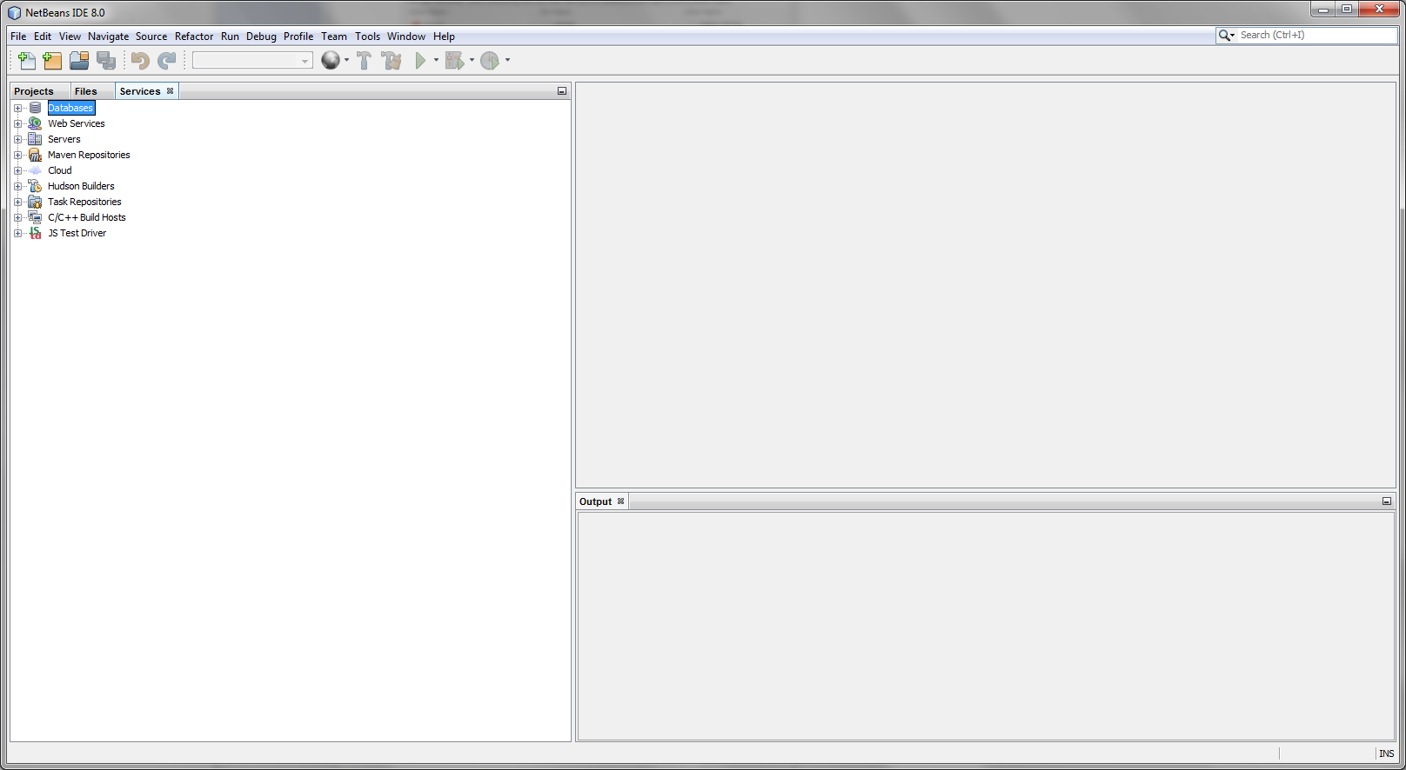

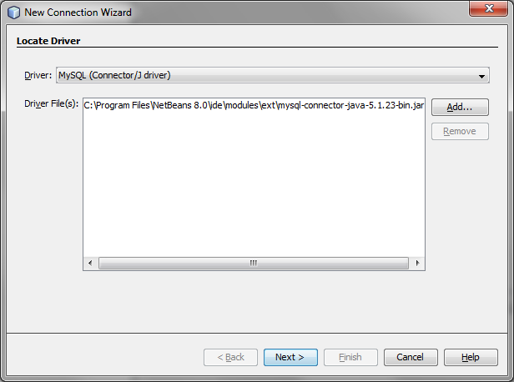

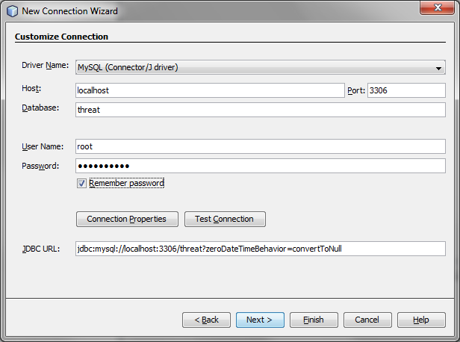

It is wise to test the new connection before finishing, using the ‘Test’ button.

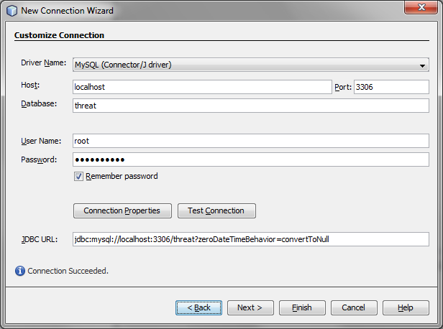

The next step is to customize the Connection in the New Connection Wizard.

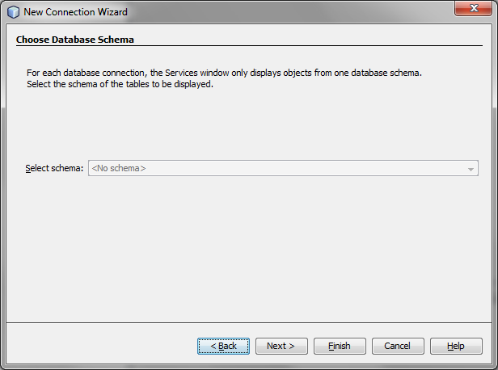

Finally select a Name for the Connection.

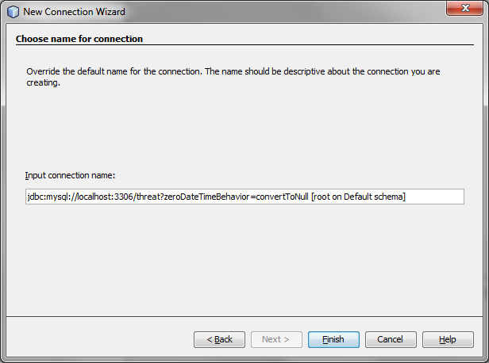

The New Database Connection for MySQL threat Database is displayed as follows:

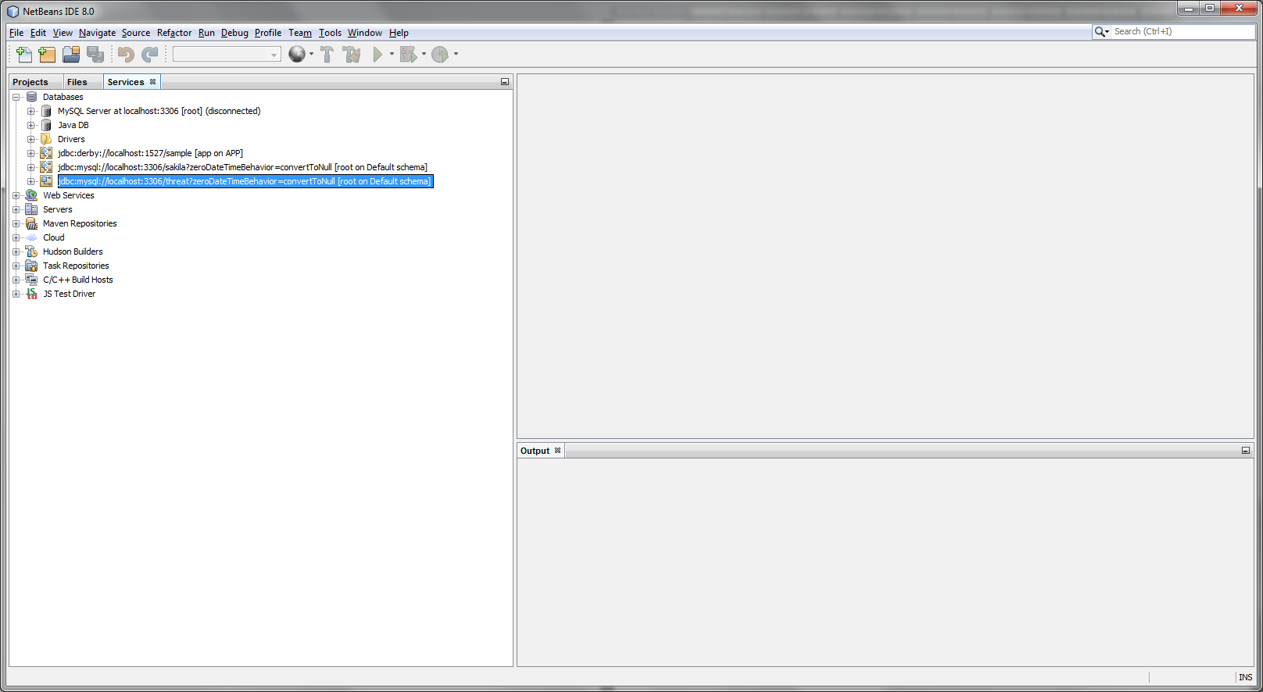

### The MySQLClassLib Project Creation

Create a new Java Class Library project in NetBeans. Select New Project -> Java -> Java Class Library. This library will eventually contain the JPA entity classes, mapped to tables (and views if applicable) in the MySQL threat database.

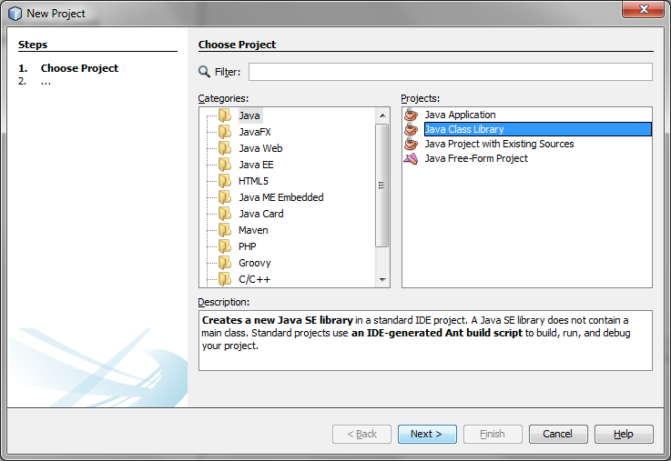

Now, name accordingly the New Java Class Library:

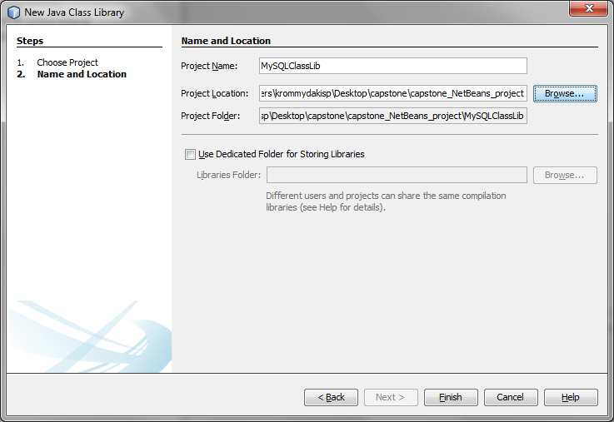

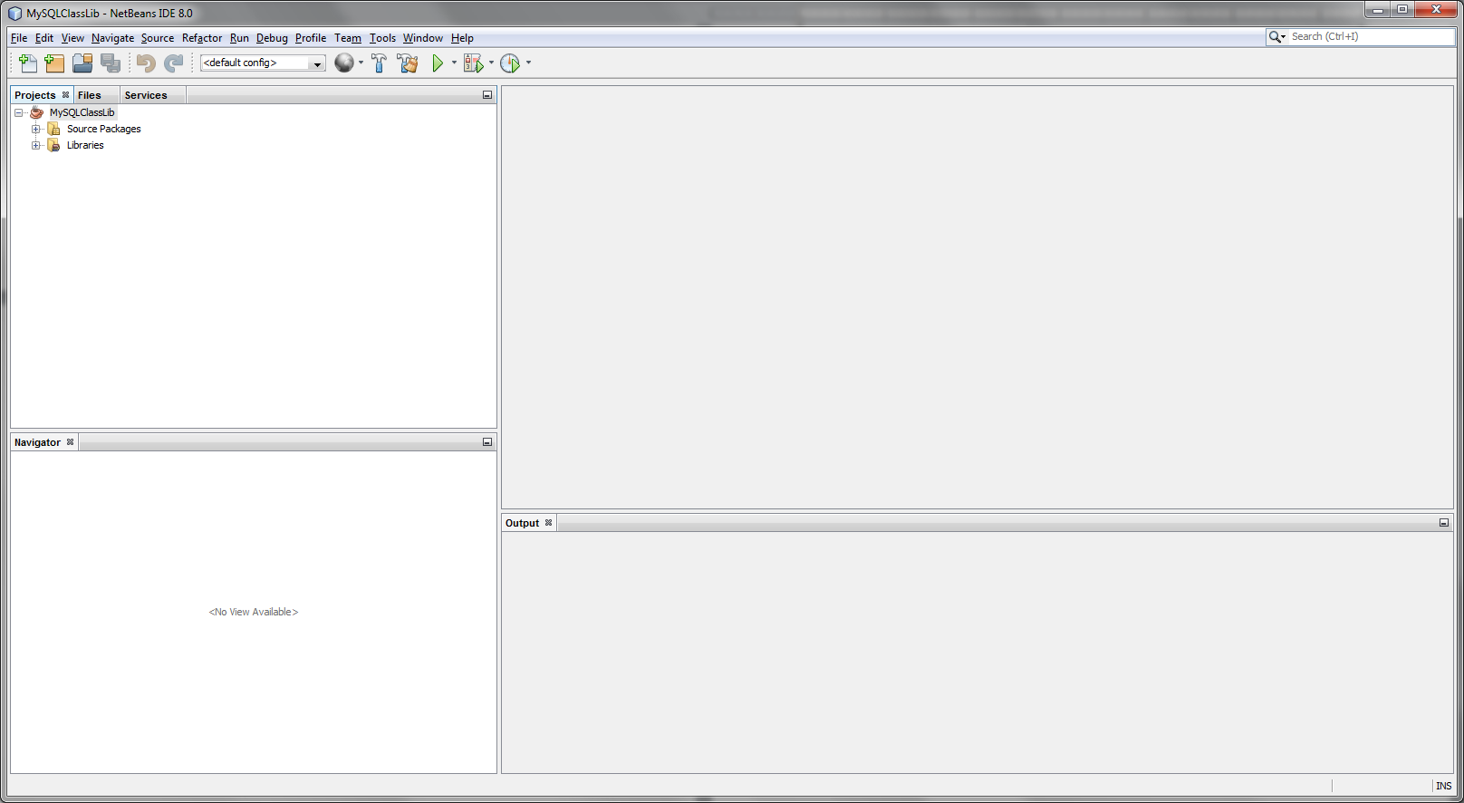

Next, we will add entity classes to our project, mapped to the necessary, of the MySQL threat database’s tables (and views). Right-click on the project and select New -> Entity Classes from Database… In the next window, choose the newly created database connection.

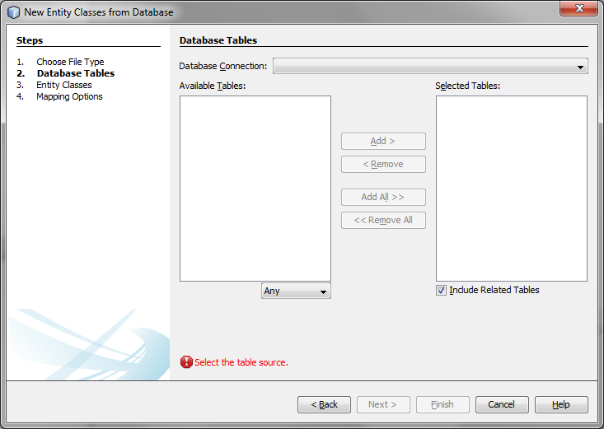

NetBeans will then load all the available tables and views from the threat database. Next, select ‘threat’.

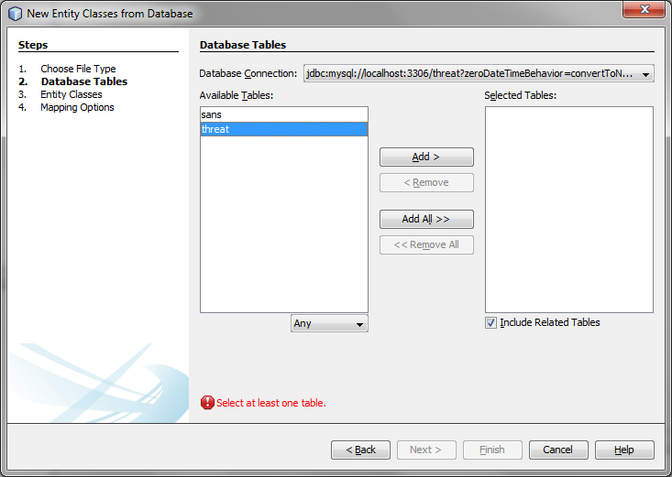

When selecting ‘Entity Classes from Database…’, NetBeans adds the ‘EclipseLink (JPA 2.x)’ global library to the project. This library contains three jars, including EclipseLink 2.x, Java Persistence API (JPA) 2.x, and state model API for JPQL queries.

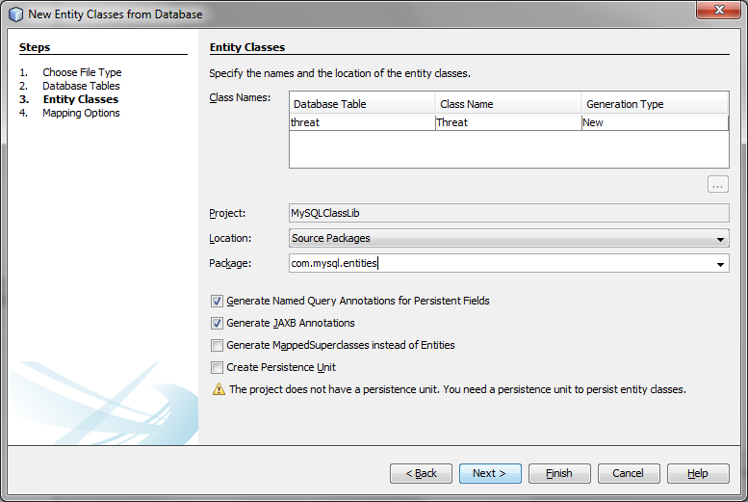

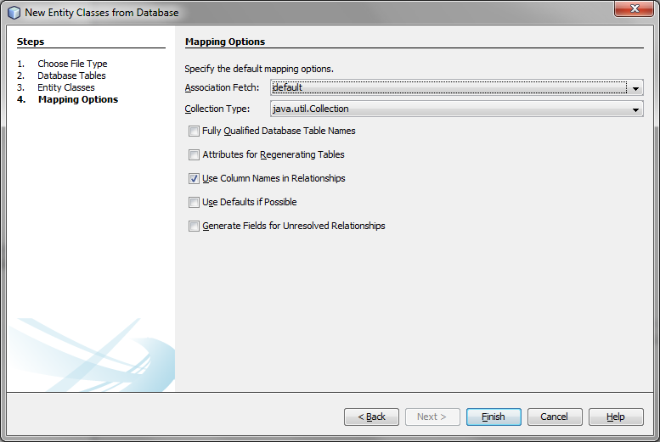

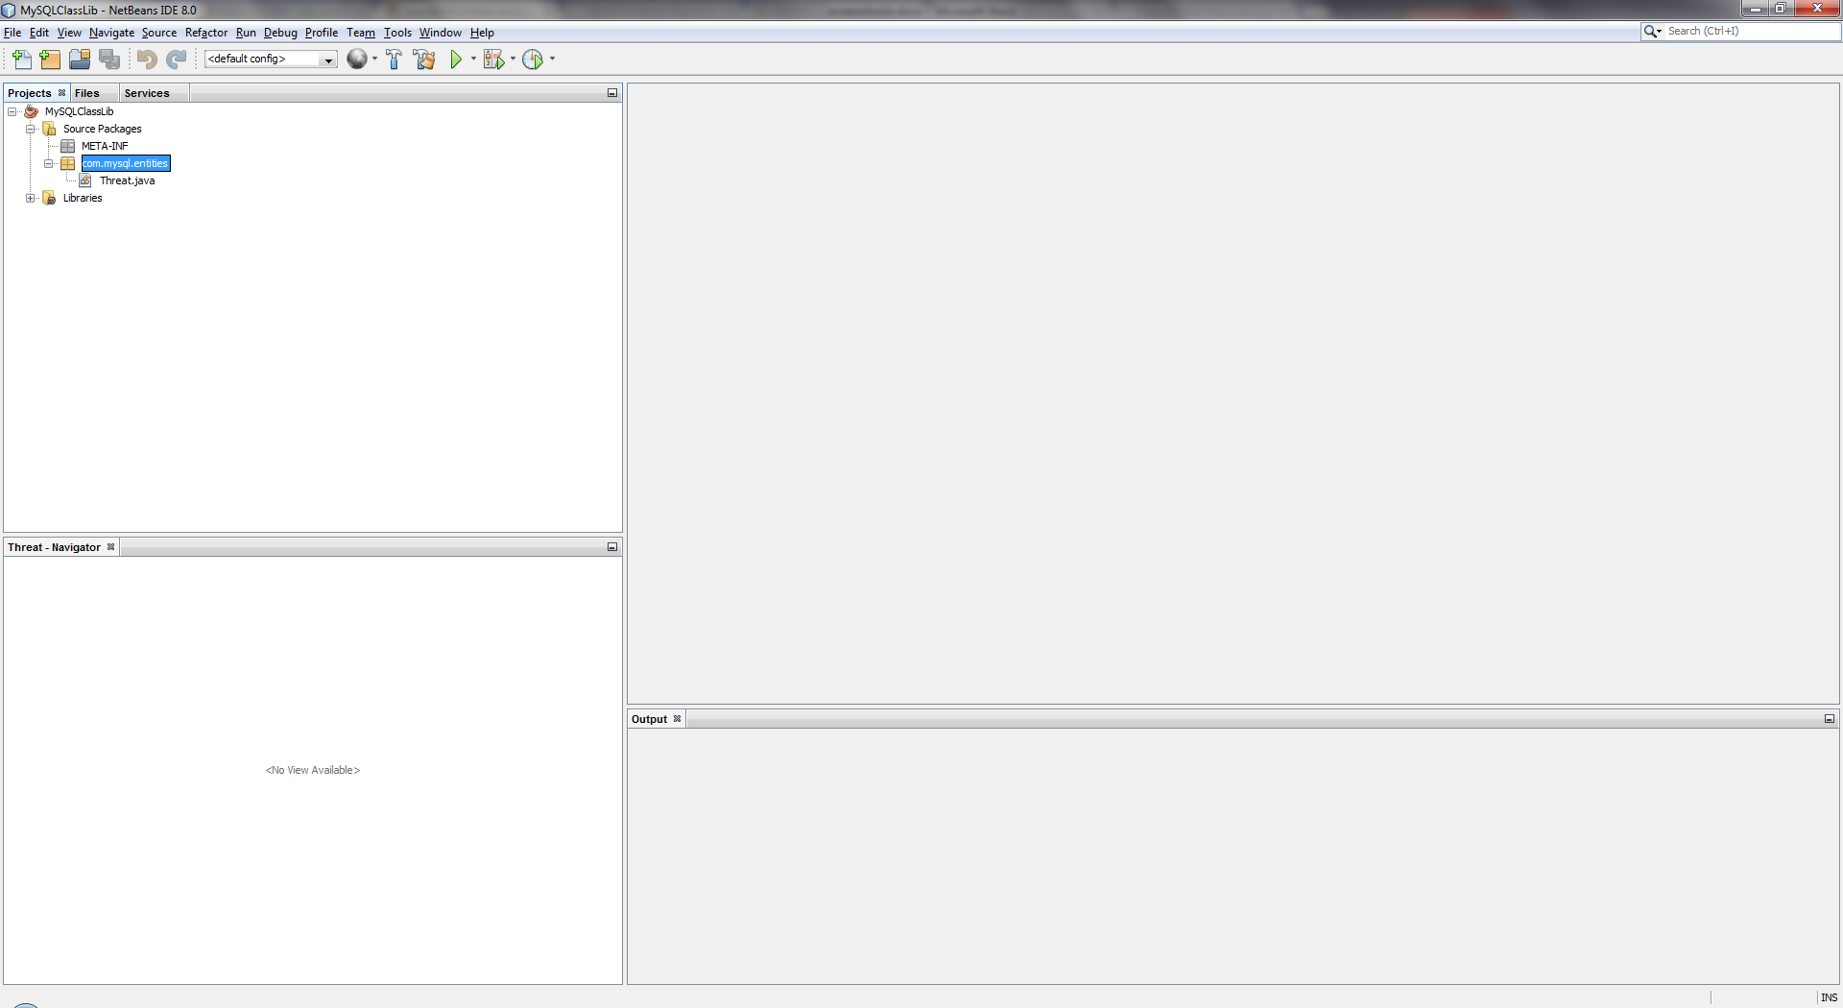

The automatically generated Threat.java Entity Class contents are:

/*

* To change this license header, choose License Headers in Project Properties.

* To change this template file, choose Tools | Templates

* and open the template in the editor.

*/

package com.mysql.entities;

import java.io.Serializable;

import javax.persistence.Basic;

import javax.persistence.Column;

import javax.persistence.Entity;

import javax.persistence.GeneratedValue;

import javax.persistence.GenerationType;

import javax.persistence.Id;

import javax.persistence.Lob;

import javax.persistence.NamedQueries;

import javax.persistence.NamedQuery;

import javax.persistence.Table;

import javax.xml.bind.annotation.XmlRootElement;

/**

*

* @author krommydakisp

*/

@Entity

@Table(name = "threat")

@XmlRootElement

@NamedQueries({

@NamedQuery(name = "Threat.findAll", query = "SELECT t FROM Threat t"),

@NamedQuery(name = "Threat.findByThreatId", query = "SELECT t FROM Threat t WHERE t.threatId = :threatId")})

public class Threat implements Serializable {

private static final long serialVersionUID = 1L;

@Id

@GeneratedValue(strategy = GenerationType.IDENTITY)

@Basic(optional = false)

@Column(name = "threat_id")

private Integer threatId;

@Lob

@Column(name = "suspicious_ip")

private String suspiciousIp;

public Threat() {

}

public Threat(Integer threatId) {

this.threatId = threatId;

}

public Integer getThreatId() {

return threatId;

}

public void setThreatId(Integer threatId) {

this.threatId = threatId;

}

public String getSuspiciousIp() {

return suspiciousIp;

}

public void setSuspiciousIp(String suspiciousIp) {

this.suspiciousIp = suspiciousIp;

}

@Override

public int hashCode() {

int hash = 0;

hash += (threatId != null ? threatId.hashCode() : 0);

return hash;

}

@Override

public boolean equals(Object object) {

// TODO: Warning - this method won't work in the case the id fields are not set

if (!(object instanceof Threat)) {

return false;

}

Threat other = (Threat) object;

if ((this.threatId == null && other.threatId != null) || (this.threatId != null && !this.threatId.equals(other.threatId))) {

return false;

}

return true;

}

@Override

public String toString() {

return "com.mysql.entities.Threat[ threatId=" + threatId + " ]";

}

}

### The MySQLService Project Creation

Next, we will create the target RESTful Web Service. Service will be mapped to the corresponding JPA entity we just created in the Java class library project. Select New Project -> Java Web -> Web Application:

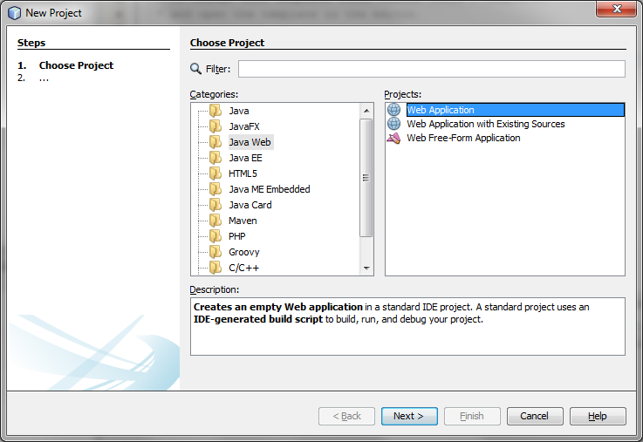

Proceed with naming the New Web Application:

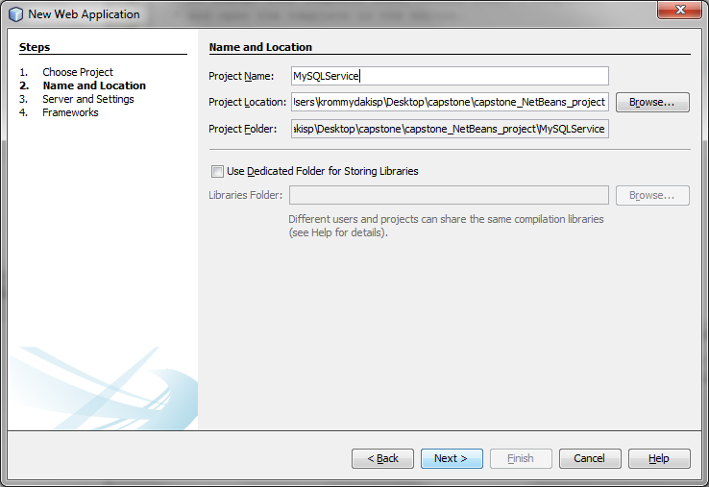

In the next step configure the Application Server and the related Settings:

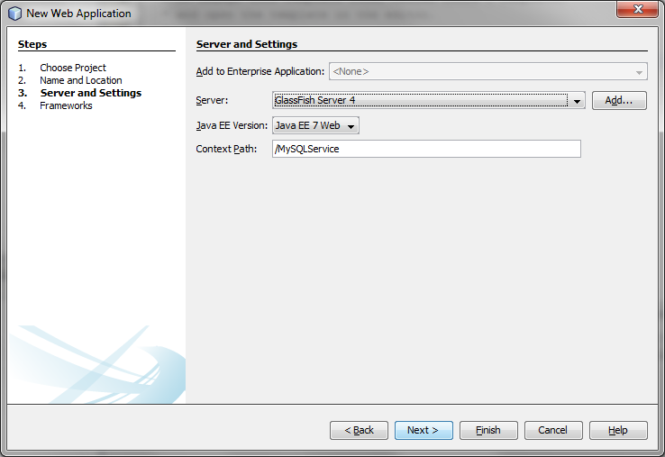

There is no need Configuring Frameworks. Just Click Finish:

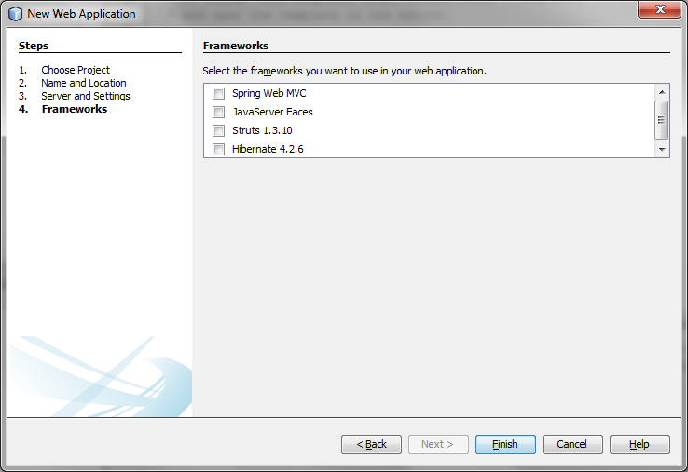

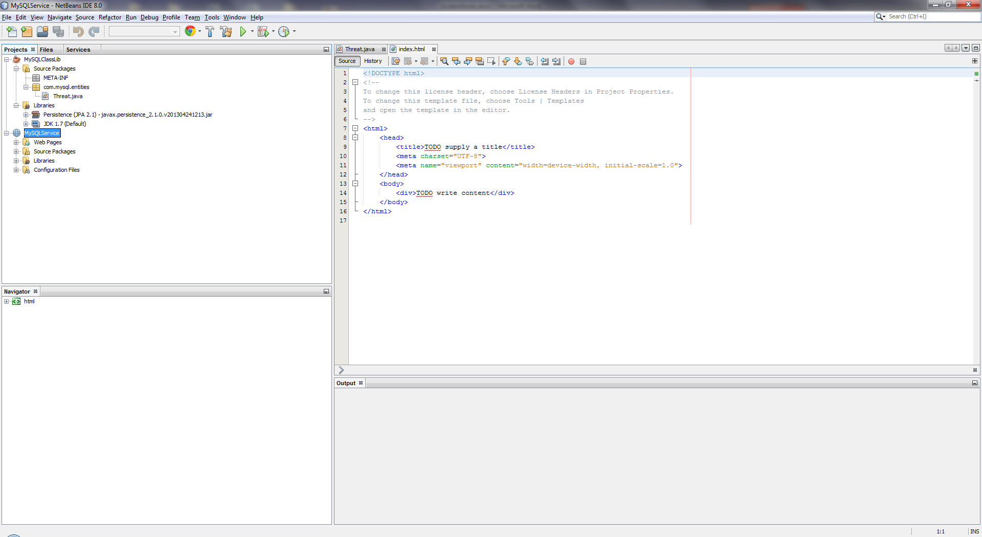

The new Java Web Application Project has been created.

Before we will build the RESTful web services, we need to add a reference to the previous Java class library project, containing the JPA entity classes. In the Java web application’s properties dialog window, under Categories -> Libraries -> Compile, add a link to the Java class library project’s .jar file:

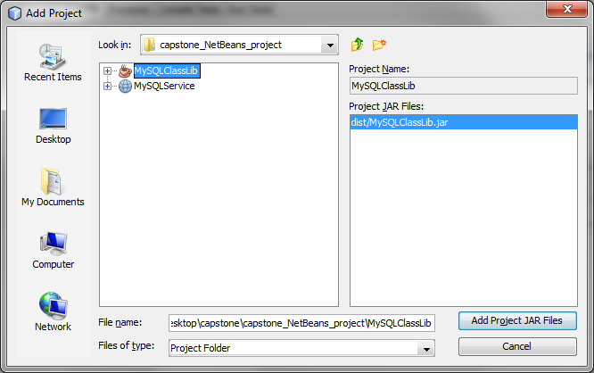

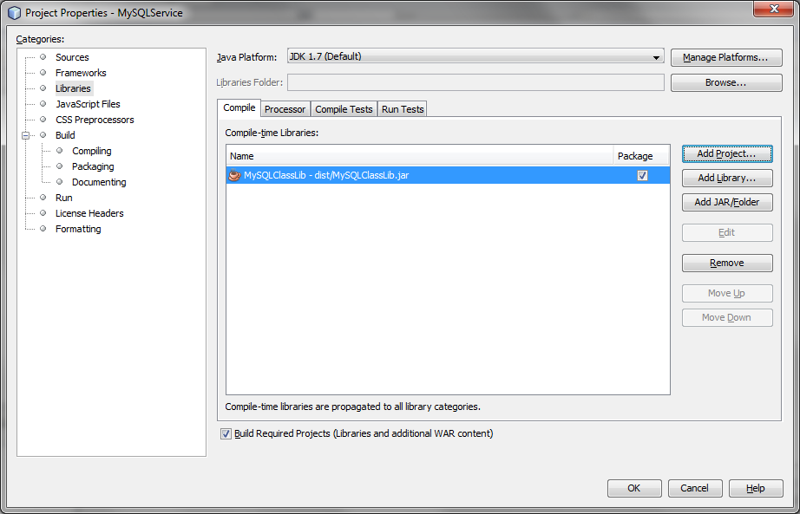

Next, right-click on the project and select New -> RESTful Web Services from Entity Classes…:

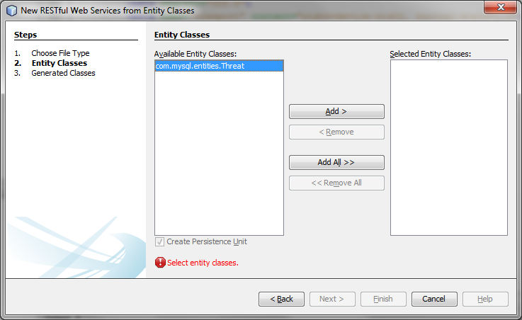

In the preceding dialogue window, add all the ‘Available Entity Classes’ to the ‘Selected Entity Classes’ column:

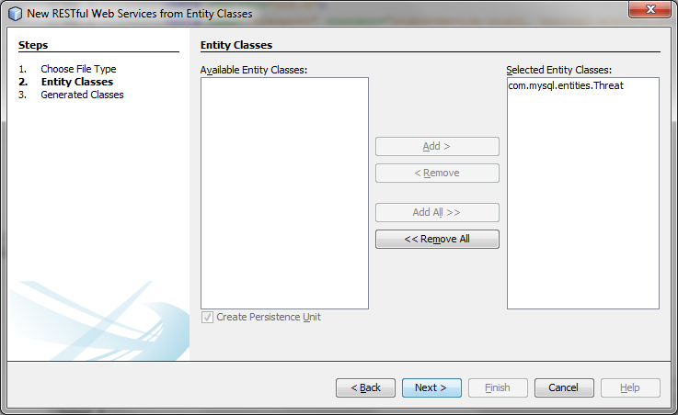

After clicking next, you are prompted to configure the Persistence Unit and the Persistence Unit’s Data Source:

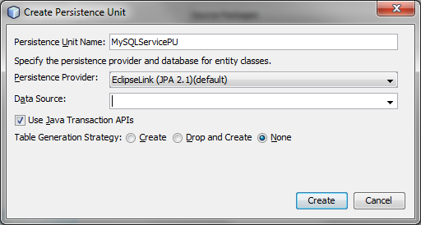

This data source will also be used by GlassFish, once the project is deployed, to connect to the threat MySQL database. The Persistence Unit will use the JNDI name to reference the data source.

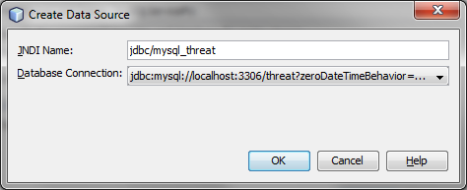

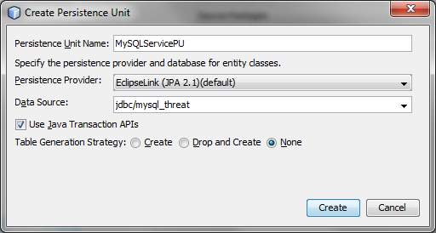

Proceed with creating the Persistence Unit:

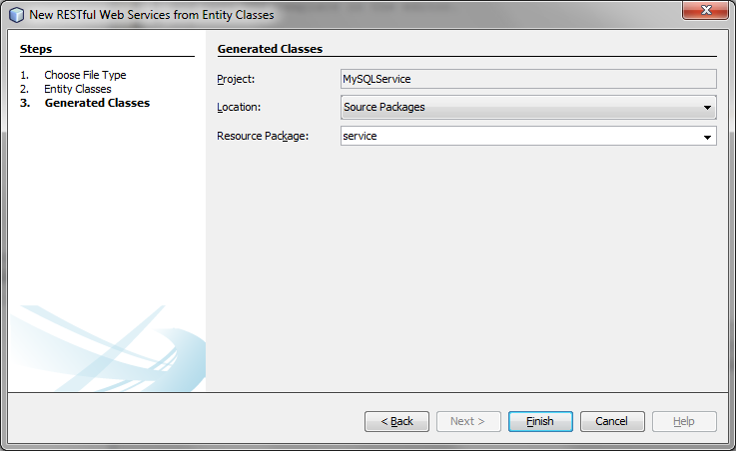

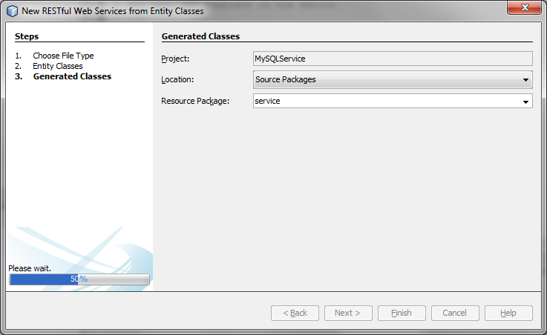

Persistence Unit (persistence.xml) contents are depicted in the screenshot below:

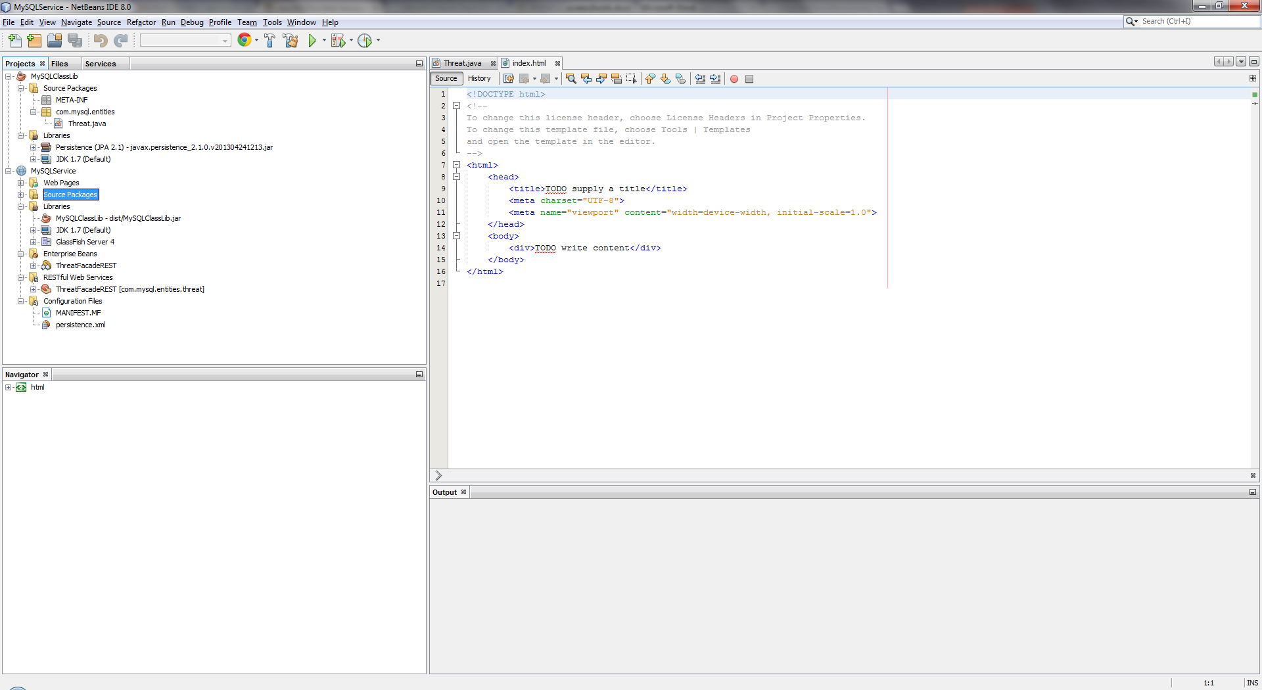

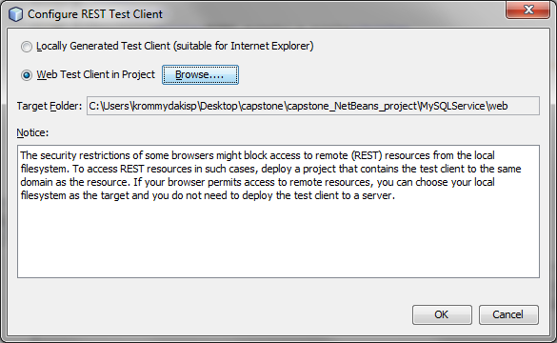

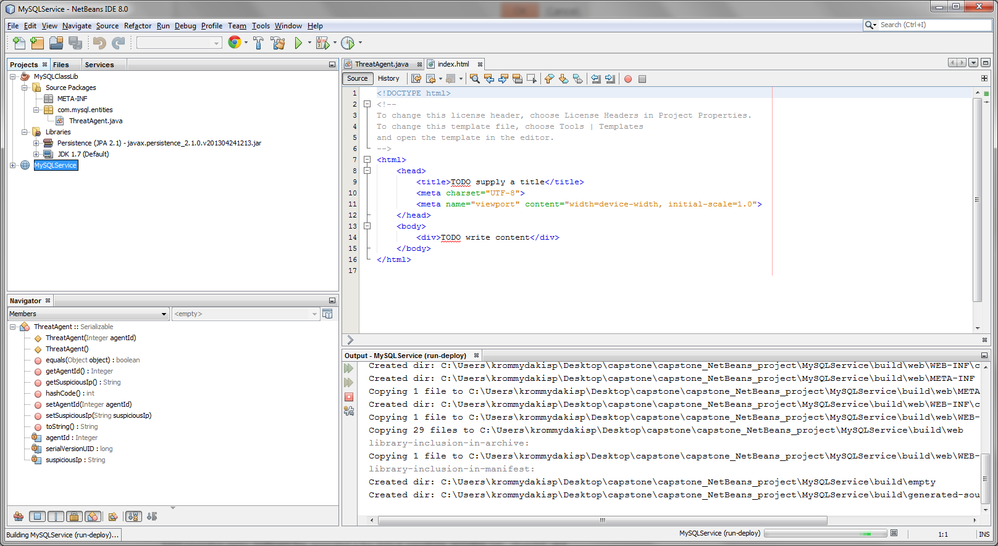

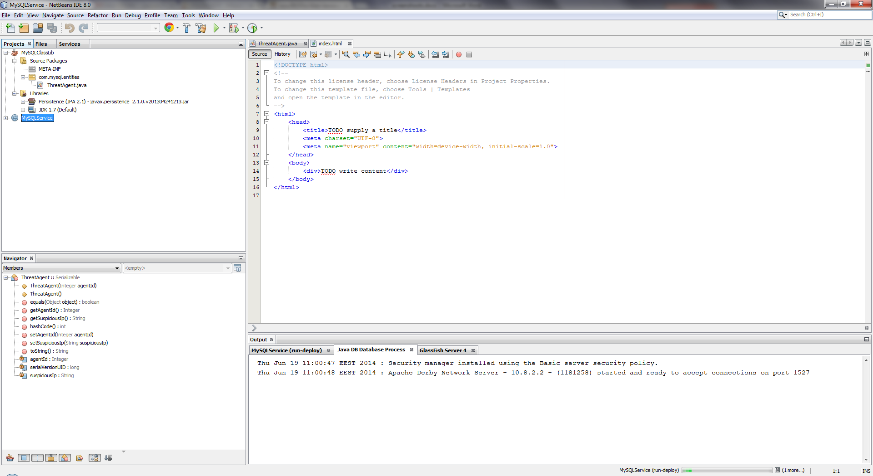

### Testing and Troubleshooting the Web Service

The attempt to publish the implemented web service fails as depicted below:

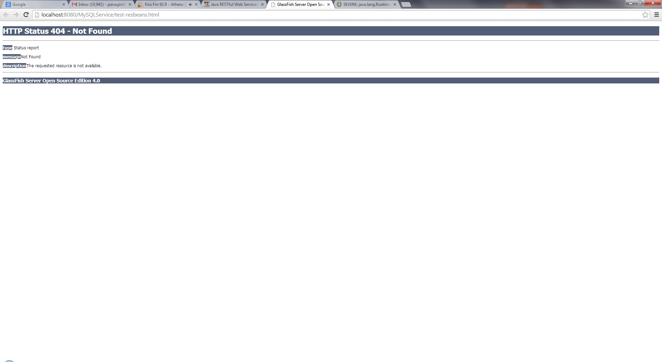

Netbeans console output verifies that module has not been deployed and suggests to check the Glashfish server log file:

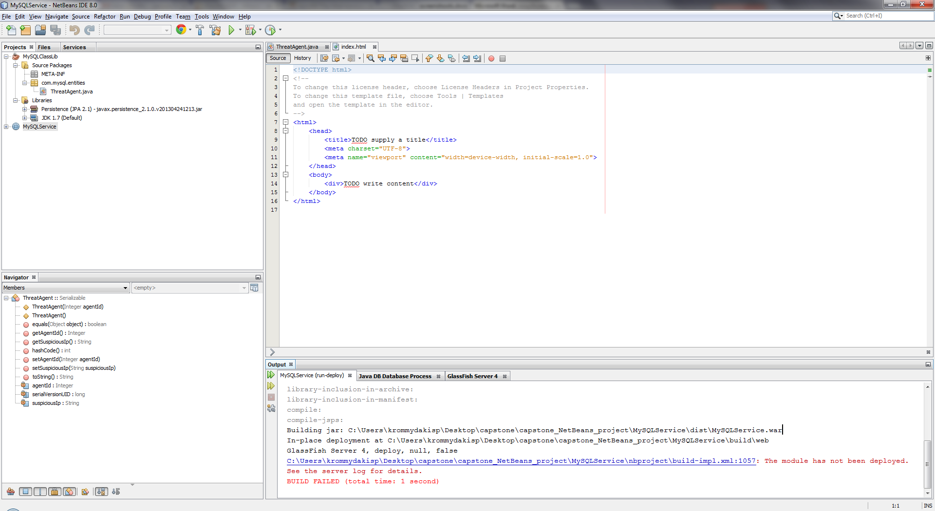

Glashfish console points to a JPA related exception:

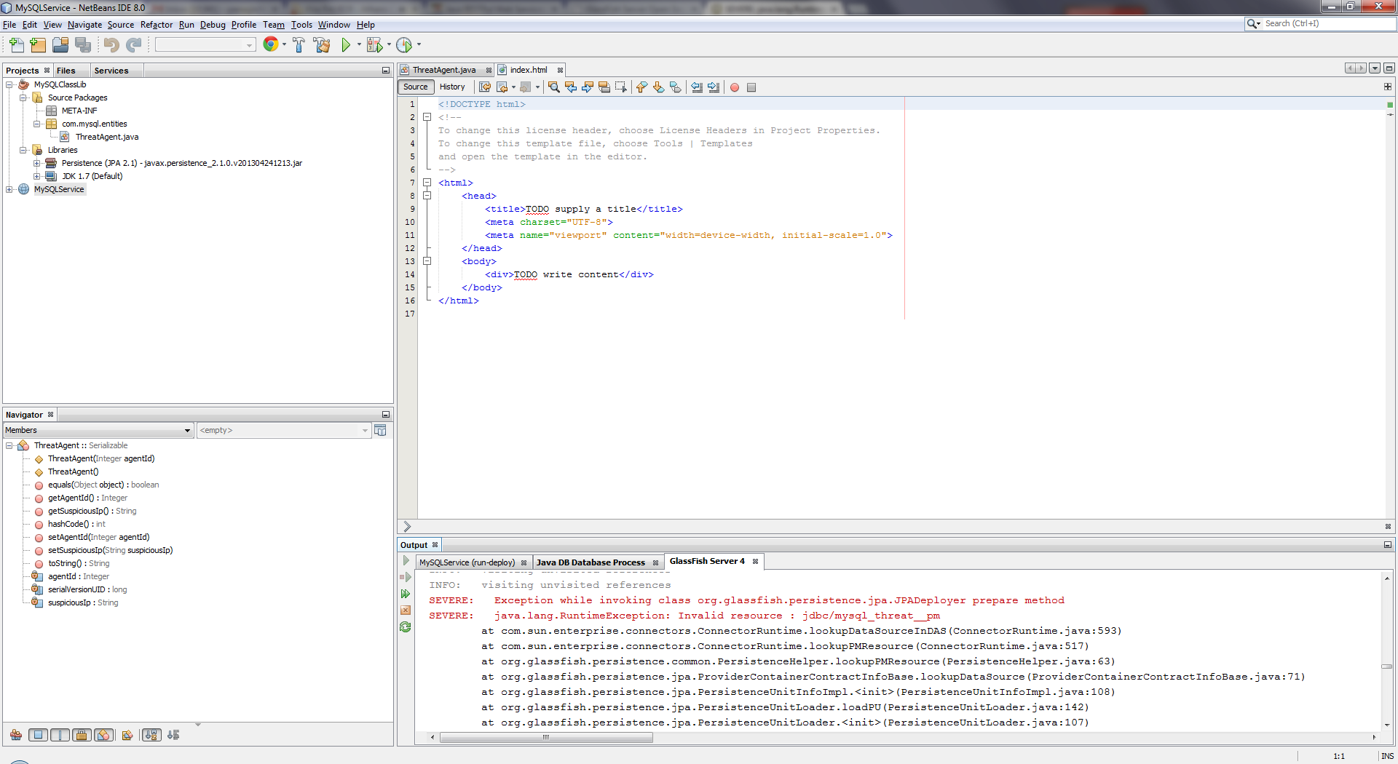

More particularly the problem relies on the jdbc connector. More particularly the “_pm” postfix seems suspicious enough:

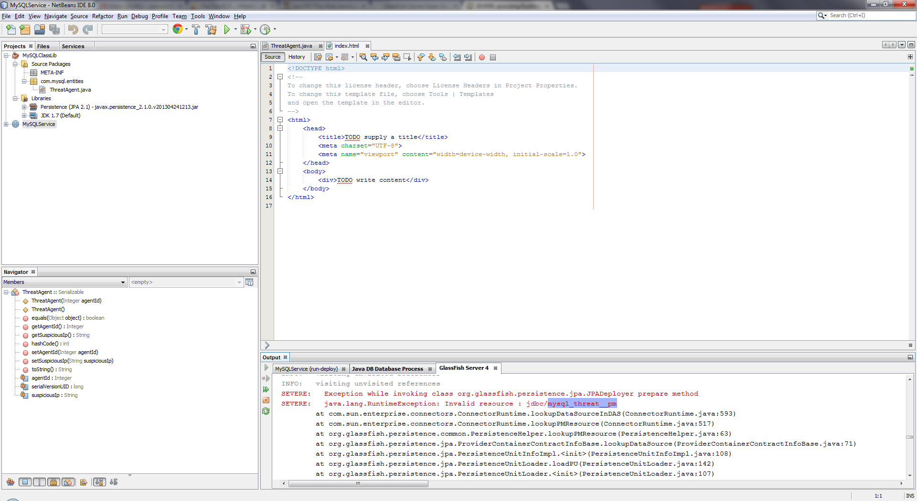

The next step is to open the Glashfish administration console and check the created resourses:

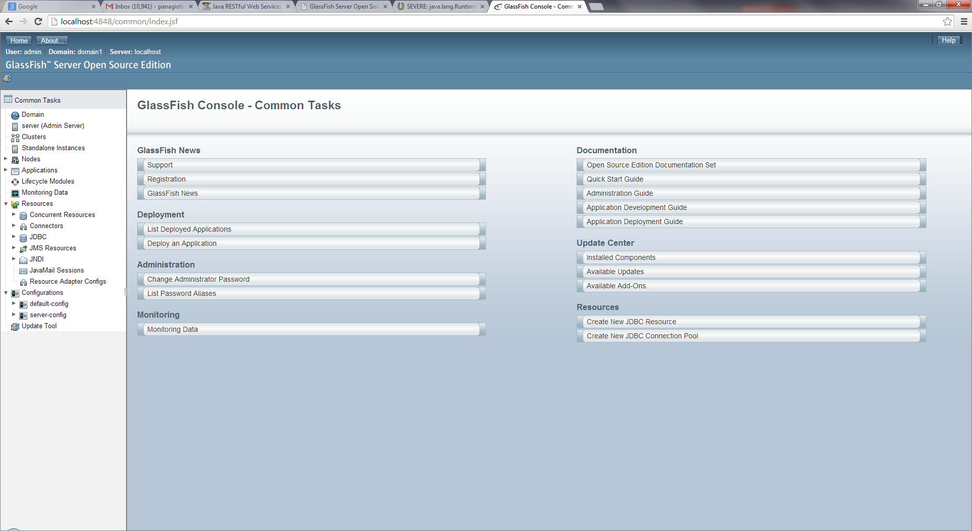

The first step is to check the created JDBC Connection Pool:

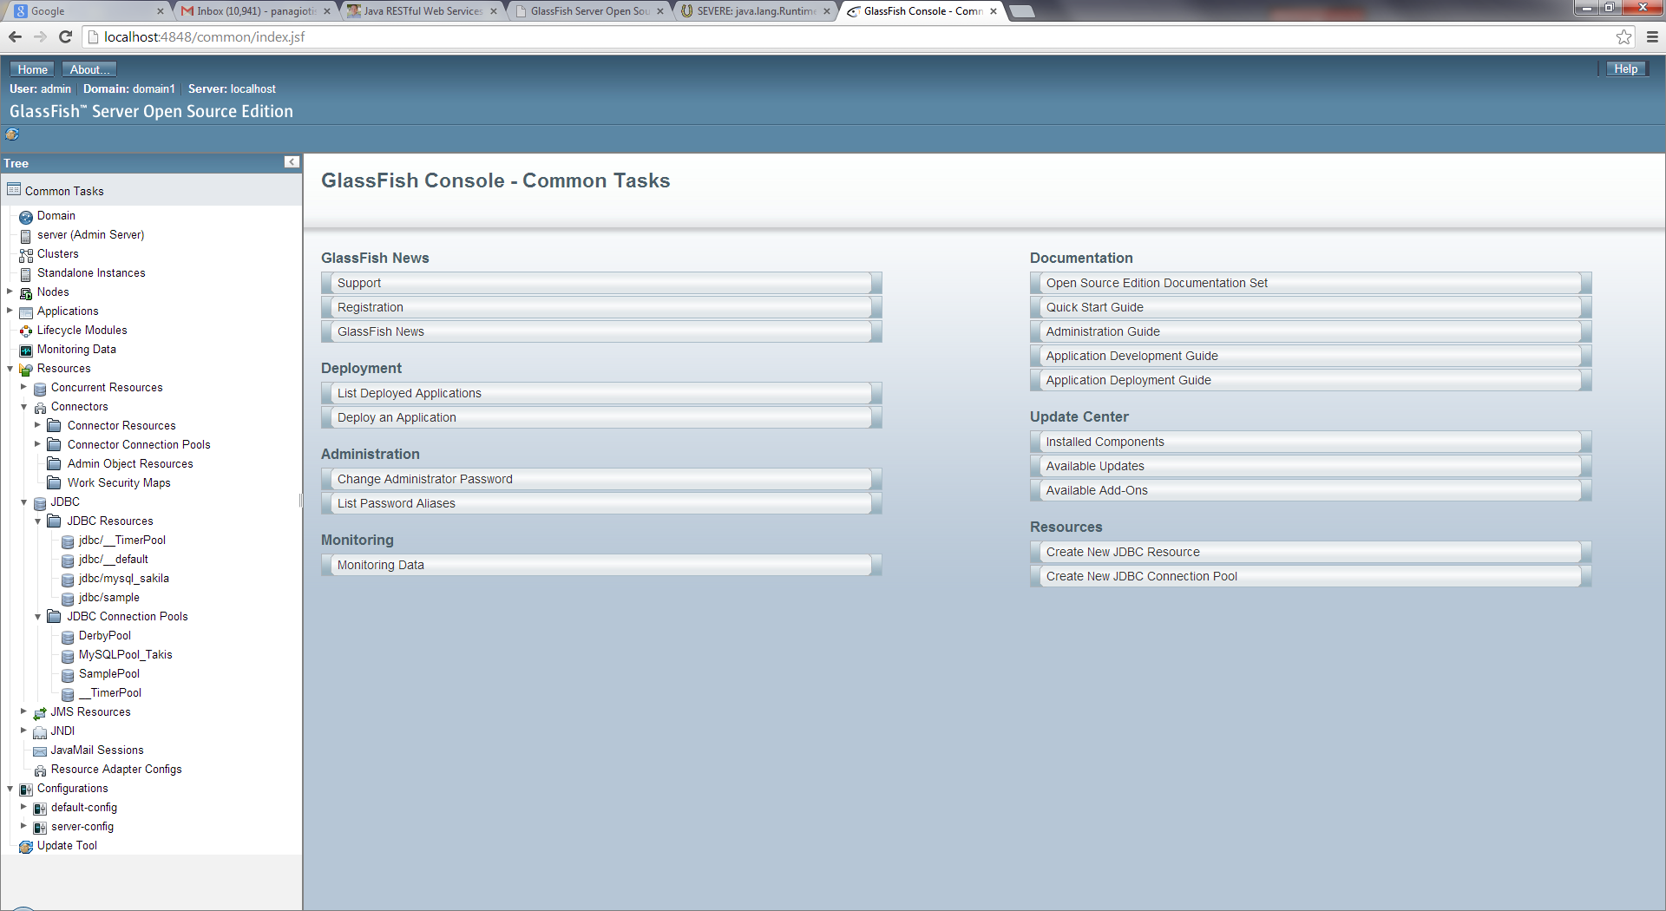

Apparently, no pool has been created automatically, although it was expected:

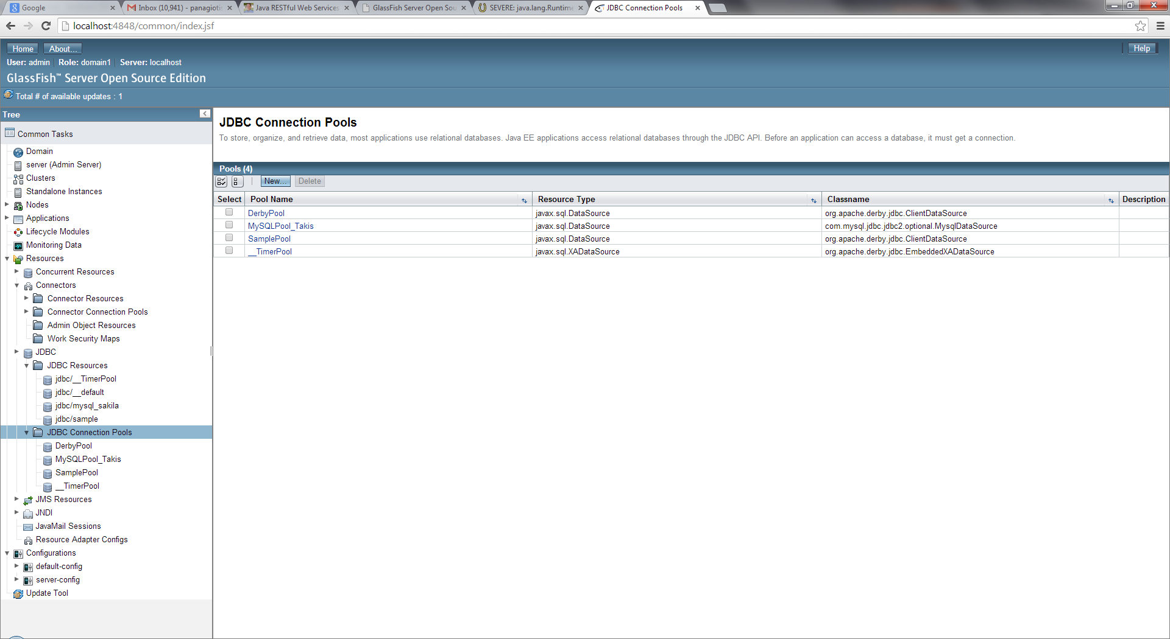

Create a new pool to be used in the context of the project:

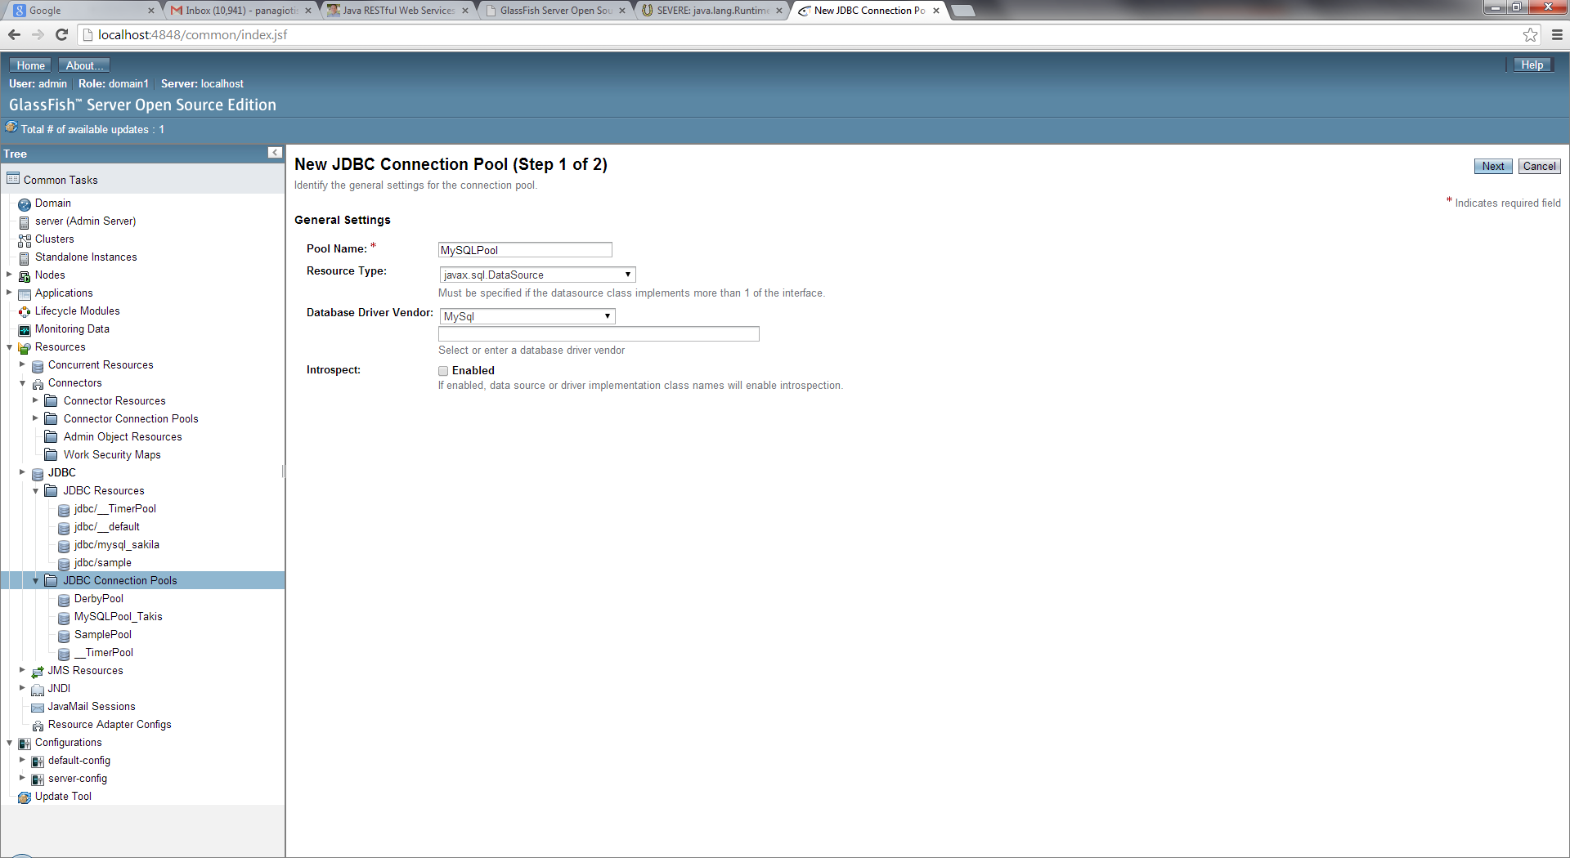

Click finish:

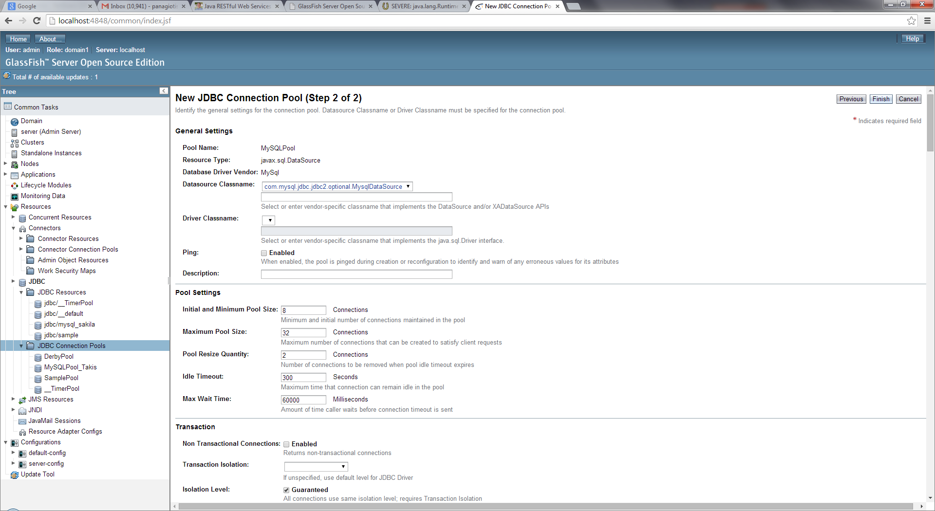

Now, create and assign the appropriate values to the still missing parameters of the new pool. That is “user”, “password” and “Encoding”:

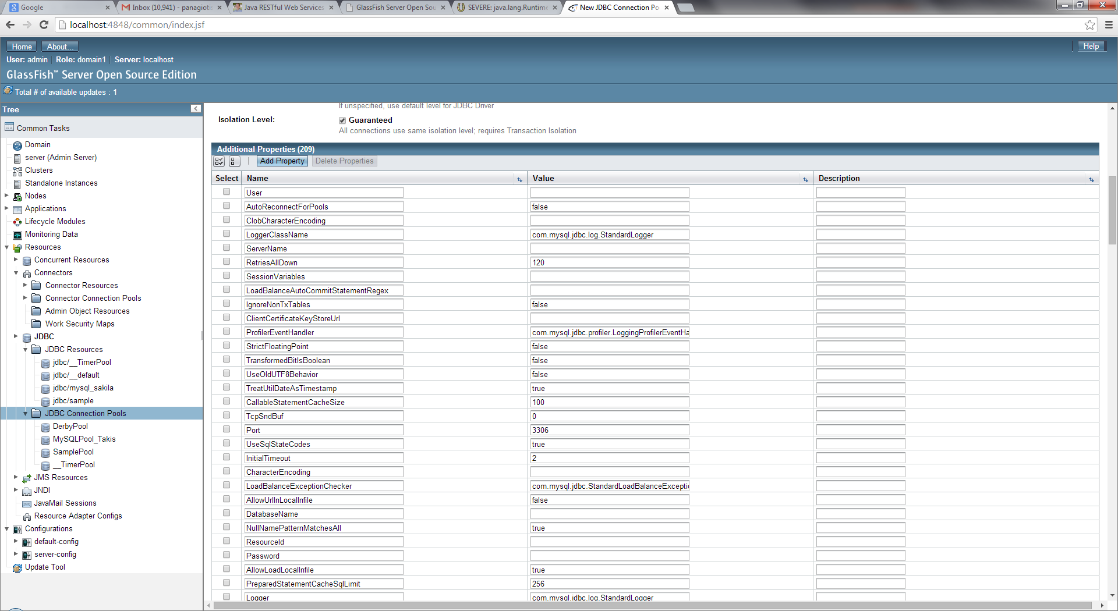

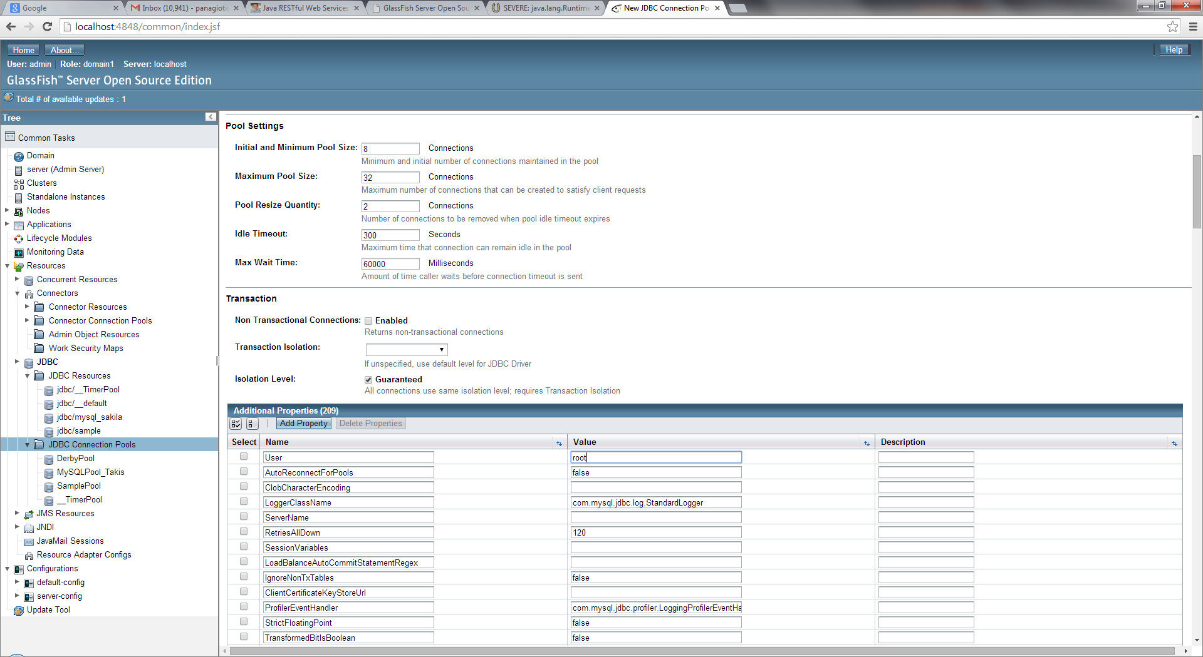

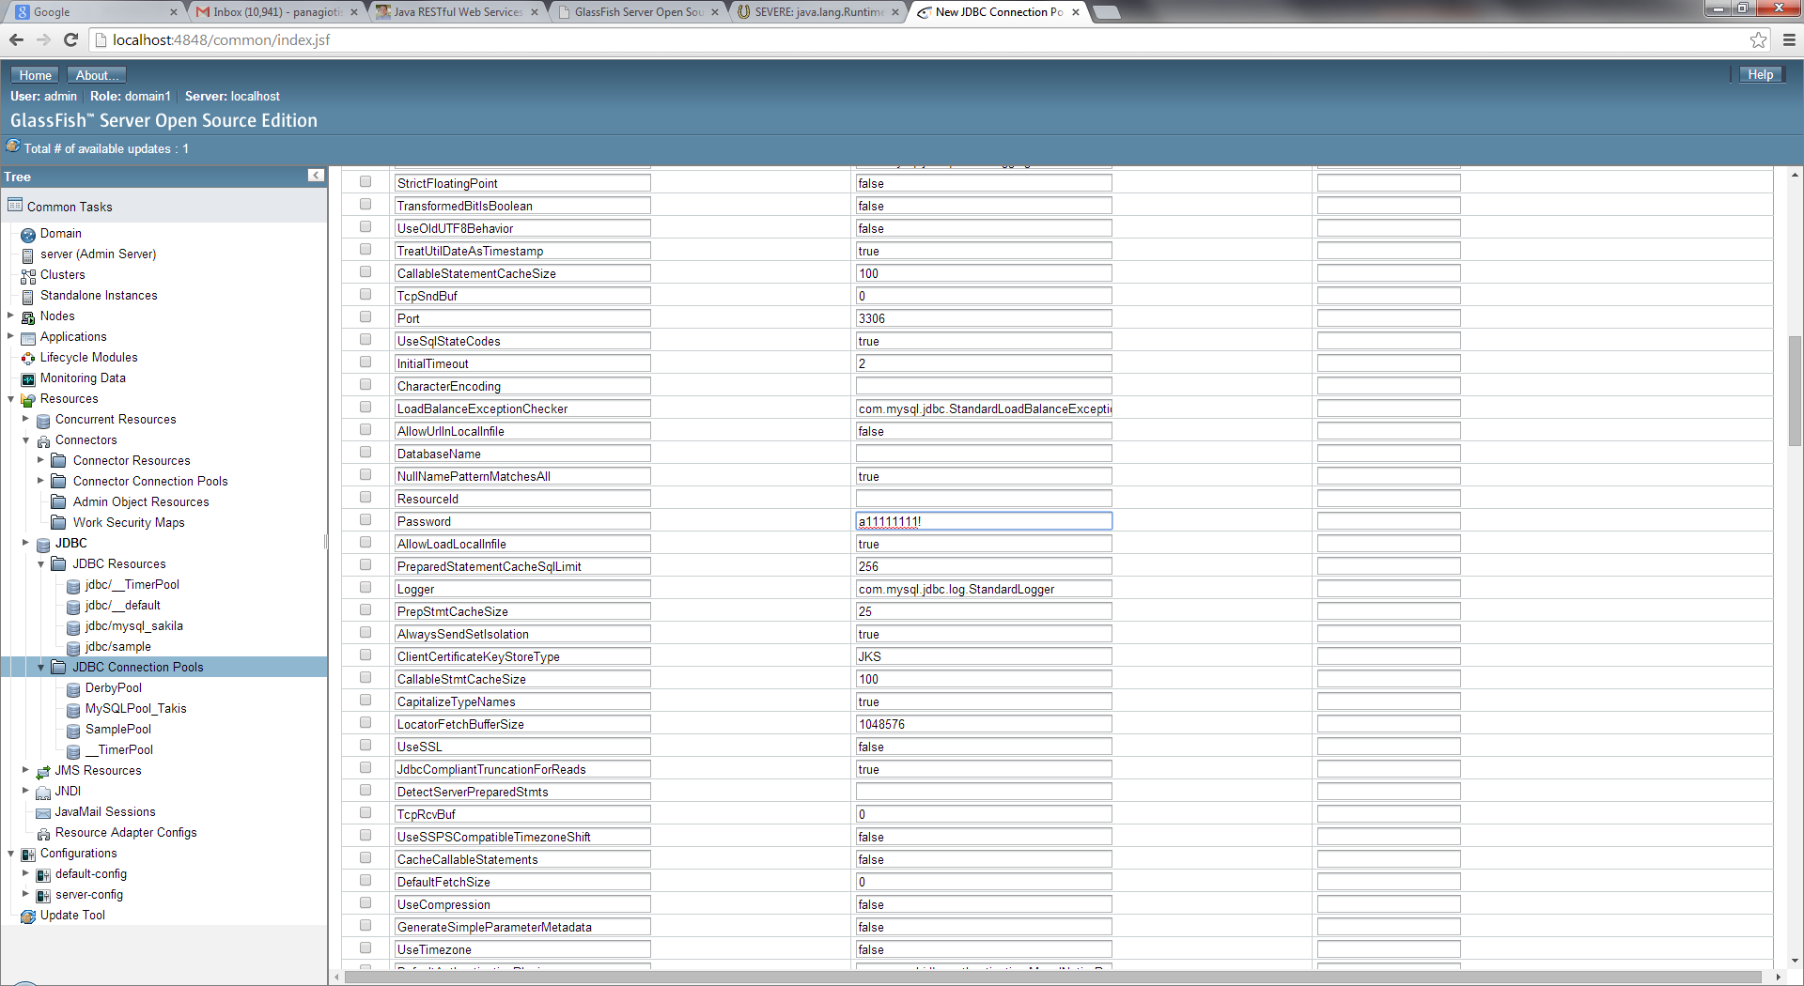

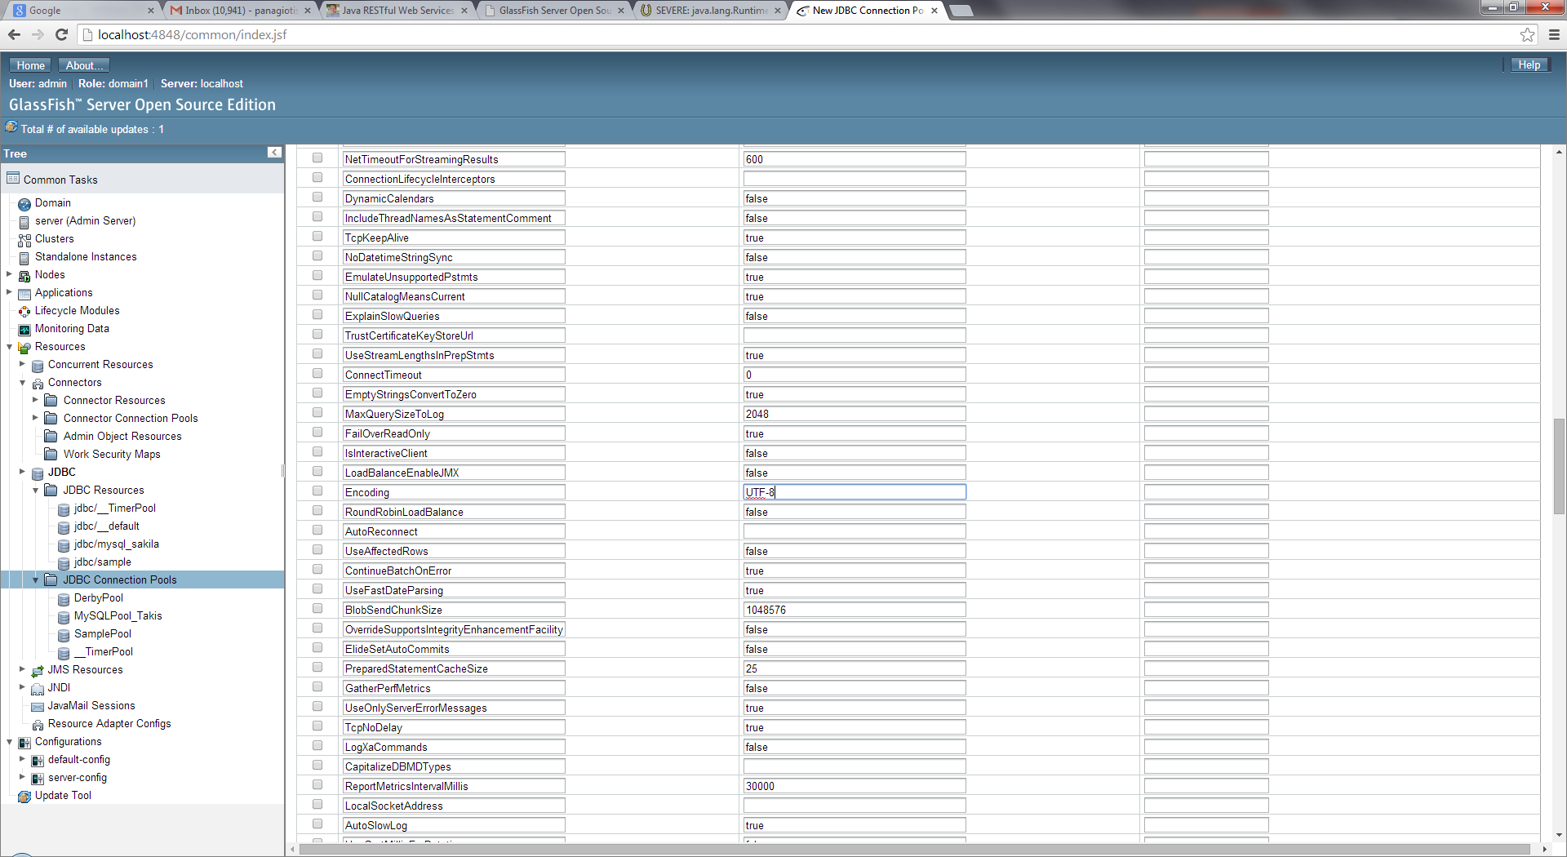

Click “Finish”:

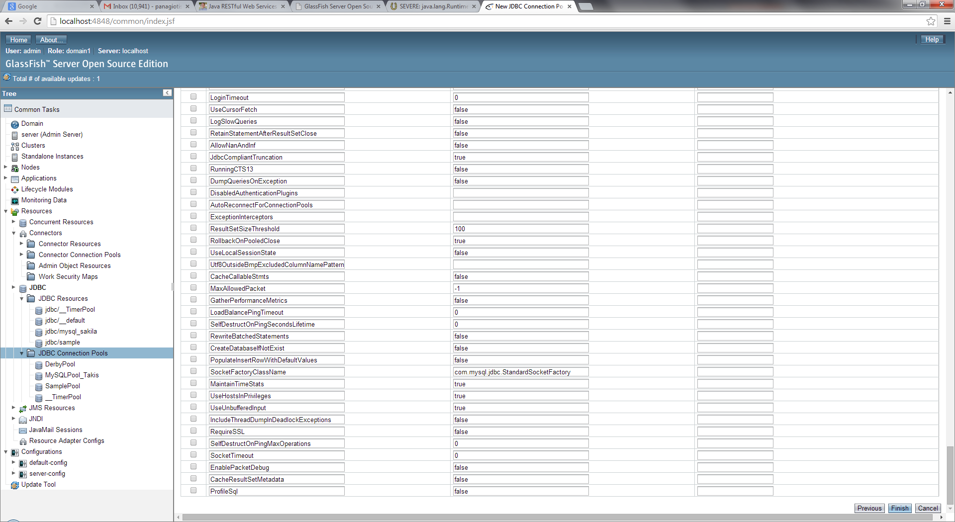

Verify that “pinging” the newly created JDBC Connection Pool using the given parameters is successful:

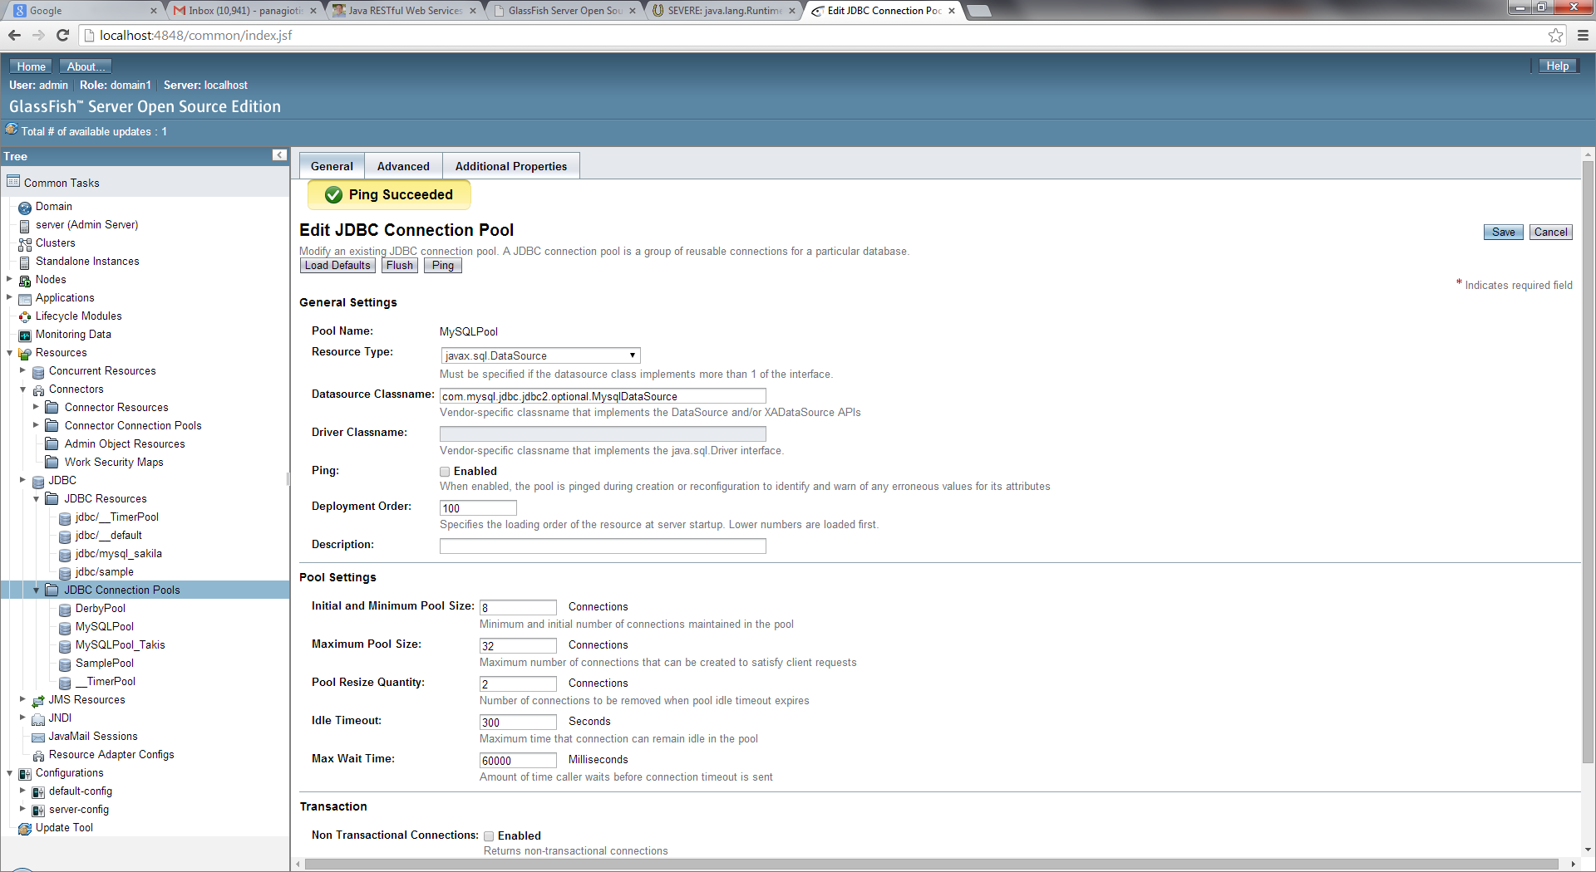

Save modifications:

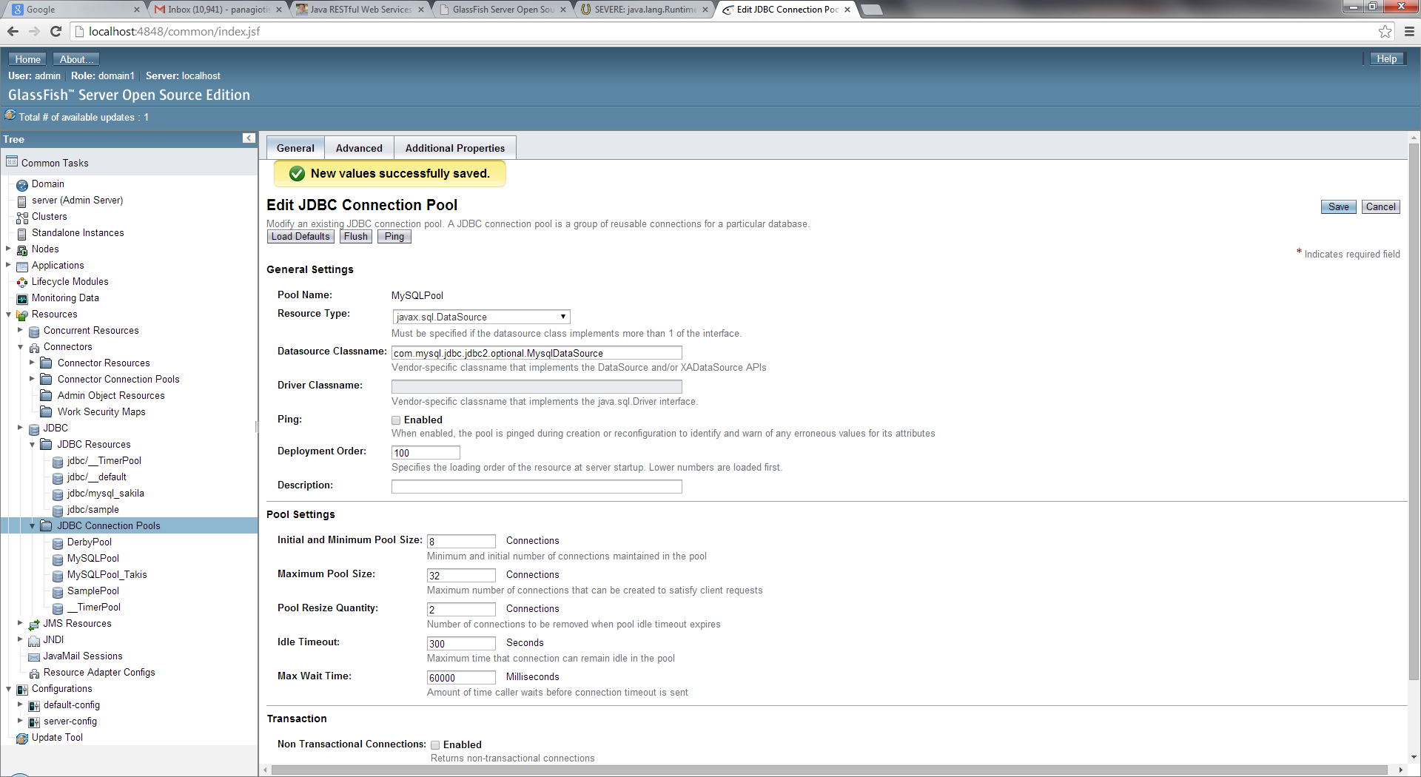

In the next step create the missing JDBC Resource:

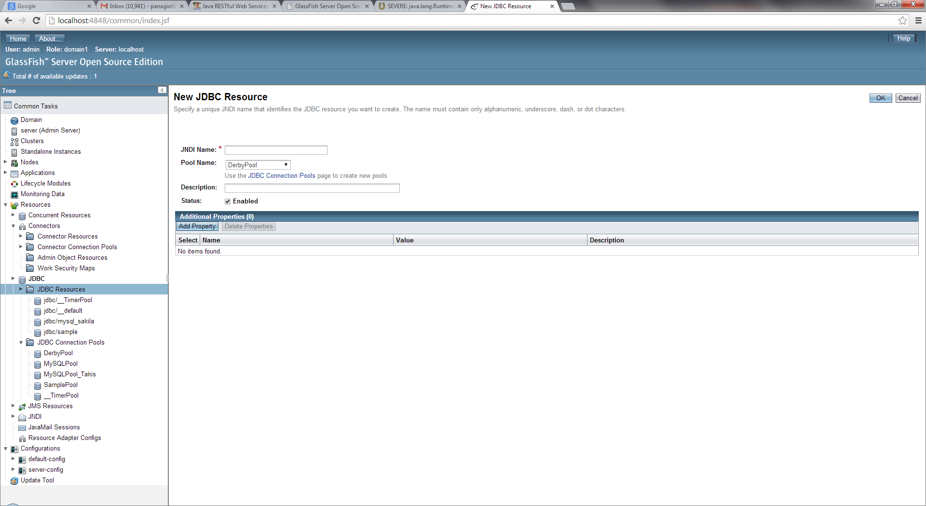

Insert the correct JNDI Name for our MySQL database and select the new pool:

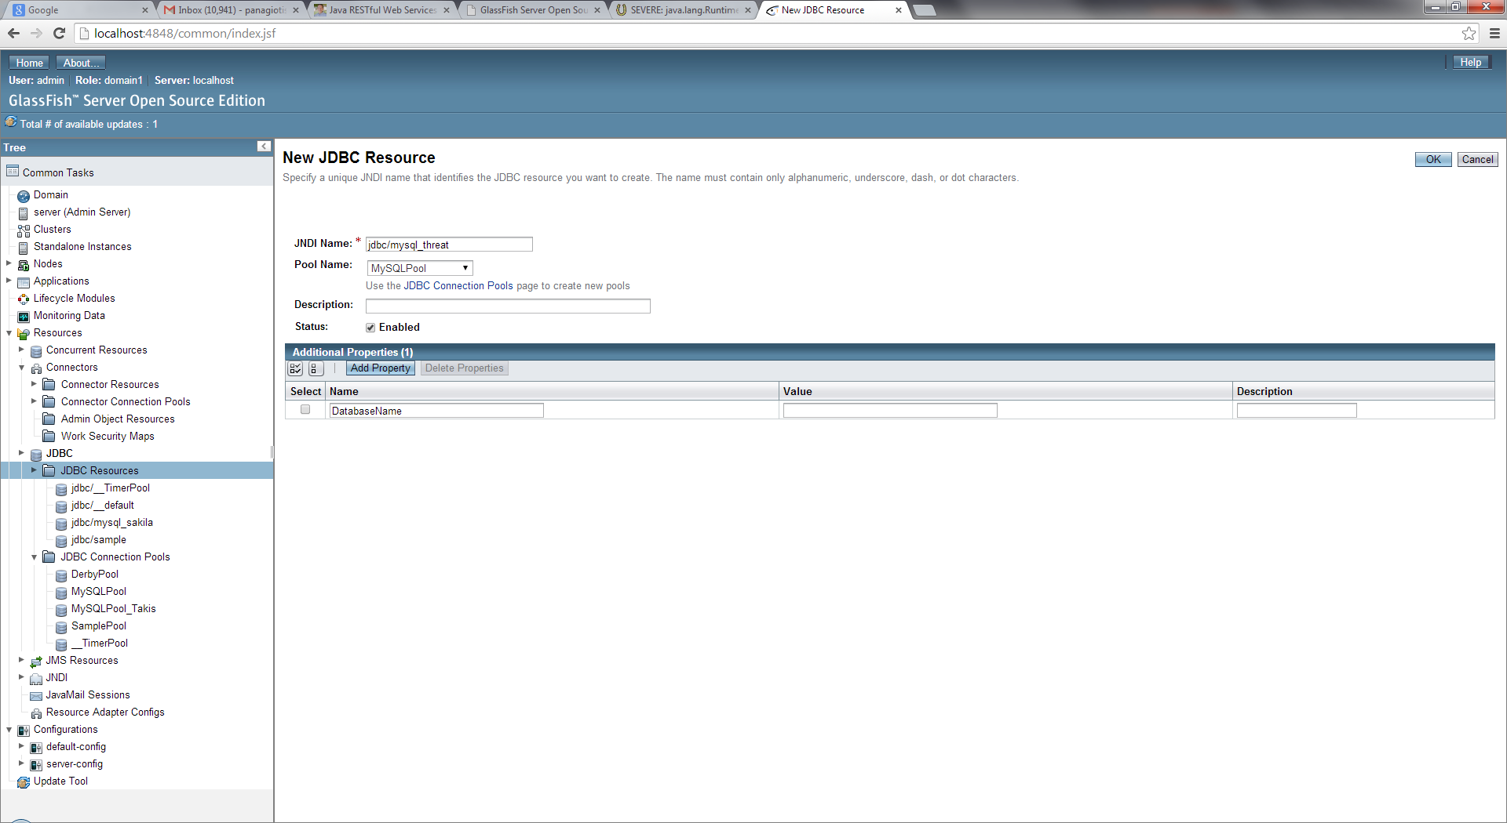

The newly created JDBC Resource should be listed in the respective table as follows:

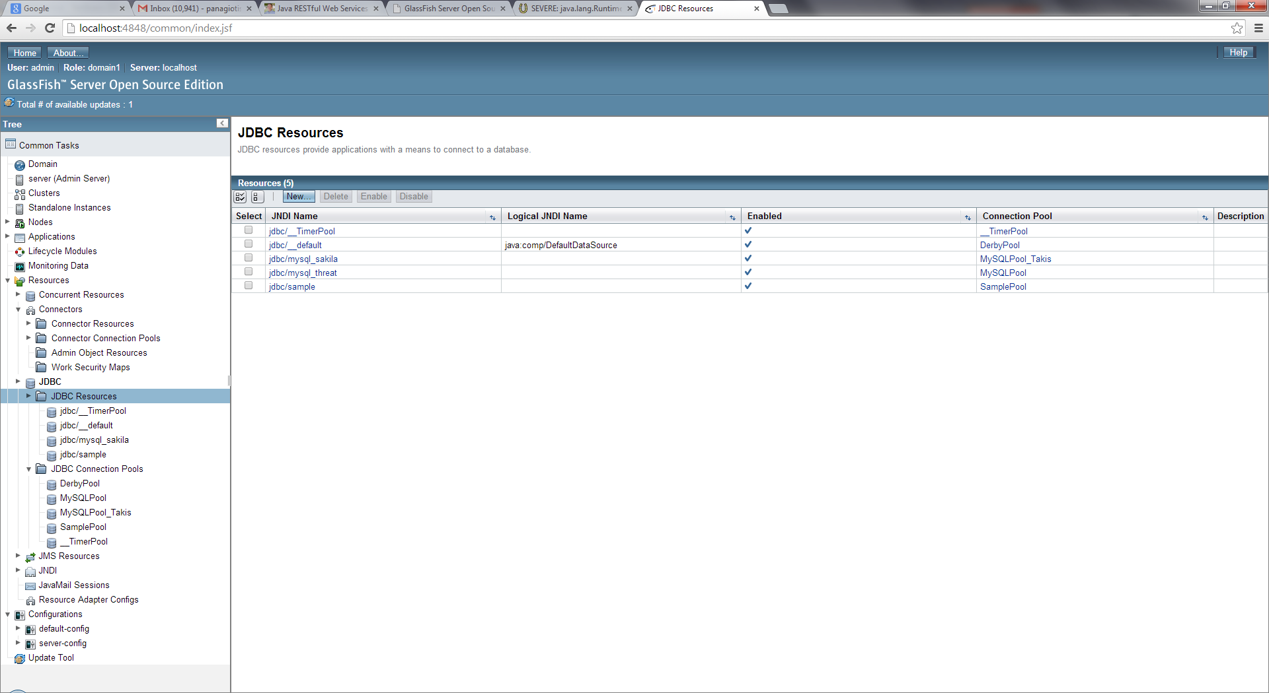

At this point test again the web service:

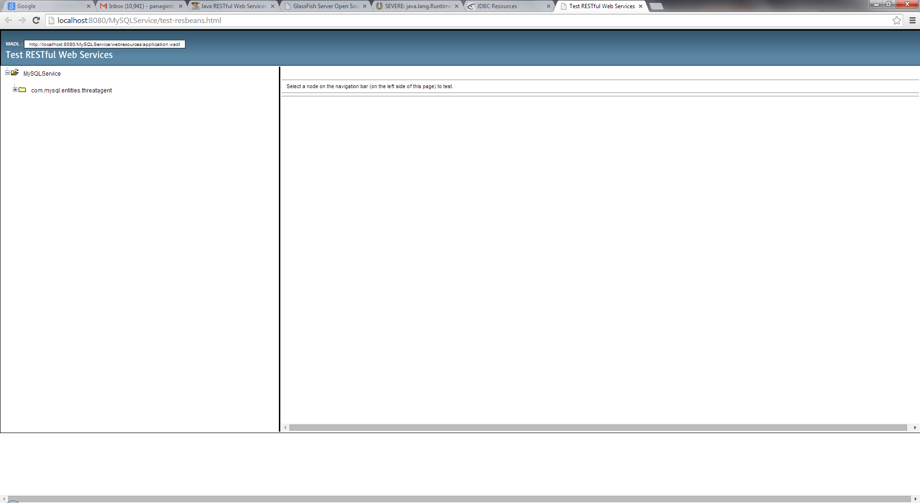

The service seems to be published:

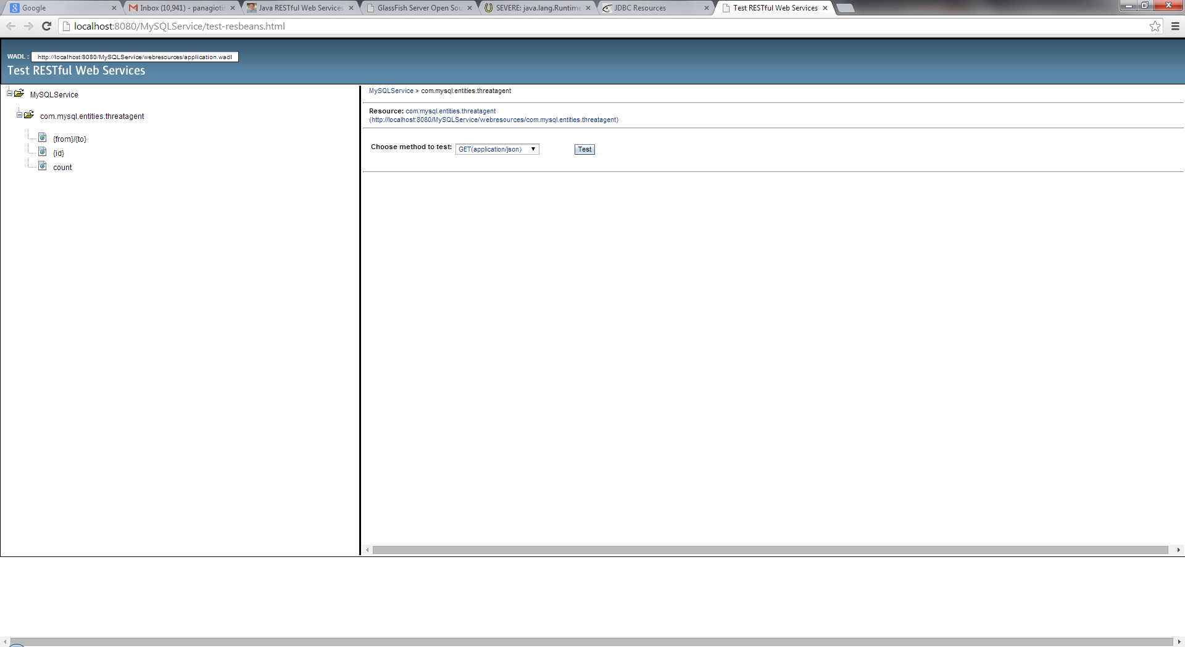

Now try to retrieve the contents of the database. A new error is shown on the browser window:

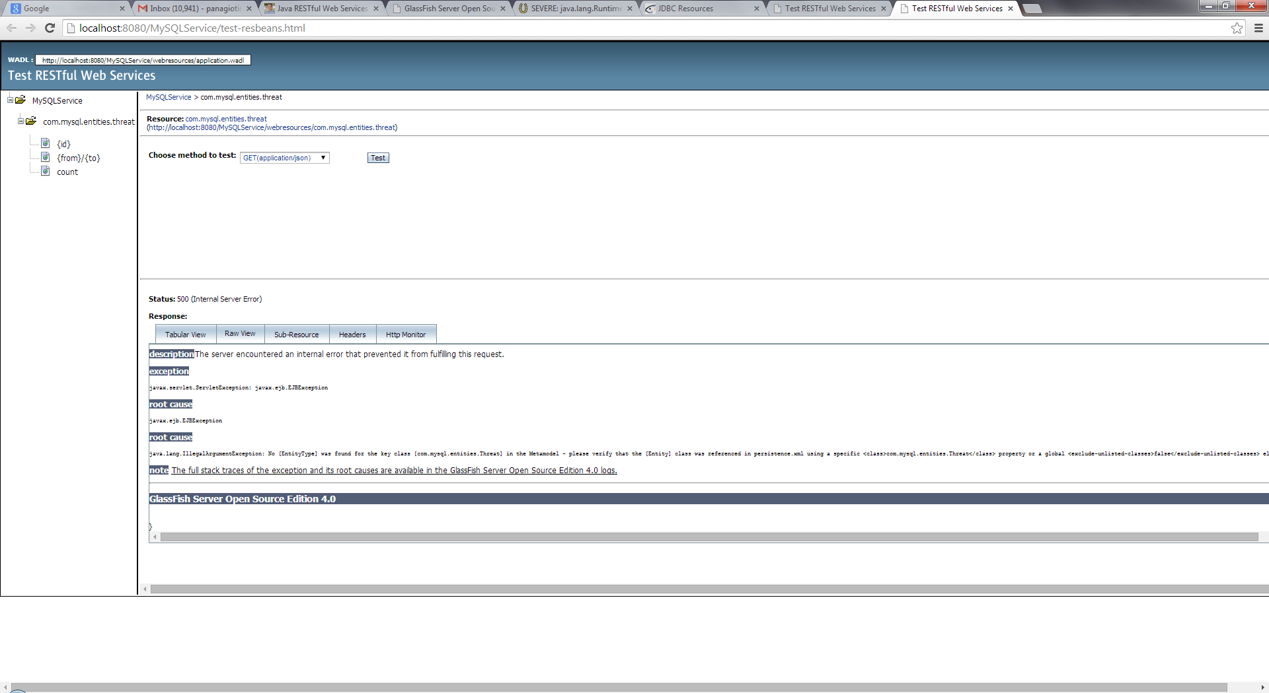

The displayed root cause points clearly to the “persistence.xml” file:

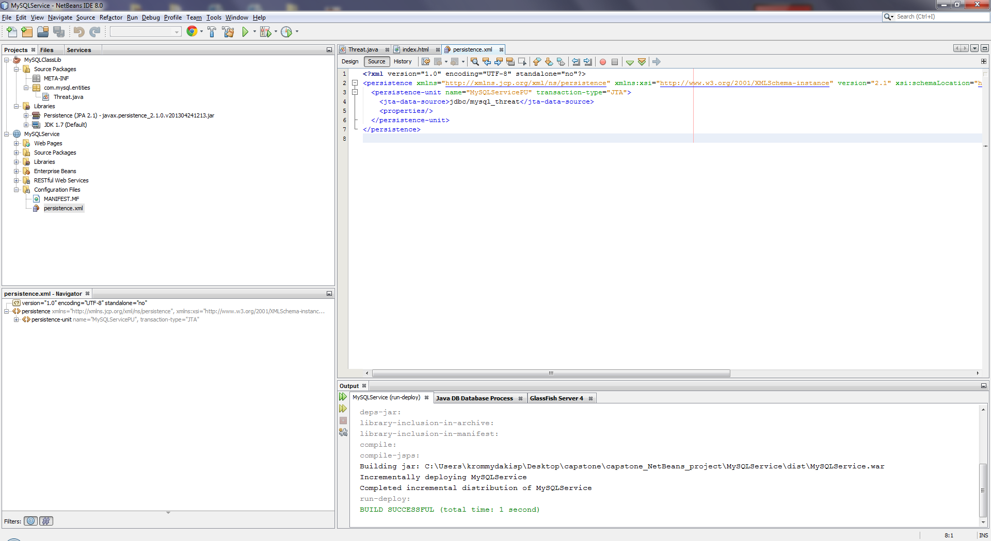

Insert the appropriate “entity” value and save modifications:

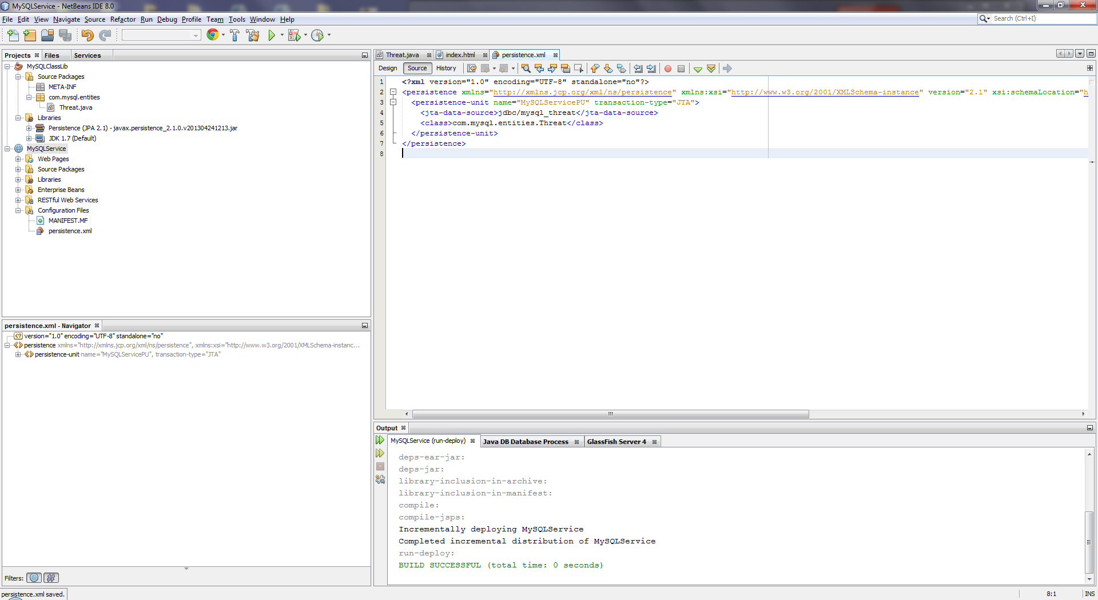

A new attempt to retrieve the database contents leads to a new error related to EclipseLink:

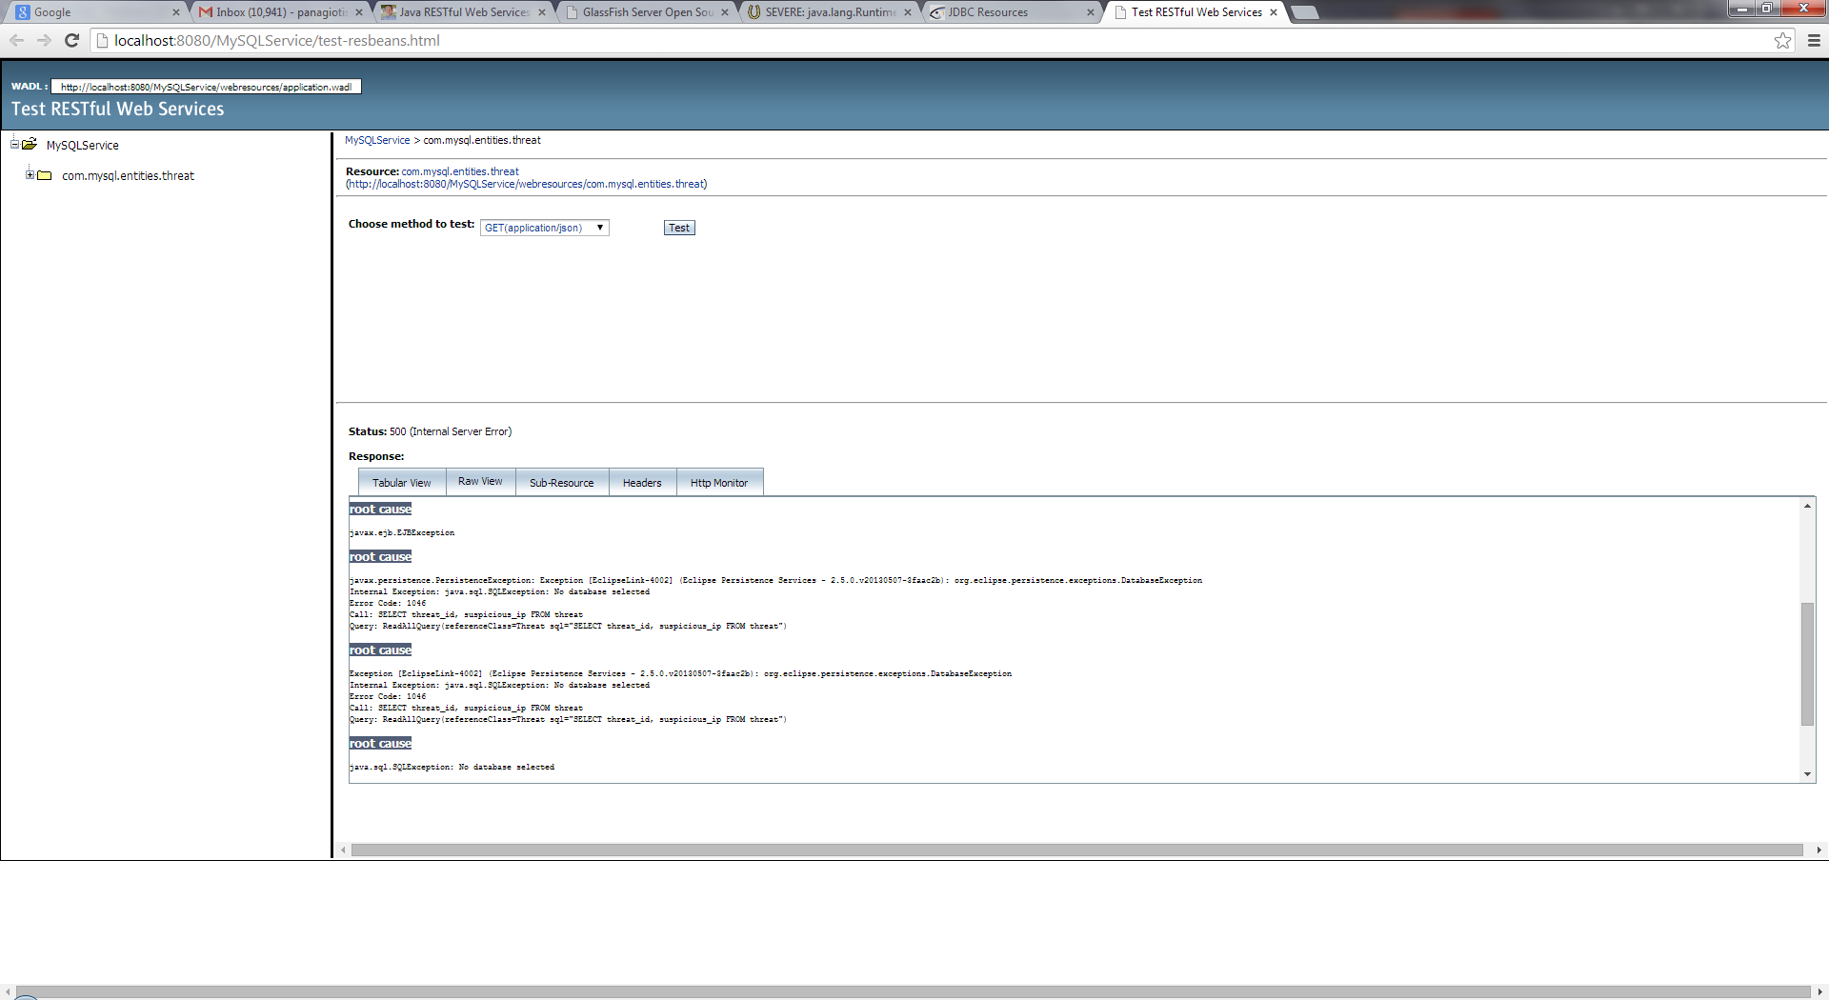

Open the GlashFish administration console and add the missing database name property on the JDBC Resource:

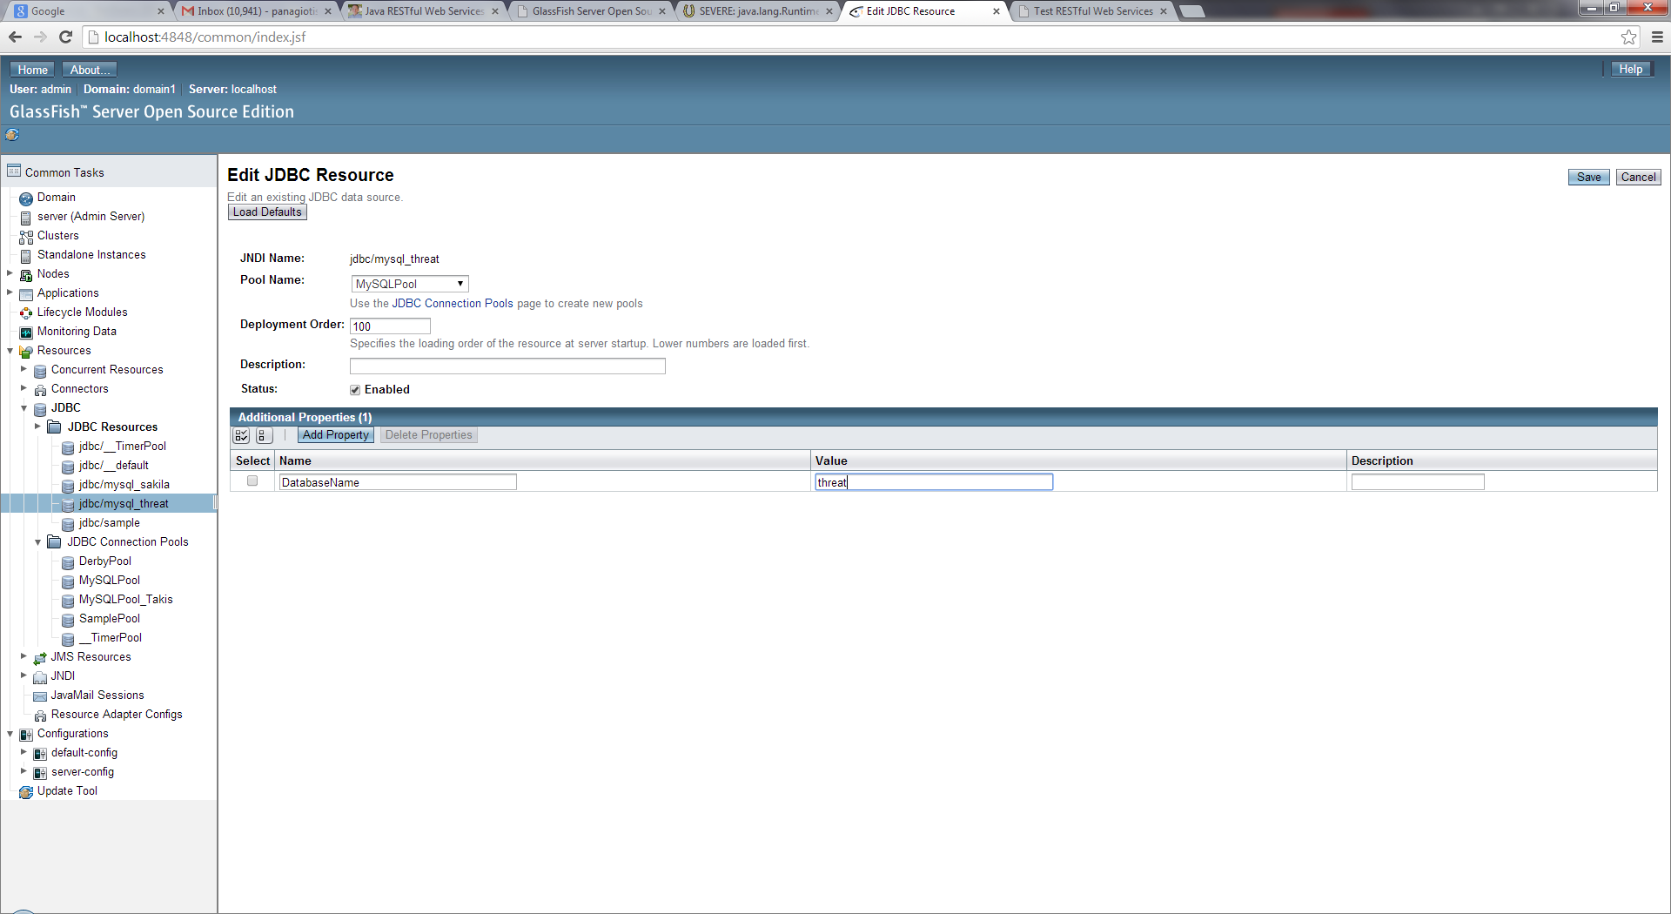

Save changes:

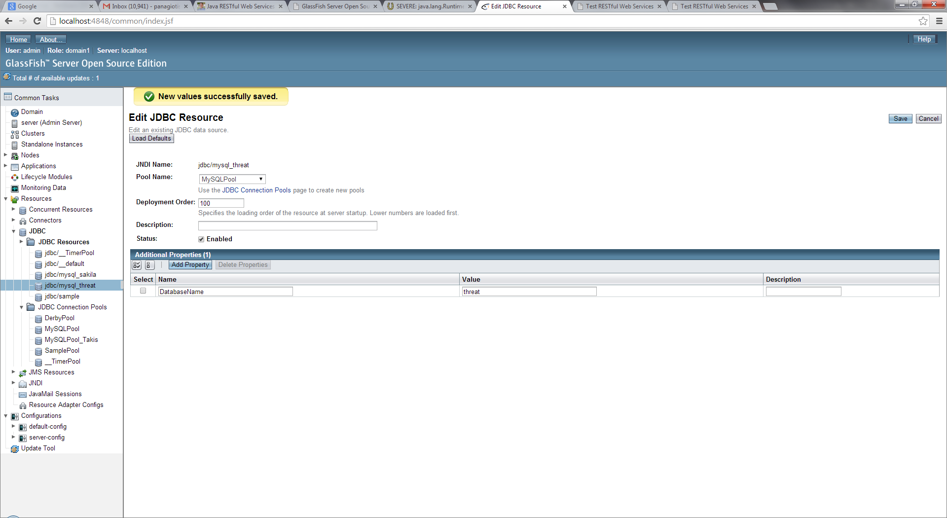

Test for once more the web service:

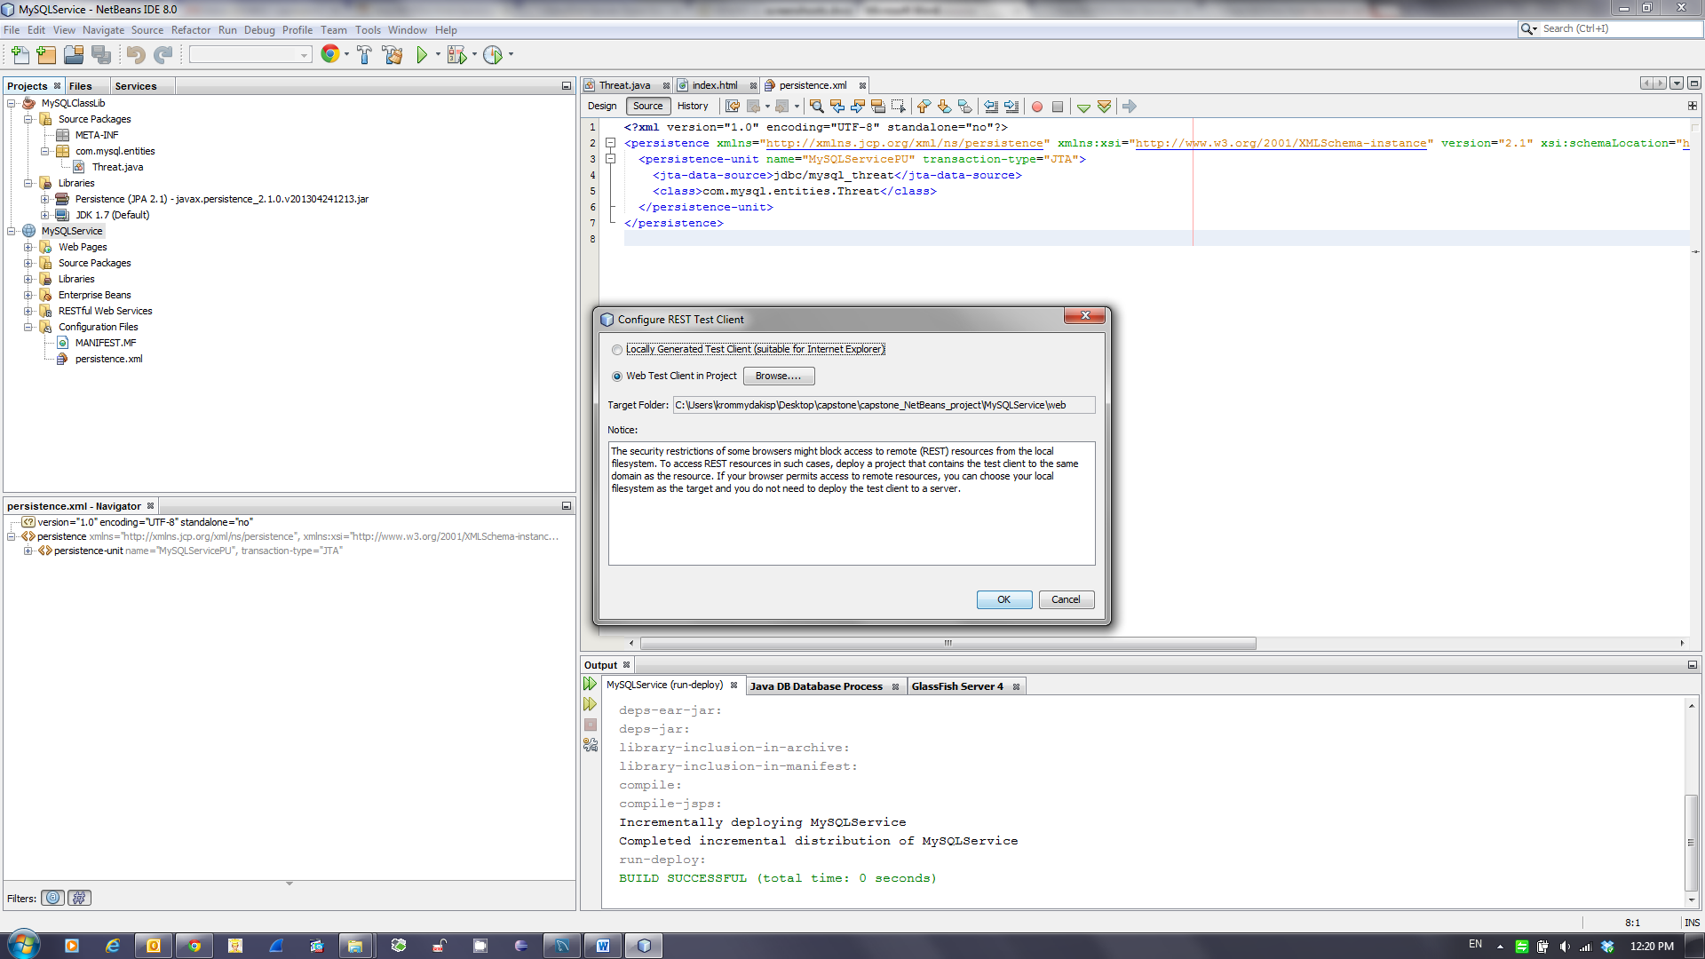

A new error occurs indicating that GlashFish has no clue about where to look for the given database:

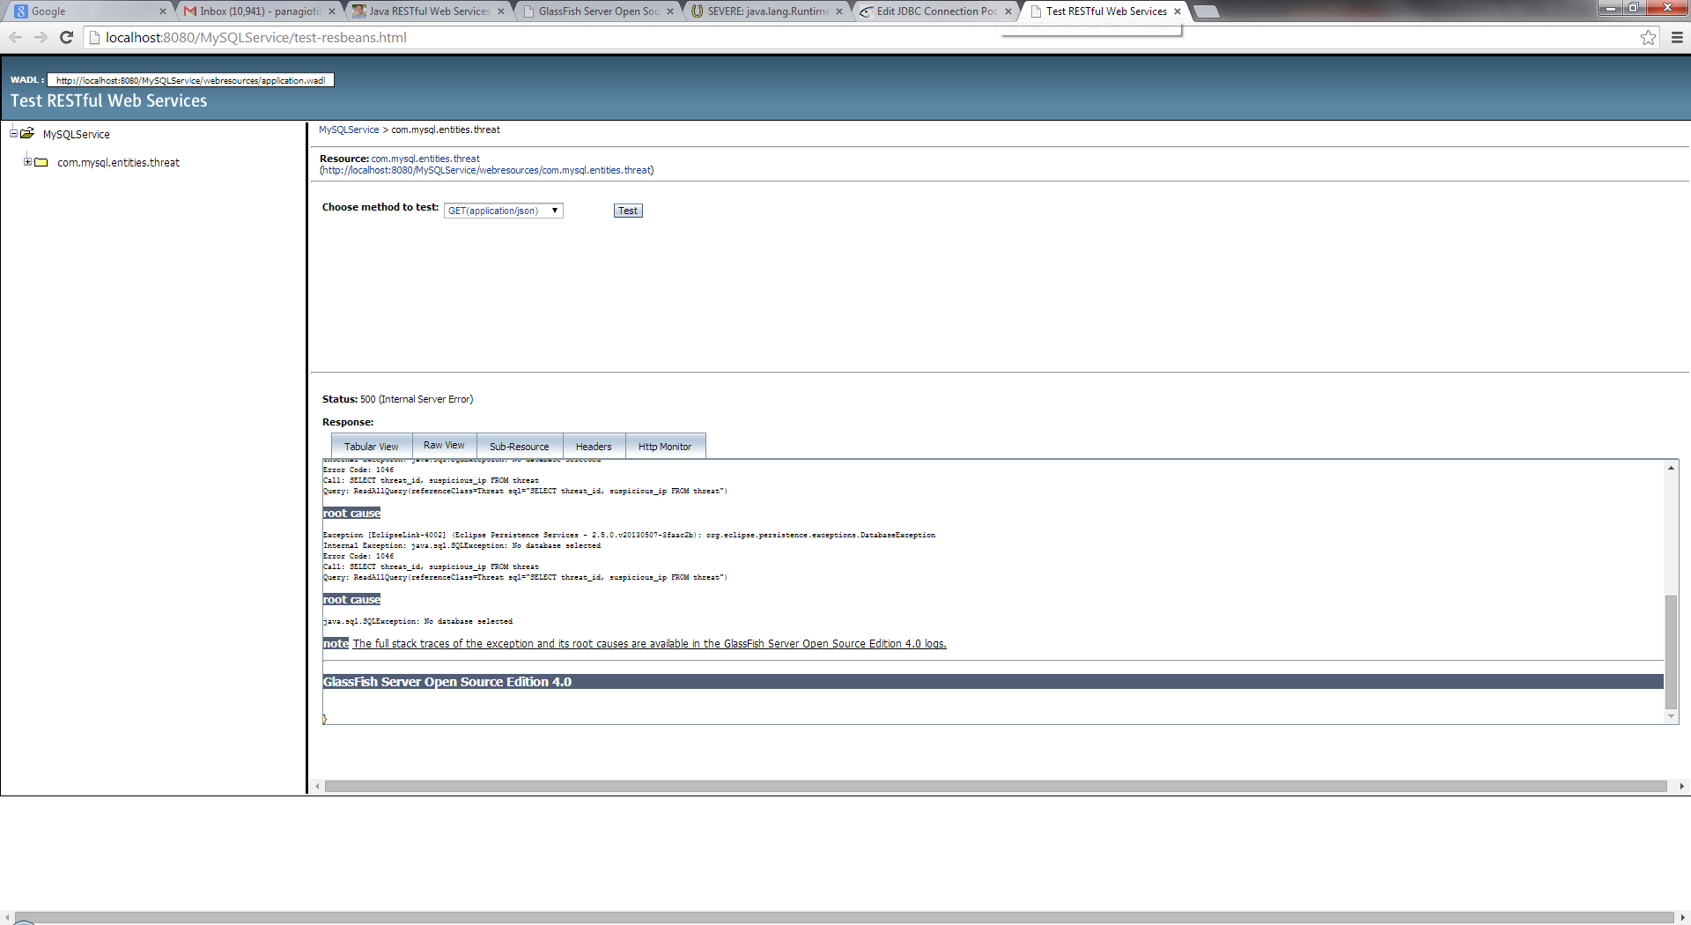

Open again the pool properties:

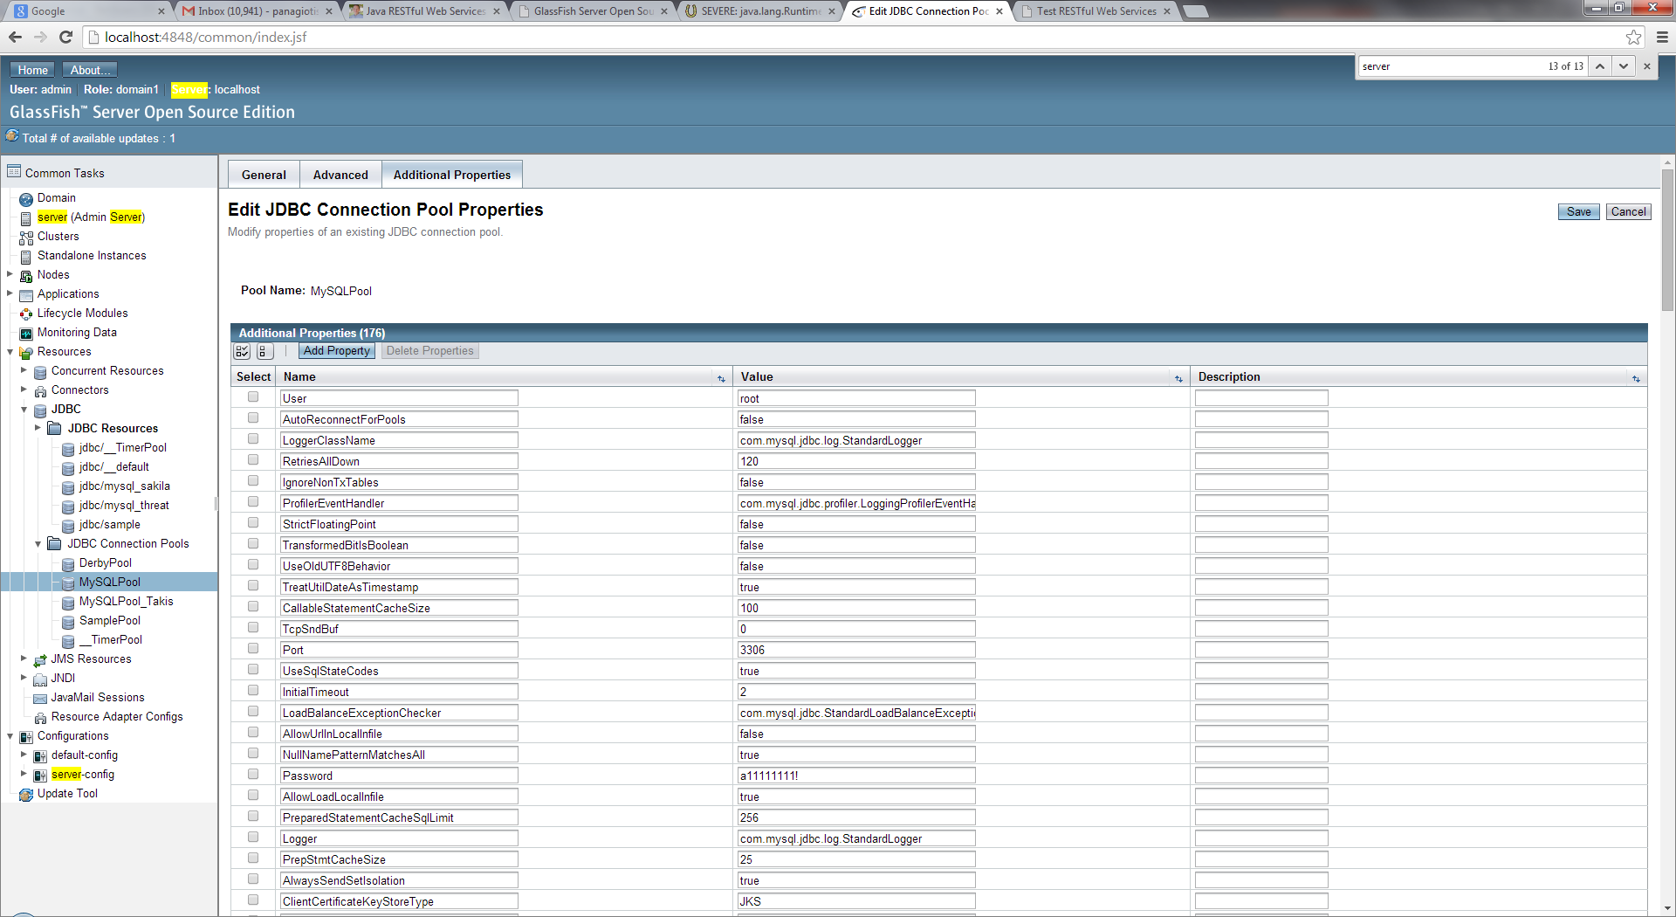

Add the server property. Afterwards assign the proper value:

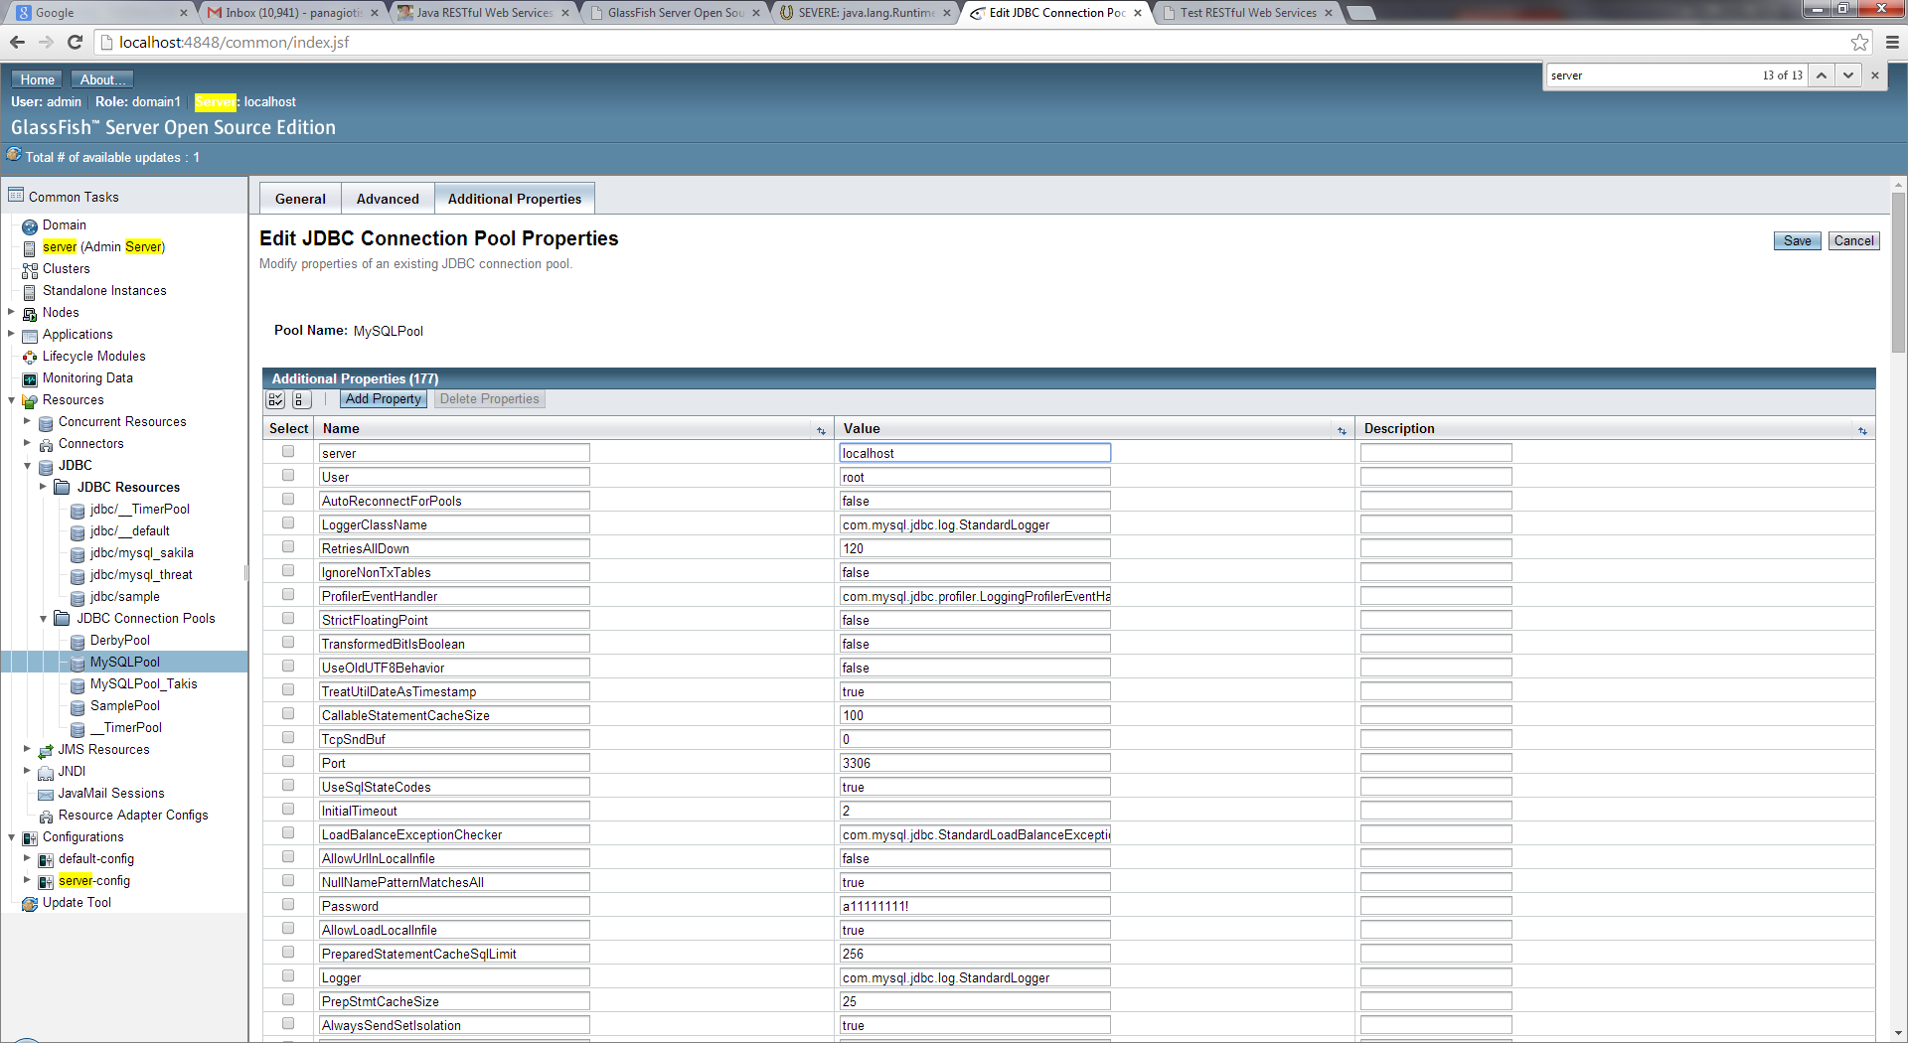

In a following step do the same for the URL property:

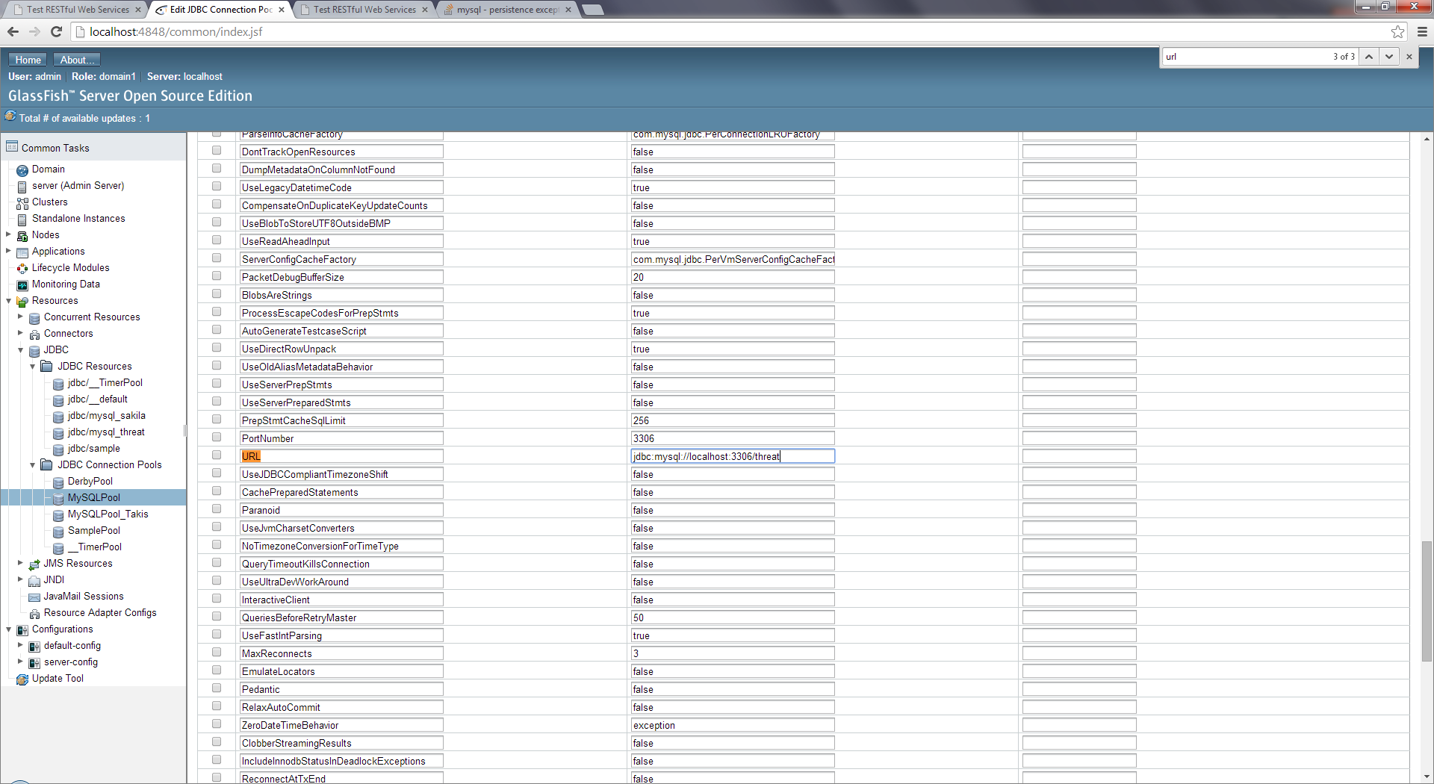

Save changes:

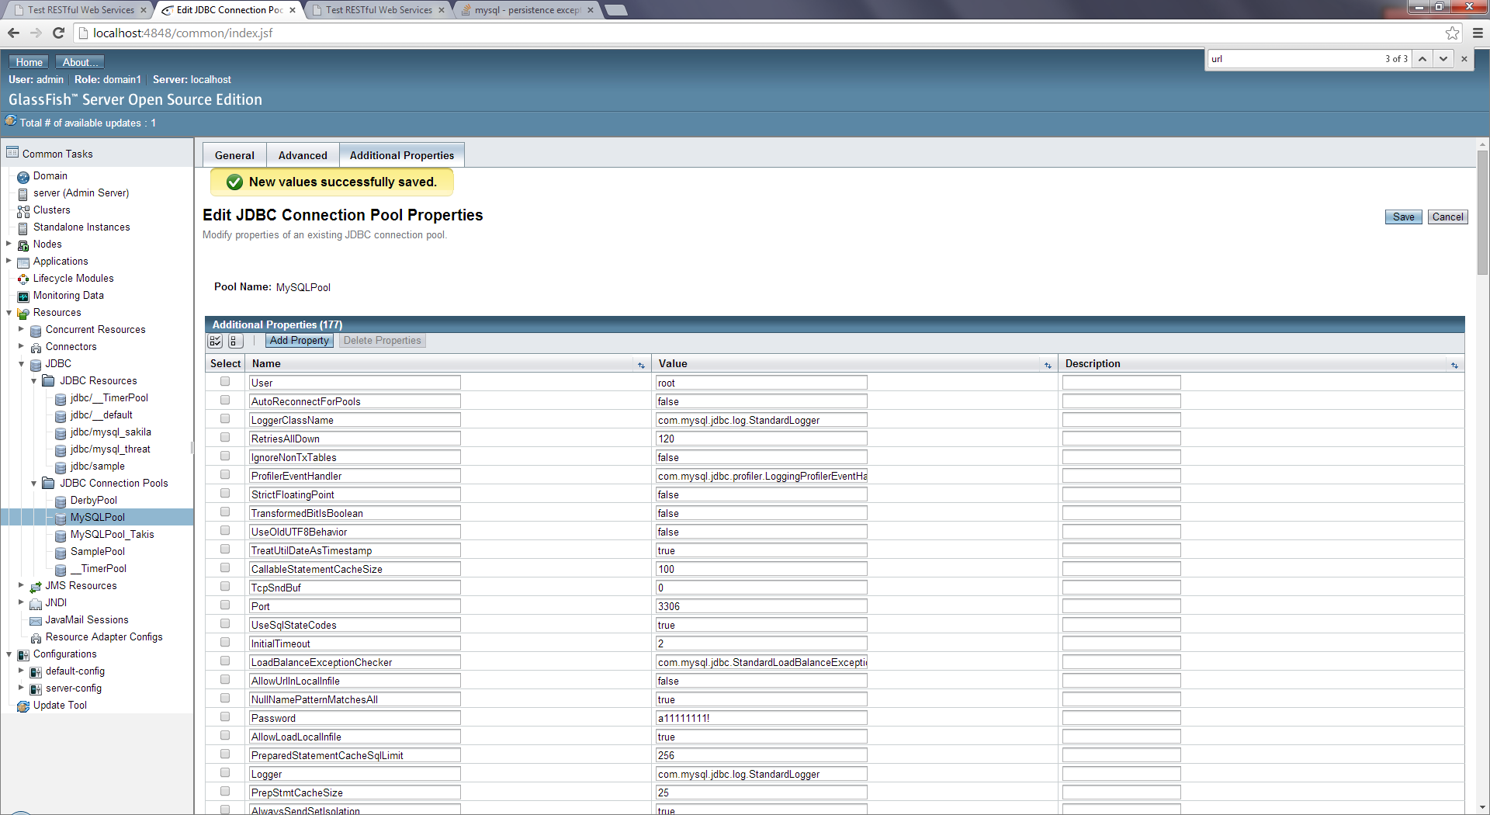

Restart the GlashFish server so as to load the changes (mandatory step):

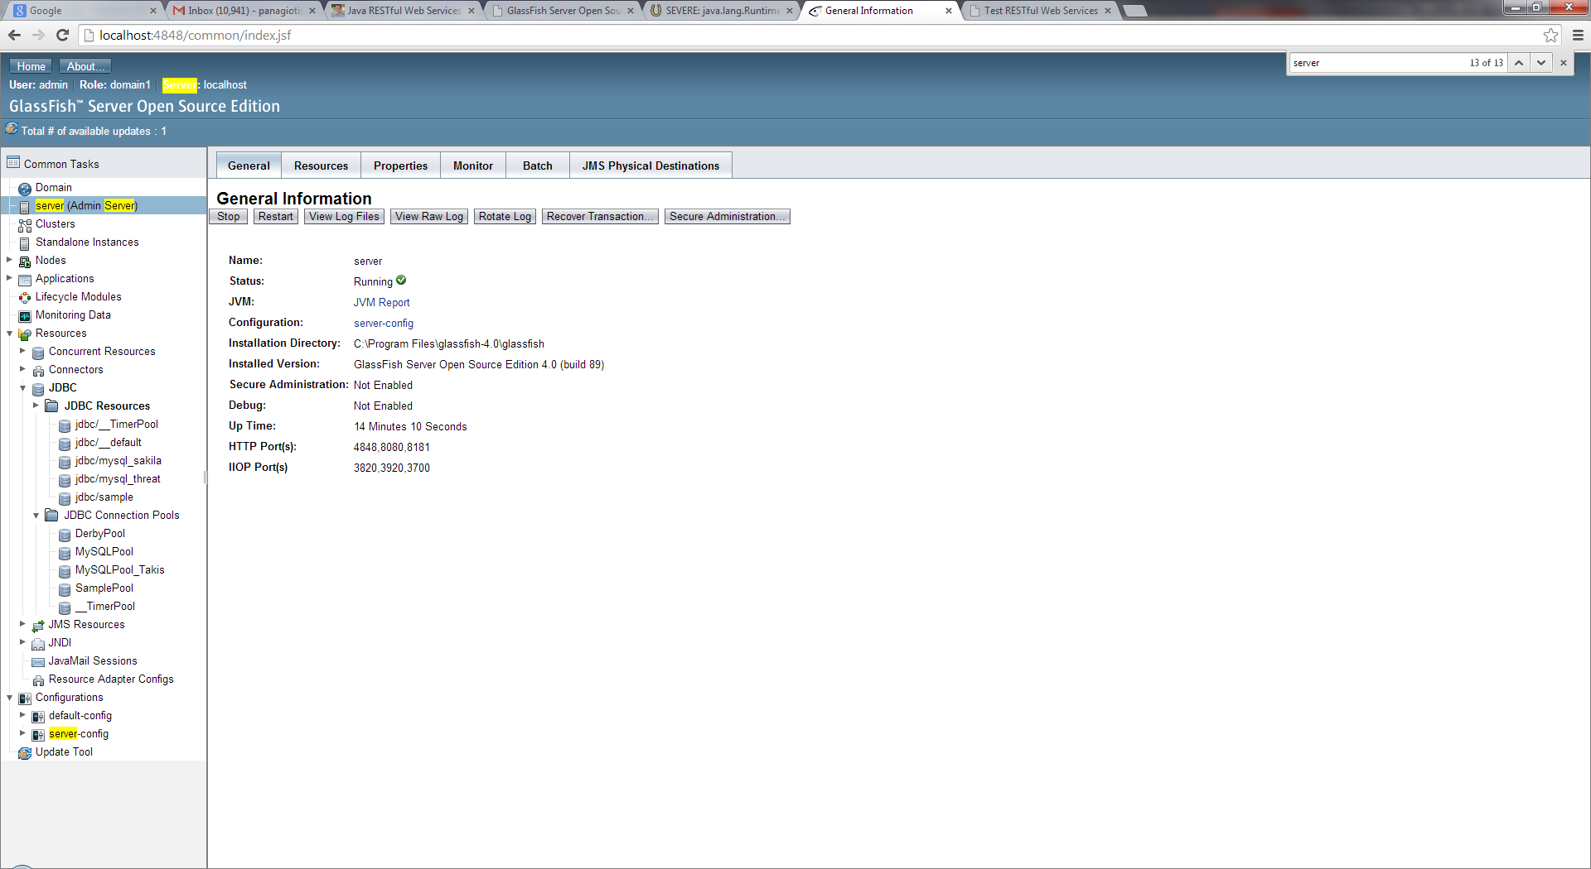

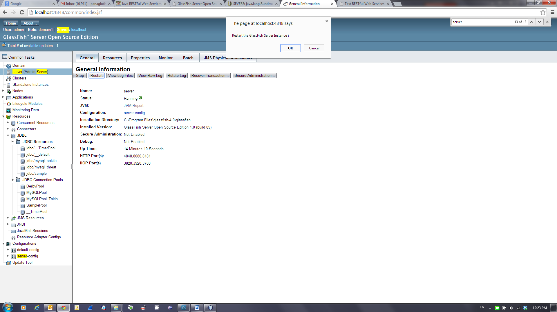

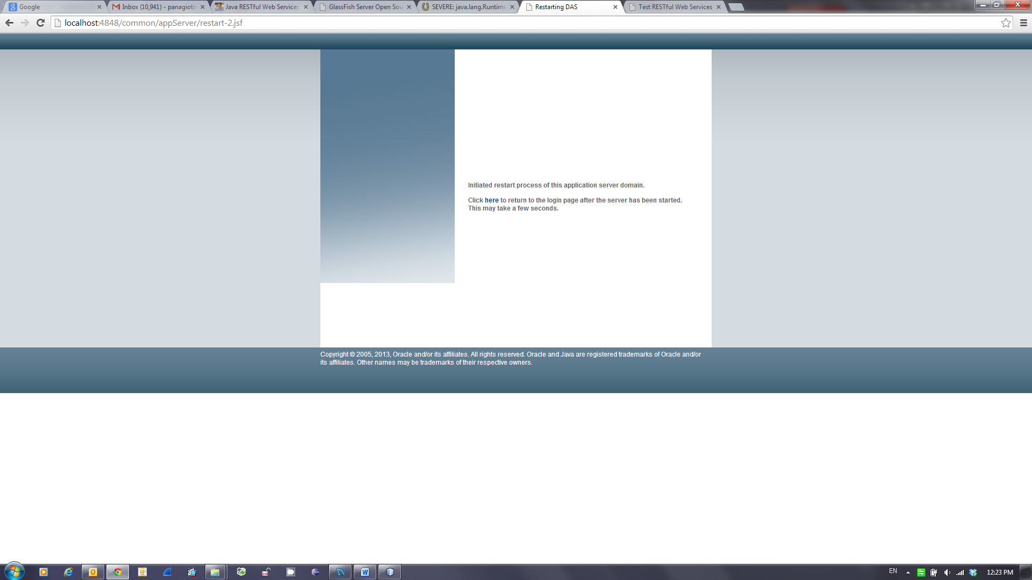

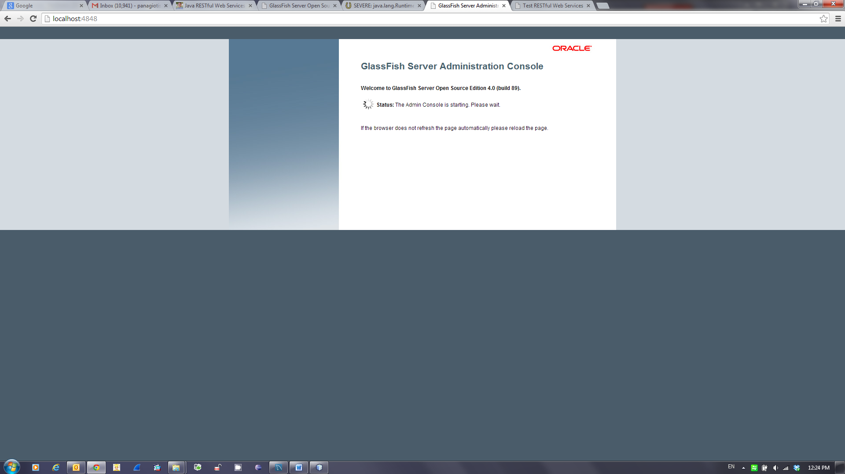

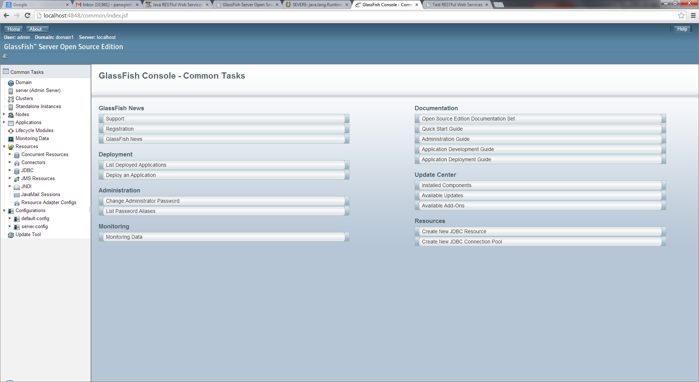

A subsequent attempt to retrieve the database values through the JSON file is finally successful:

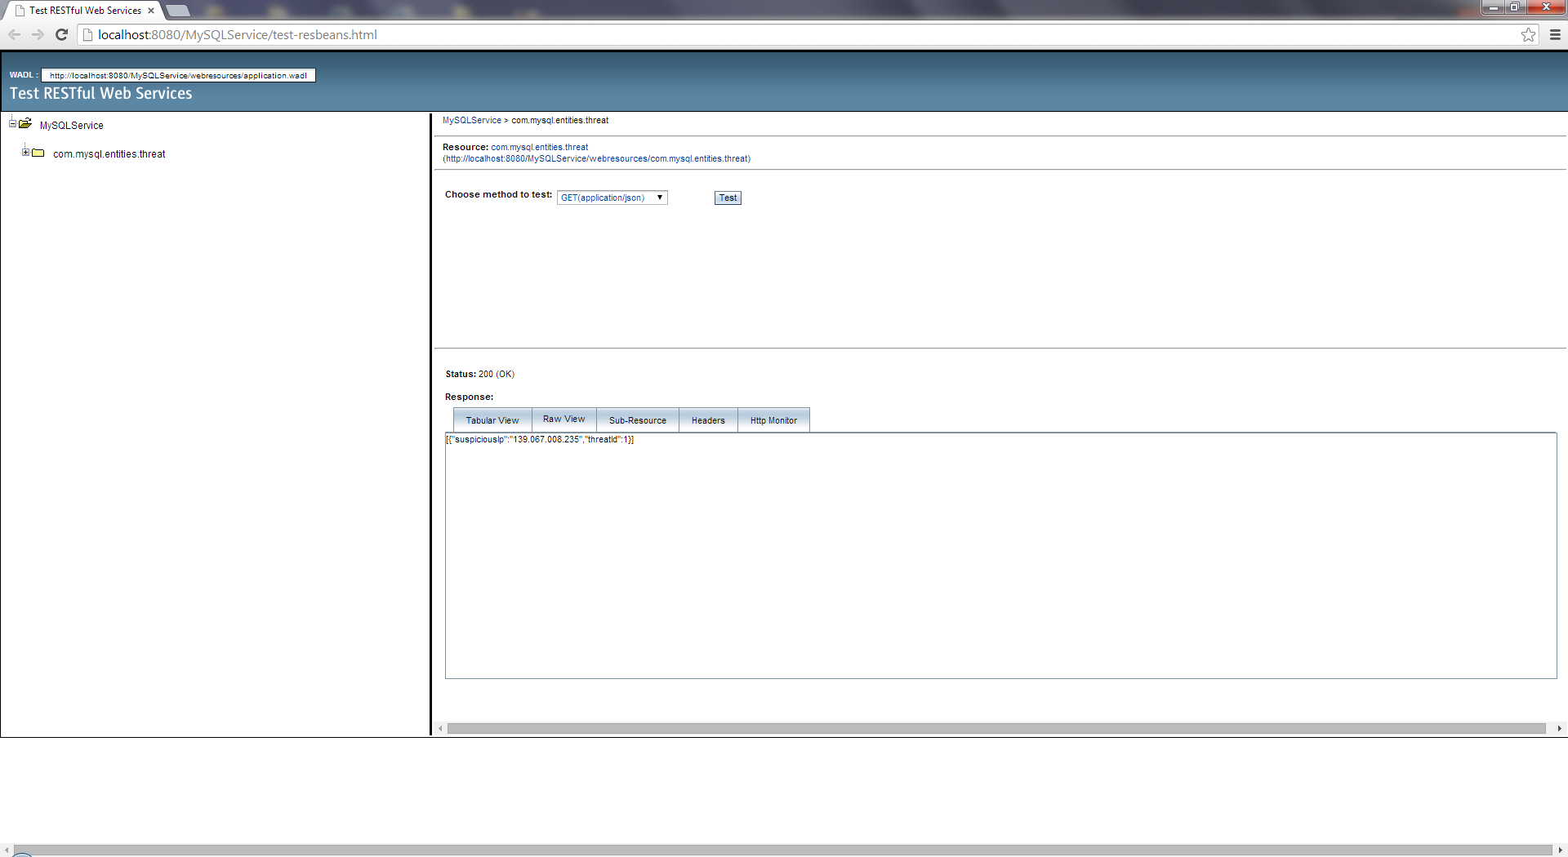

Figure 24: The RestFul Web Service

## The Demo IOs App (“Attack Monitor”)

**Note**: Implementation is based on

<http://www.raywenderlich.com/58682/introduction-restkit-tutorial>

This application has been created in as a new project in XCode 5, based on the *iOS\Application\Master-Detail Application* template. To keep things simple, the Detail View Controller is not used. Consequently, the following information has been deleted:

* prepareForSegue:sender: from MasterViewController.m
* The #import for DetailViewController.h at the top of MasterViewController.m
* The files DetailViewController.h and DetailViewController.m,. and finally the
* “Detail View Controller – Detail” from Main.storyboard. (both iPhone and iPad versions).

### Installation of the RestKit Framework

CocoaPods has been used so as to integrate RestKit with the newly created XCode project. CocoaPods is a popular tool to manage library dependencies in Objective-C projects. In particular, the following commands have been entered using “root” access rights via the MacOS Terminal (Note: guidance in order to setup the administrator account on a MacOS workstation is beyond the scope of this document):

$ sudo gem install cocoapods

$ pod setup

$ cd /path/to/*AttackMonitor project*

$ touch Podfile

$ nano Podfile

platform :ios, '5.0'

pod 'RestKit', '~> 0.20.0'

Save changes and exit nano editor

$ pod install

Now close the AttackMonitor.xcodeproj and start working exclusively with AttackMonitor.xcworkspace.

//

// main.m

// AttackMonitor

//

// Created by MacBookPro on 6/19/14.

// Copyright (c) 2014 HAU. All rights reserved.

//

#import <UIKit/UIKit.h>

#import "AppDelegate.h"

int main(int argc, char * argv[])

{

@autoreleasepool {

return UIApplicationMain(argc, argv, nil, NSStringFromClass([AppDelegate class]));

}

}

### Attack.h

//

// Attack.h

// AttackMonitor

//

// Created by MacBookPro on 6/19/14.

// Copyright (c) 2014 HAU. All rights reserved.

//

#import <Foundation/Foundation.h>

@interface Attack : NSObject

@property (nonatomic, strong) NSString *suspiciousIp;

@property (nonatomic, strong) NSNumber *threatId;

@end

### Attack.m

//

// Attack.m

// AttackMonitor

//

// Created by MacBookPro on 6/19/14.

// Copyright (c) 2014 HAU. All rights reserved.

//

#import "Attack.h"

@implementation Attack

@end

### AppDelegate.h

//

// AppDelegate.h

// AttackMonitor

//

// Created by MacBookPro on 6/19/14.

// Copyright (c) 2014 HAU. All rights reserved.

//

#import <UIKit/UIKit.h>

@interface AppDelegate : UIResponder <UIApplicationDelegate>

@property (strong, nonatomic) UIWindow *window;

@end

### AppDelegate.m

//

// AppDelegate.m

// AttackMonitor

//

// Created by MacBookPro on 6/19/14.

// Copyright (c) 2014 HAU. All rights reserved.

//

#import "AppDelegate.h"

@implementation AppDelegate

-(BOOL)application:(UIApplication *)application didFinishLaunchingWithOptions:(NSDictionary *)launchOptions

{

// Override point for customization after application launch.

if ([[UIDevice currentDevice] userInterfaceIdiom] == UIUserInterfaceIdiomPad) {

UISplitViewController *splitViewController = (UISplitViewController *)self.window.rootViewController;

UINavigationController *navigationController = [splitViewController.viewControllers lastObject];

splitViewController.delegate = (id)navigationController.topViewController;

}

return YES;

}

- (void)applicationWillResignActive:(UIApplication *)application

{

// Sent when the application is about to move from active to inactive state. This can occur for certain types of temporary interruptions (such as an incoming phone call or SMS message) or when the user quits the application and it begins the transition to the background state.

// Use this method to pause ongoing tasks, disable timers, and throttle down OpenGL ES frame rates. Games should use this method to pause the game.

}

- (void)applicationDidEnterBackground:(UIApplication *)application

{

// Use this method to release shared resources, save user data, invalidate timers, and store enough application state information to restore your application to its current state in case it is terminated later.

// If your application supports background execution, this method is called instead of applicationWillTerminate: when the user quits.

}

- (void)applicationWillEnterForeground:(UIApplication *)application

{

// Called as part of the transition from the background to the inactive state; here you can undo many of the changes made on entering the background.

}

- (void)applicationDidBecomeActive:(UIApplication *)application

{

// Restart any tasks that were paused (or not yet started) while the application was inactive. If the application was previously in the background, optionally refresh the user interface.

}

- (void)applicationWillTerminate:(UIApplication *)application

{

// Called when the application is about to terminate. Save data if appropriate. See also applicationDidEnterBackground:.

}

@end

### MasterViewController.h

//

// MasterViewController.h

// AttackMonitor

//

// Created by MacBookPro on 6/19/14.

// Copyright (c) 2014 HAU. All rights reserved.

//

#import <UIKit/UIKit.h>

@class DetailViewController;

@interface MasterViewController : UITableViewController

@property (strong, nonatomic) DetailViewController *detailViewController;

@end

### MasterViewController.m

//

// MasterViewController.m

// AttackMonitor

//

// Created by MacBookPro on 6/19/14.

// Copyright (c) 2014 HAU. All rights reserved.

//

#import "MasterViewController.h"

#import <RestKit/RestKit.h>

#import "Attack.h"

@interface MasterViewController ()

@property (nonatomic, strong) NSArray *attacks;

@end

@implementation MasterViewController

- (void)awakeFromNib

{

if ([[UIDevice currentDevice] userInterfaceIdiom] == UIUserInterfaceIdiomPad) {

self.clearsSelectionOnViewWillAppear = NO;

self.preferredContentSize = CGSizeMake(320.0, 600.0);

}

[super awakeFromNib];

}

-(void)loadAttacks

{

RKObjectMapping* attackMapping = [RKObjectMapping mappingForClass:[Attack class]];

[attackMapping addAttributeMappingsFromDictionary:@{@"suspiciousIp": @"suspiciousIp", @"threatId": @"threatId"}];

RKResponseDescriptor *responseDescriptor = [RKResponseDescriptor responseDescriptorWithMapping:attackMapping method:RKRequestMethodAny pathPattern:nil keyPath:nil statusCodes:RKStatusCodeIndexSetForClass(RKStatusCodeClassSuccessful)];

NSURL *URL = [NSURL URLWithString:@"http://192.168.1.14:8080/MySQLService/webresources/com.mysql.entities.threat"];

NSMutableURLRequest *request = [NSMutableURLRequest requestWithURL:URL];

[request setHTTPMethod:@"GET"];

[request setValue:@"application/json" forHTTPHeaderField:@"Accept"];

RKObjectRequestOperation *objectRequestOperation = [[RKObjectRequestOperation alloc] initWithRequest:request responseDescriptors:@[ responseDescriptor ]];

[objectRequestOperation setCompletionBlockWithSuccess:^(RKObjectRequestOperation *operation, RKMappingResult *mappingResult) {

RKLogInfo(@"Load collection of Attacks: %@", mappingResult.array);

_attacks = mappingResult.array;

[self.tableView reloadData];

} failure:^(RKObjectRequestOperation *operation, NSError *error) {

RKLogError(@"Operation failed with error: %@", error);

}];

[objectRequestOperation start];

}

- (void)viewDidLoad

{

[super viewDidLoad];

// Do any additional setup after loading the view, typically from a nib.

[self loadAttacks];

// self.navigationItem.leftBarButtonItem = self.editButtonItem;

//

// UIBarButtonItem *addButton = [[UIBarButtonItem alloc] initWithBarButtonSystemItem:UIBarButtonSystemItemAdd target:self action:@selector(insertNewObject:)];

// self.navigationItem.rightBarButtonItem = addButton;

// self.detailViewController = (DetailViewController *)[[self.splitViewController.viewControllers lastObject] topViewController];

}

- (void)didReceiveMemoryWarning

{

[super didReceiveMemoryWarning];

// Dispose of any resources that can be recreated.

}

//- (void)insertNewObject:(id)sender

//{

// if (!_objects) {

// _objects = [[NSMutableArray alloc] init];

// }

// [_objects insertObject:[NSDate date] atIndex:0];

// NSIndexPath *indexPath = [NSIndexPath indexPathForRow:0 inSection:0];

// [self.tableView insertRowsAtIndexPaths:@[indexPath] withRowAnimation:UITableViewRowAnimationAutomatic];

//}

#pragma mark - Table View

- (NSInteger)numberOfSectionsInTableView:(UITableView *)tableView

{

return 1;

}

- (NSInteger)tableView:(UITableView *)tableView numberOfRowsInSection:(NSInteger)section

{

return _attacks.count;

}

- (UITableViewCell *)tableView:(UITableView *)tableView cellForRowAtIndexPath:(NSIndexPath *)indexPath

{

UITableViewCell *cell = [tableView dequeueReusableCellWithIdentifier:@"Cell" forIndexPath:indexPath];

Attack *attack = _attacks[indexPath.row];

cell.textLabel.text = attack.suspiciousIp;

return cell;

}

- (BOOL)tableView:(UITableView *)tableView canEditRowAtIndexPath:(NSIndexPath *)indexPath

{

// Return NO if you do not want the specified item to be editable.

return YES;

}

@end

# Test Specification

Test cases specify the inputs, predicted results and execution conditions. Each test case aims to evaluate the operation of a key element or function of the system. The abstract contents of the test specification are depicted in the following subsections for completeness purposes only as they don’t fall into the scope of POC. Nevertheless, author believes this information will be rather useful for future implementations

## Testing Strategy

Testing should be focused on the usual operational conditions of the Attack Monitor and no much attention should be paid on glare cases for the time being at least. The aim is to verify the functionality (verification testing) in a timely manner and proceed immediately with the system evaluation (validation testing) against real world conditions.

## Testing Environment

The test environment will be prepared using a similar hardware configuration as the production environment. Since this is a small system, there is no need to scale down the hardware layout.

There are no special staffing needs.

## Test Activities

The two strategies to be used are value-based and risk-based testing.

**Value-based Testing Strategy**

Value-based testing is an approach which attempts to identify the capabilities or features of a system that provide the highest amount of “value-added” to the project.  These are typically related to a set of prioritized requirements that are agreed upon by the project’s success critical stakeholders.

**Risk-based Testing Strategy**

Risk-based testing is an approach which attempts to identify components of the system that have the highest amount of associated “risk”.  These “high-risk” components are identified previously during the project elaboration phases.

Consequently there are two levels of testing, which are applicable to this project:

* **System Qualification level tests** implement Risk Based testing strategy, and adopt a Black Box (functional test) strategy. No assumptions are made about the internal structure of the system.
* **User Acceptance Testing (UAT)** implement value based testing strategy. This test is client driven. Test cases for UAT should be presented to the client for approval and any additional test cases suggested will be incorporated. UAT will be executed in collaboration with the client representative after general release of code.

## Tests Execution Strategy

The tests will be executed manually (“user-session” technique). Results of each test shall be recorded manually in test result sheets. In many cases this is not always feasible and the test sheet cannot cover all the possible senarios.

Failure of a test case, depending upon the severity of the failure, shall be catalogued as part of the overall evaluation of the suitability of the system as a whole for its intended use.

The following method of evaluating the impact of a testcase failure is proposed:

* **Level 1 (high)** - failure is critical for operations or performing the desired task
* **Level 2 (medium)** - the task can be performed, but not very well

## Defects Management System

Defects can be stored in an open source bug/issue tracking system like “Trac” or “Mantis”.

## Inter-case Dependencies

The inter-case dependencies are included in the use cases describing the test scenarios

## Suspension Criteria and Resumption Requirements

* **Suspension Criteria**: If any of the tests selected by the test team do not give the expected result and the Failure Severity of the testcase is “high”, then the testing activities will be suspended until the bug is fixed
* **Resumption Requirements**: Testing will be done again to ensure that the bug has been fixed and the selected tests give the expected results. Only then will the testing be resumed.

## Correction Verification Tests

For every failed testcase the development team has to provide an offline tested correction. In order to verify the fault elimination, the test team has to re-execute the failed testcase and all its dependencies (if feasible).

## Regression Tests

The test team must select a minimum set of testcases that could verify the overall system functionality whenever a new release or a major correction is provided by the development.

## Test Automation

Not applicable (for the time being at least).

## Fault Reports and Bug fixes handling

Following table depicts the information to be collected and reported for each discovered fault. It is essential all involved parties to maintain synchronized versions of the fault reports table.

|  |  |  |  |  |  |  |
| --- | --- | --- | --- | --- | --- | --- |
| No | Fault Report-ID | Description | Found in version/release | Found by /Date | Corrected in version/release/date | Verified by/date |
| **1** |  |  |  |  |  |  |
|  |  |  |  |  |  |  |
|  |  |  |  |  |  |  |

Table 4: Fault Reports and Corrections

## Quality Assurance – UAT Completion Criteria

All testcases shall be executed according to the test plan and within the agreed timeframe. All the available corrections, from development, must have been verified or rejected. For every unresolved error an agreed resolution plan must be available. In addition, the UAT team should report any unallocated requirement as occurs from the acceptance tests.

**Important Note**: Functionality not described in the final release of this document should be considered as change request.

## Acceptance Criteria

The system acceptance criteria should be defined according to the following scheme:

|  |  |
| --- | --- |
| **Criterion** | **Condition** |
| 1. Successful Prio 1 UAT testcases | > 95% |
| 2. For the failed Prio1 UAT testcases | Bug fixes shall be available in the final release |

Table 5 Acceptance Criteria

## User Acceptance Tests Report Form

A UAT report in .xls should be used

## Testcase Identifiers

The following notation has been selected to identify the testcases:

**TC_RM-n-xx**

Where

n: F (Functional) or N(Non-functional) and

xx: is the actual testcase number.

## Testcase Template

|  |  |
| --- | --- |
| **Test Case ID** | *As occurs from the testcace naming convention schema* |
| **Test Case Number** | *Suggested testcase execution order* |
| **Actor** | *The user/actor who performs the test steps* |
| **Test Item** | *Function to be tested* |
| **Test Priority** | *Testcase priority according to the requirement priority as defined in the req. spec:*  *High (by default for this phase of the project)* |
| **Pre-Conditions** | *System or data status prior to test execution* |
| **Post - Conditions** | *System or data status after the test execution* |
| **Input Specifications** | *Test-steps in chronological order* |
| **Expected Output Specifications** | *System reaction to the corresponding test steps* |
| **Pass / Fail Criteria** | *Testcase validation criteria* |
| **Assumptions and Constraints** | *Testcase related assumptions and constraints* |
| **Dependencies** | *Dependencies to other testcases* |
| **Failure Severity** | *In case of testcase failure what shall be the impact on the tests execution sequence?*  *(value should be set according to the levels defined in the Failure Severity paragraph)* |
| **Traceability** | *Relationship with the functional requirements list* |

Table 6 Testcase Template

# Prototype Test Run and Evaluation

## Step 1 – Database Cleanup

Open “threat” database using MySQL Workbench:

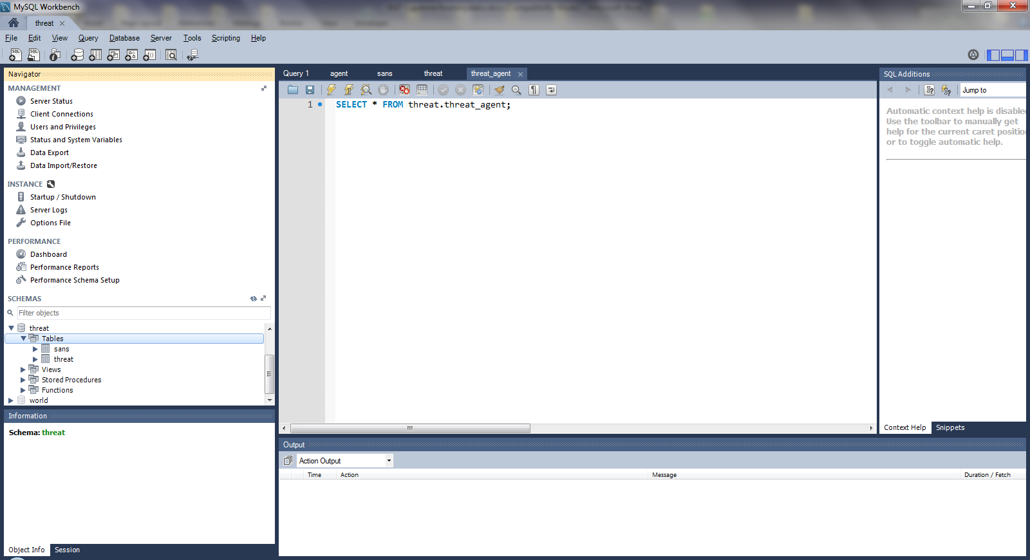

Retrieve the “sans” table records and select them all:

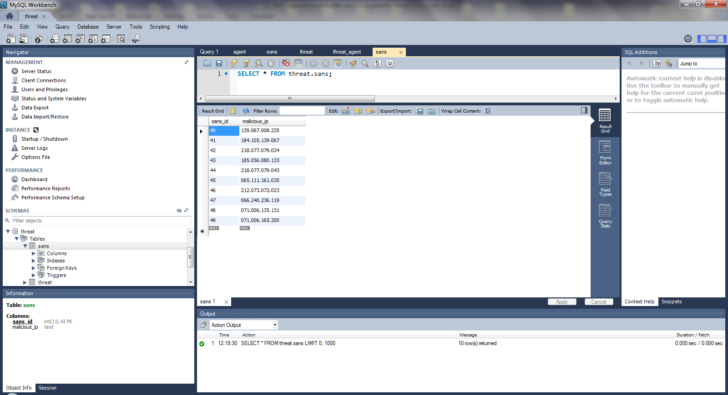

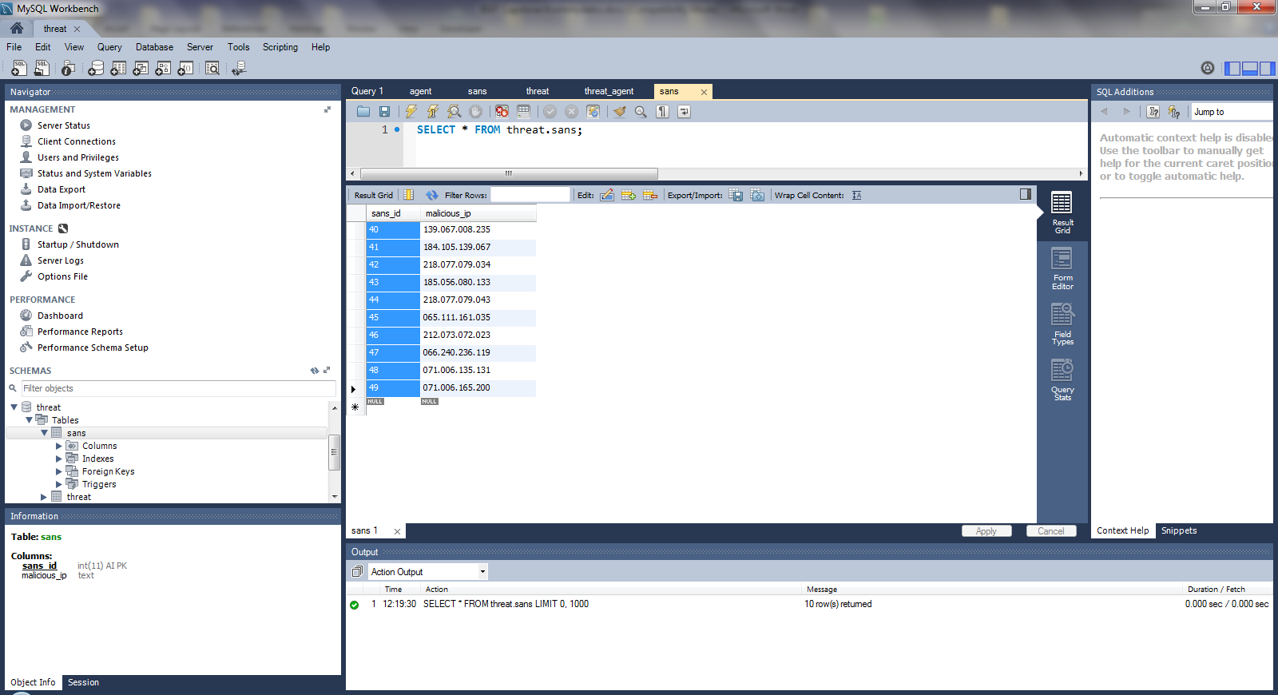

Right click and choose “Delete Rows”. Confirm action by pushing the “Apply” button:

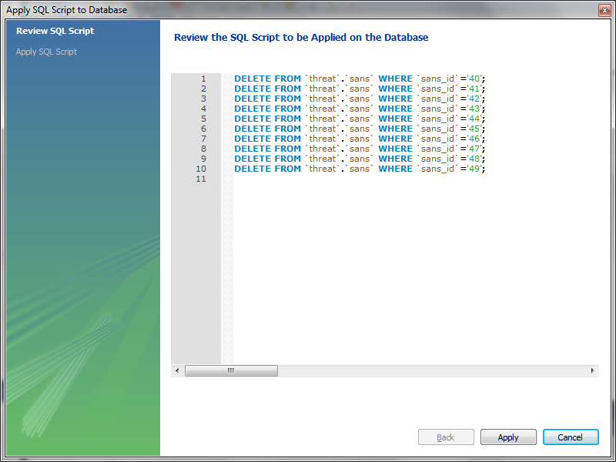

Click “Finish”:

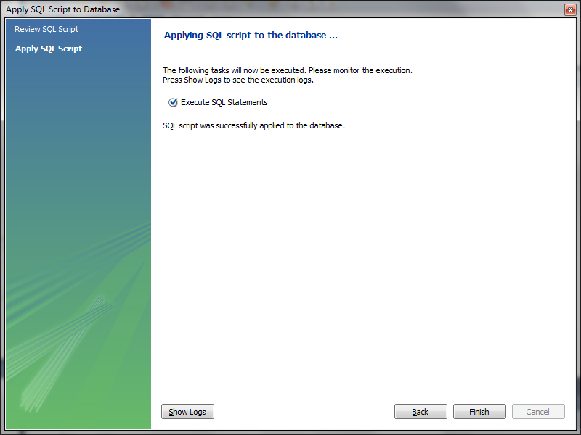

Now, please follow the same procedure for the records of “threat: table:

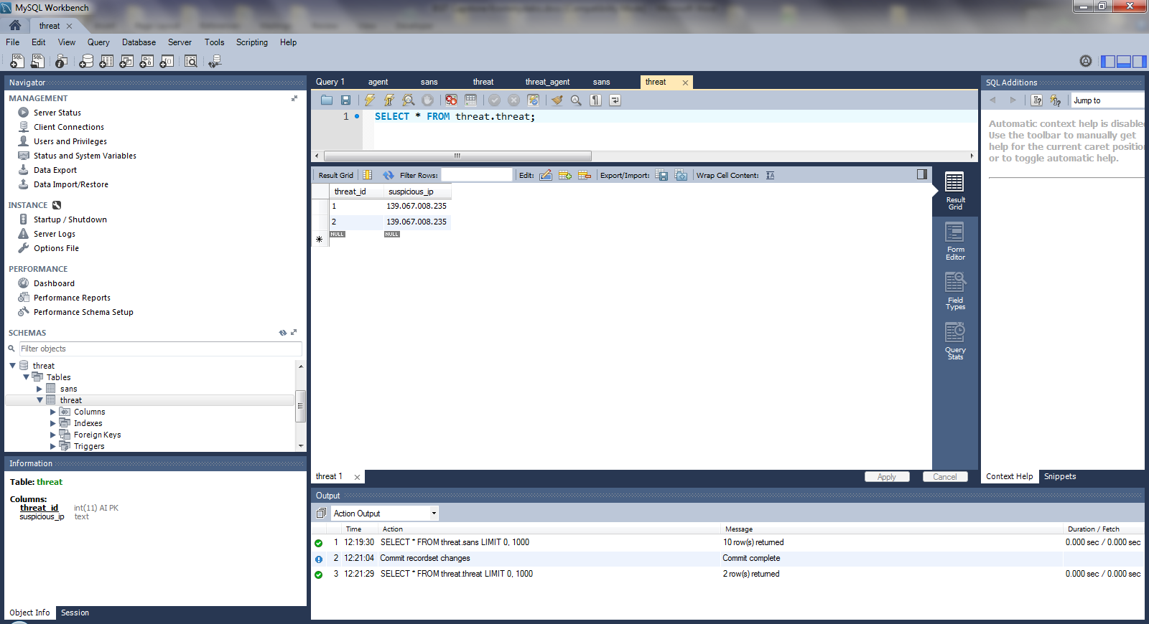

Click “Apply”:

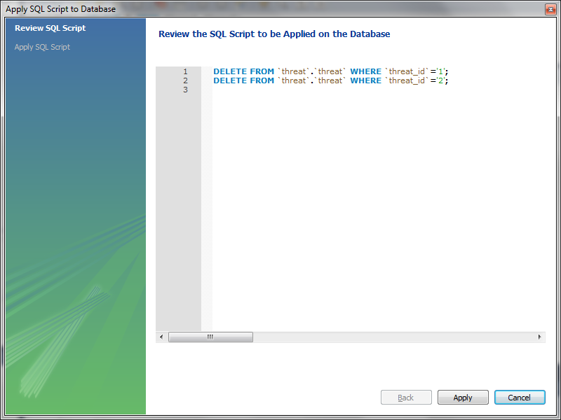

Click “Finish”:

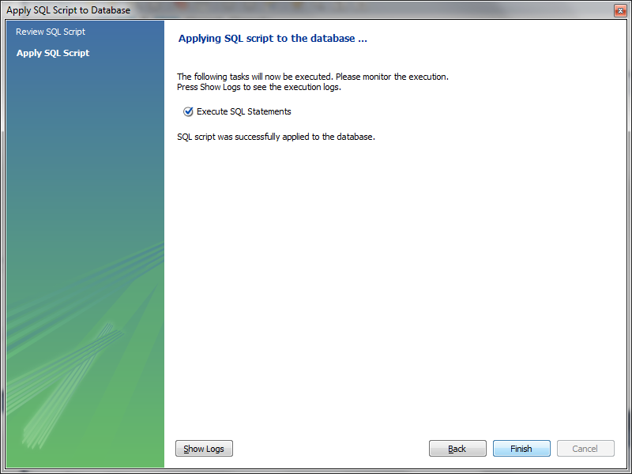

## Step 2 – Retrieve the List of Malicious IPs from Internet Storm Center

“Open” the “xmlParser” project in Eclipse. Configure the xml parser parameters as needed. In the following screenshot, our parser is configured to request the top 10 malicious IPs as published, by SANS Institute, on the 29th of June 2014. Then “Run” the project:

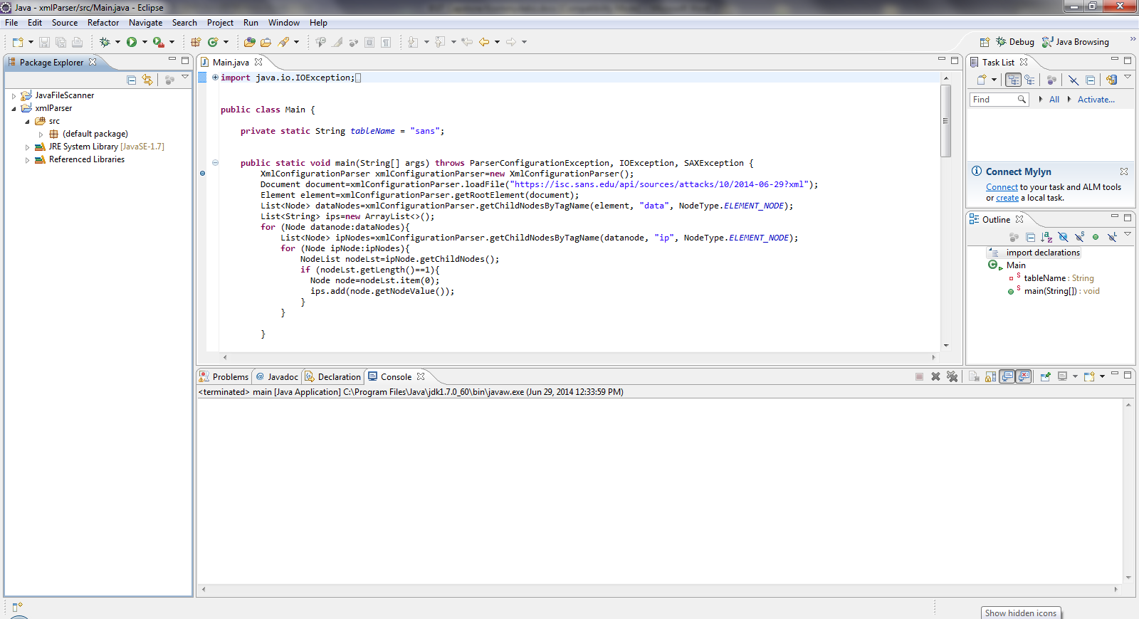

Using “Wireshark” sniff the messages exchanged with Internet Storm Centre for verification purposes.

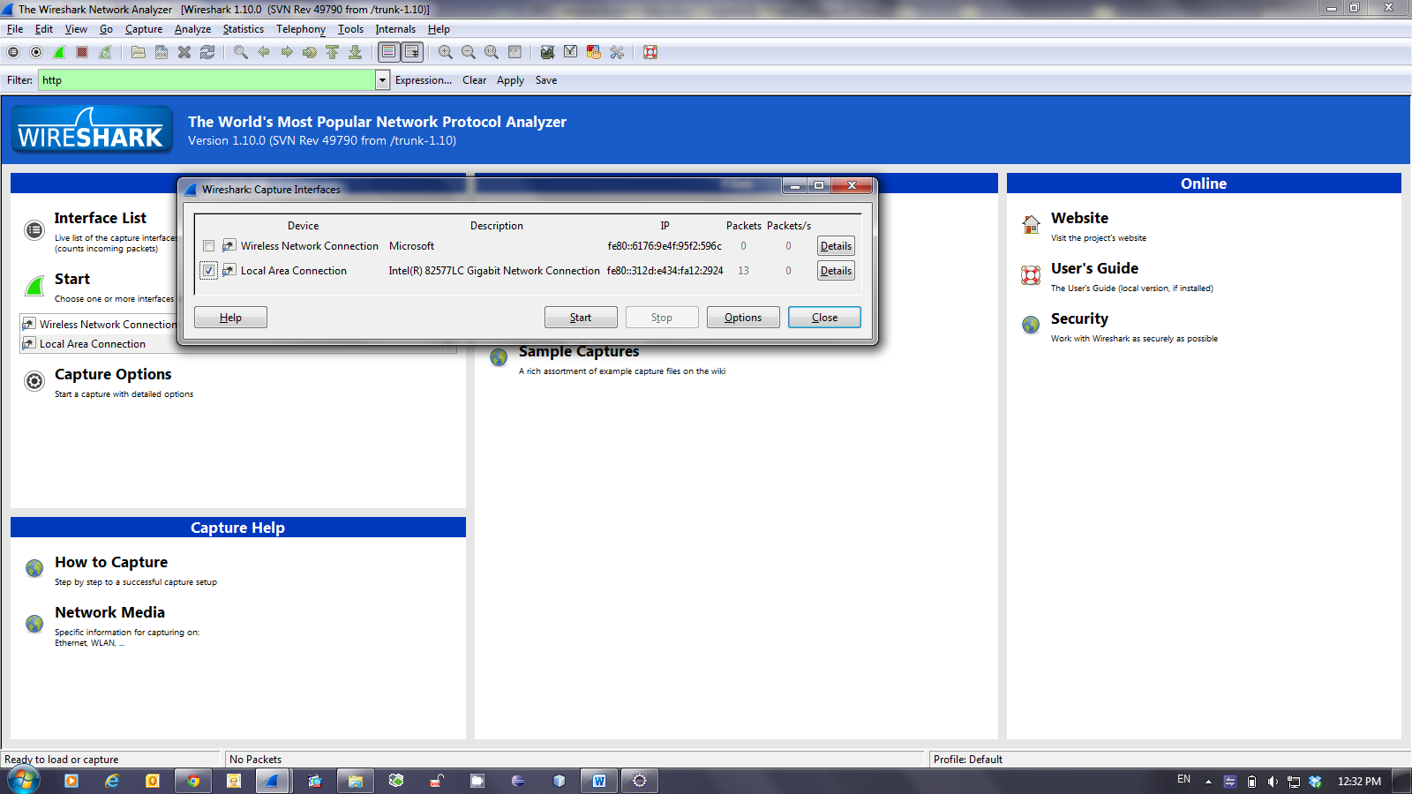

As long as encryption is used on the transport layer (according to OSI reference model) – due to HTTP**S** -, it is not possible to get the messages content in plain text.

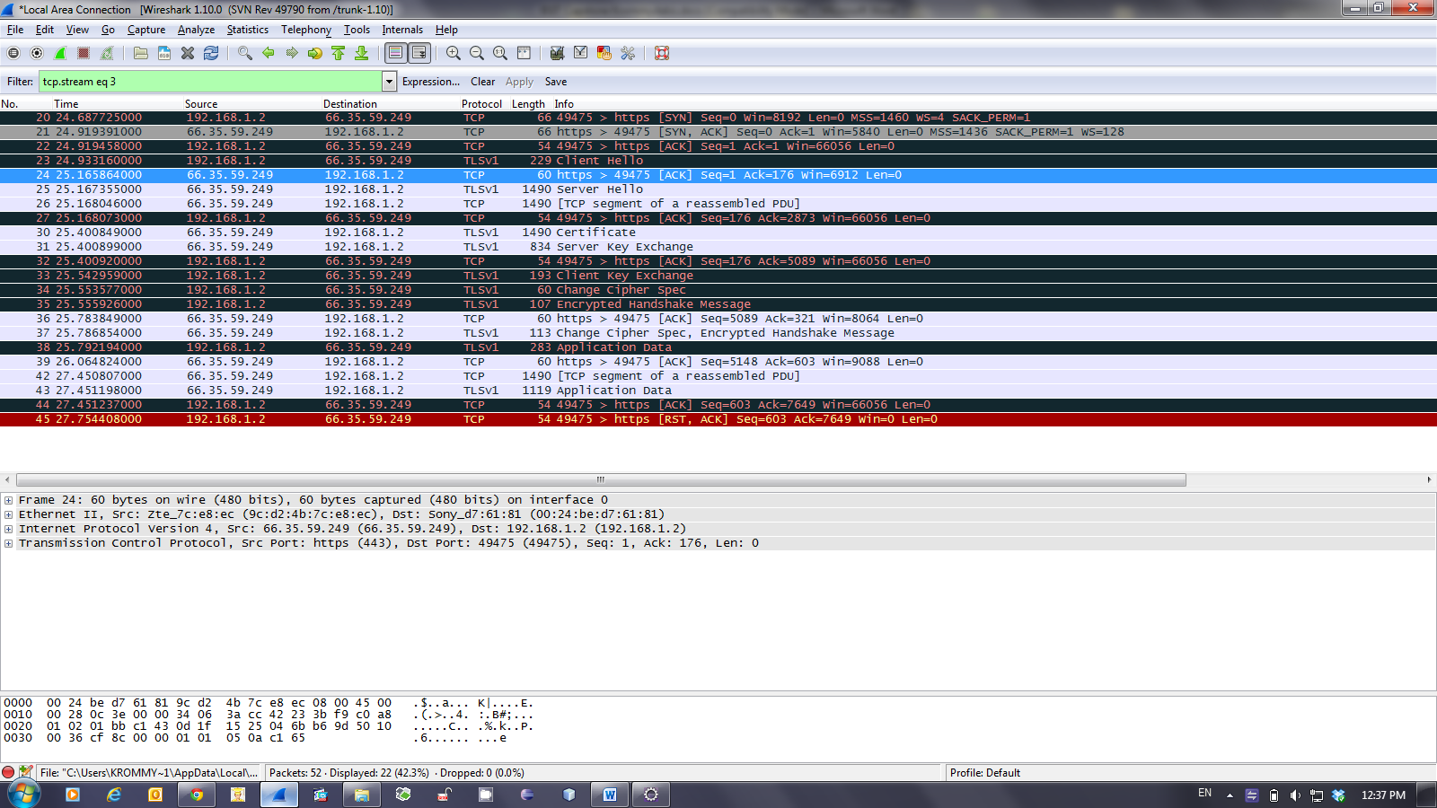

Check the “Console” output in Eclipse so as to verify that retrieved values has been successfully inserted into the “threat” database.

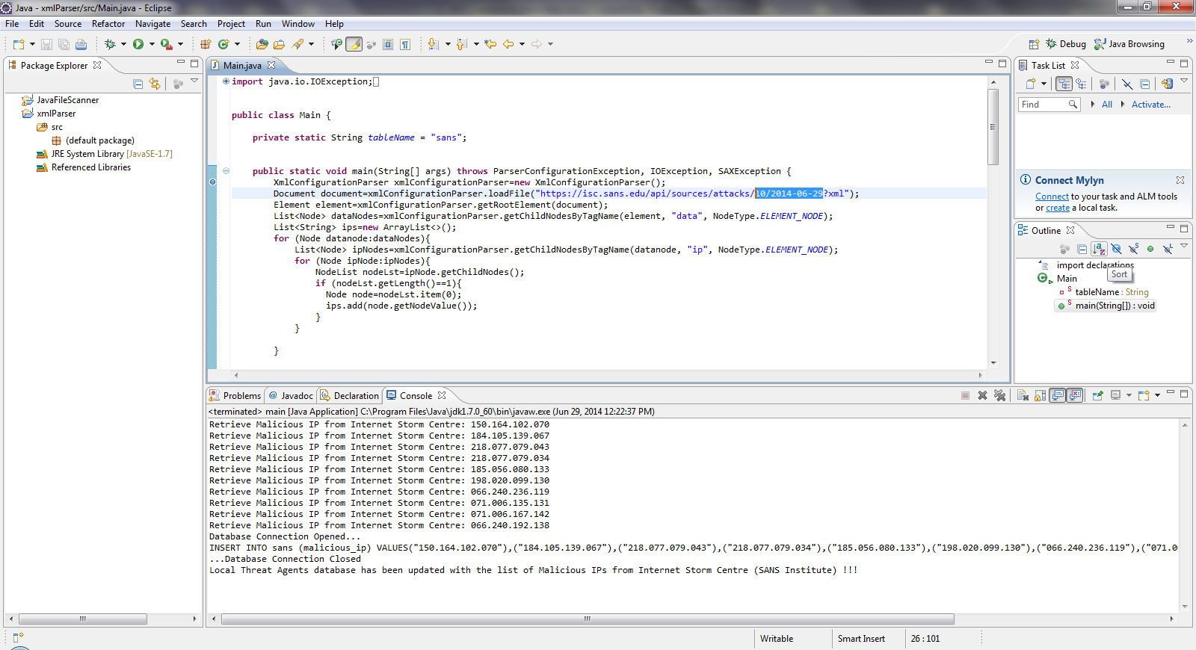

Inspect the newly inserted records of the “sans” table for consistency with the logging messages of the Eclipse Console:

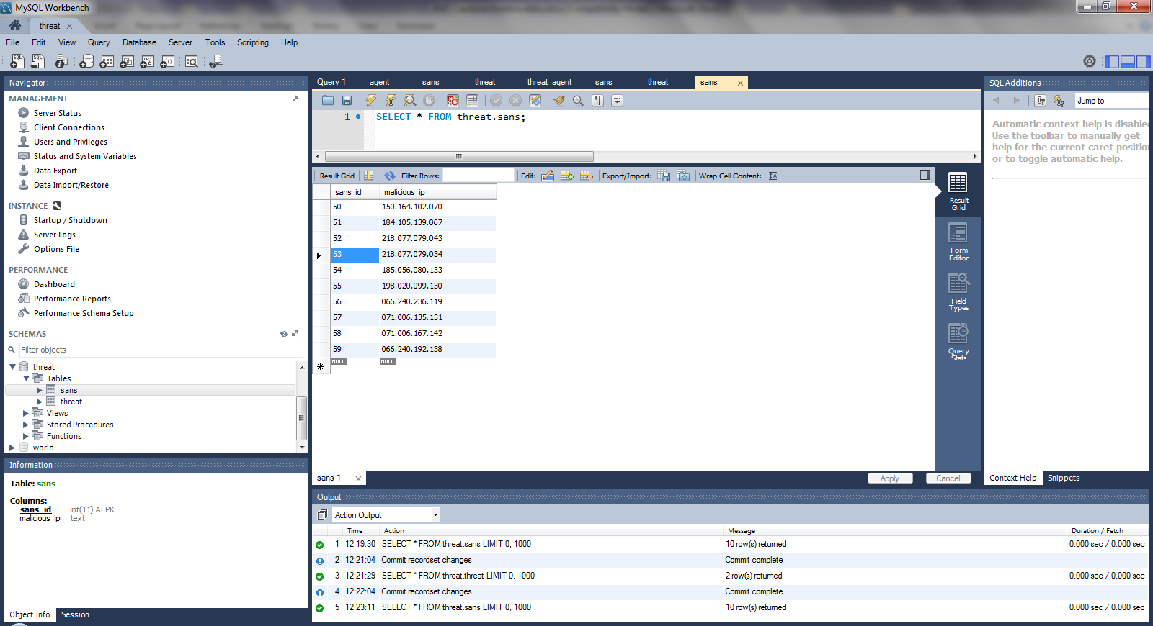

Mark one of the inserted IPs, so as to use it as the source of simulated attack at the perimeter of the network we have to protect:

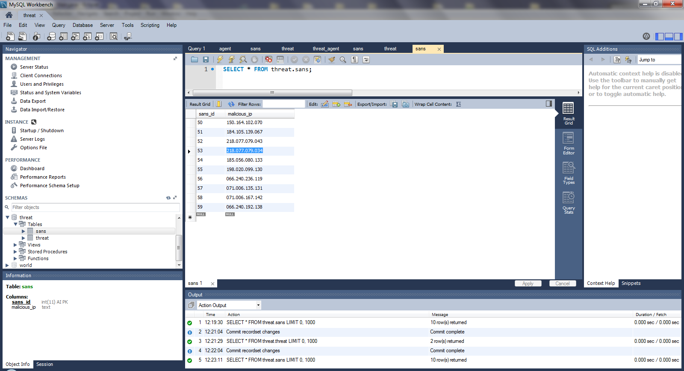

## Step 3 – Prepare the Test Data for the Simulated Attack

Replace an existing value with the aforementioned IP in the Firewall Log File as follows:

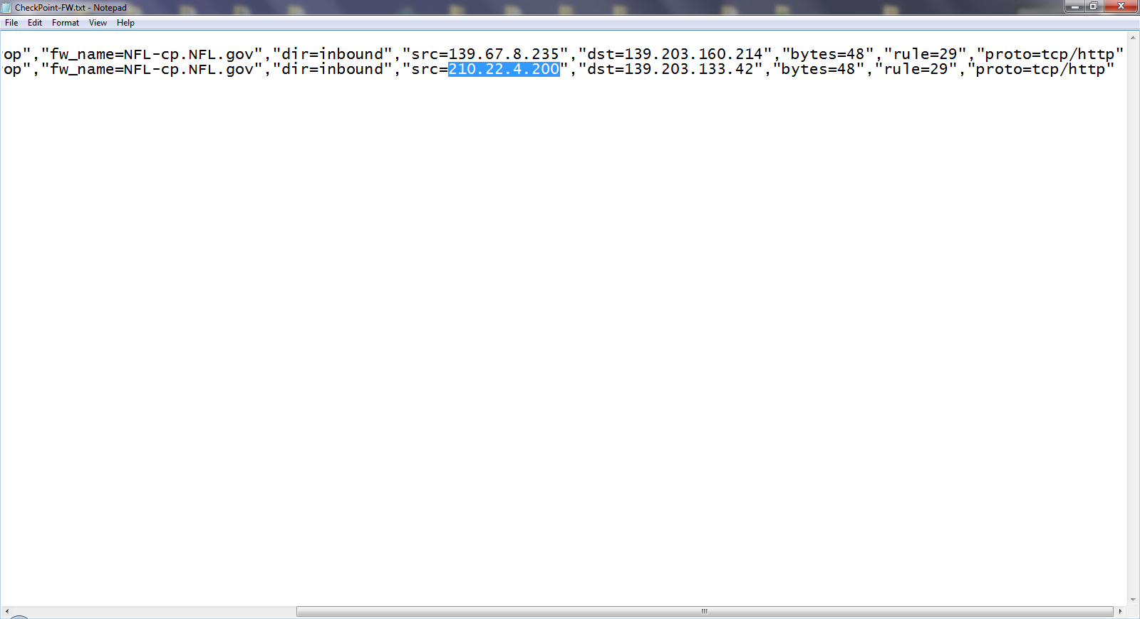

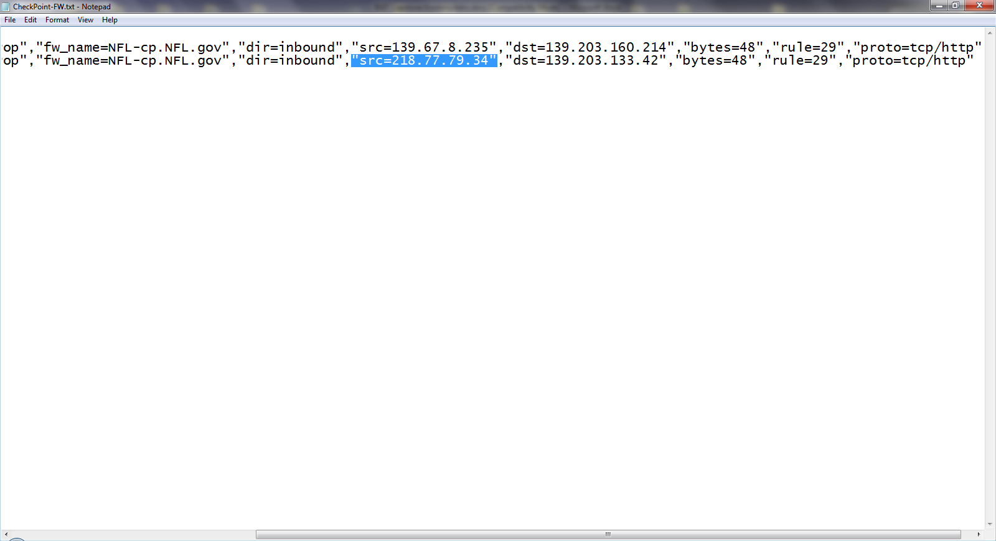

Now save changes:

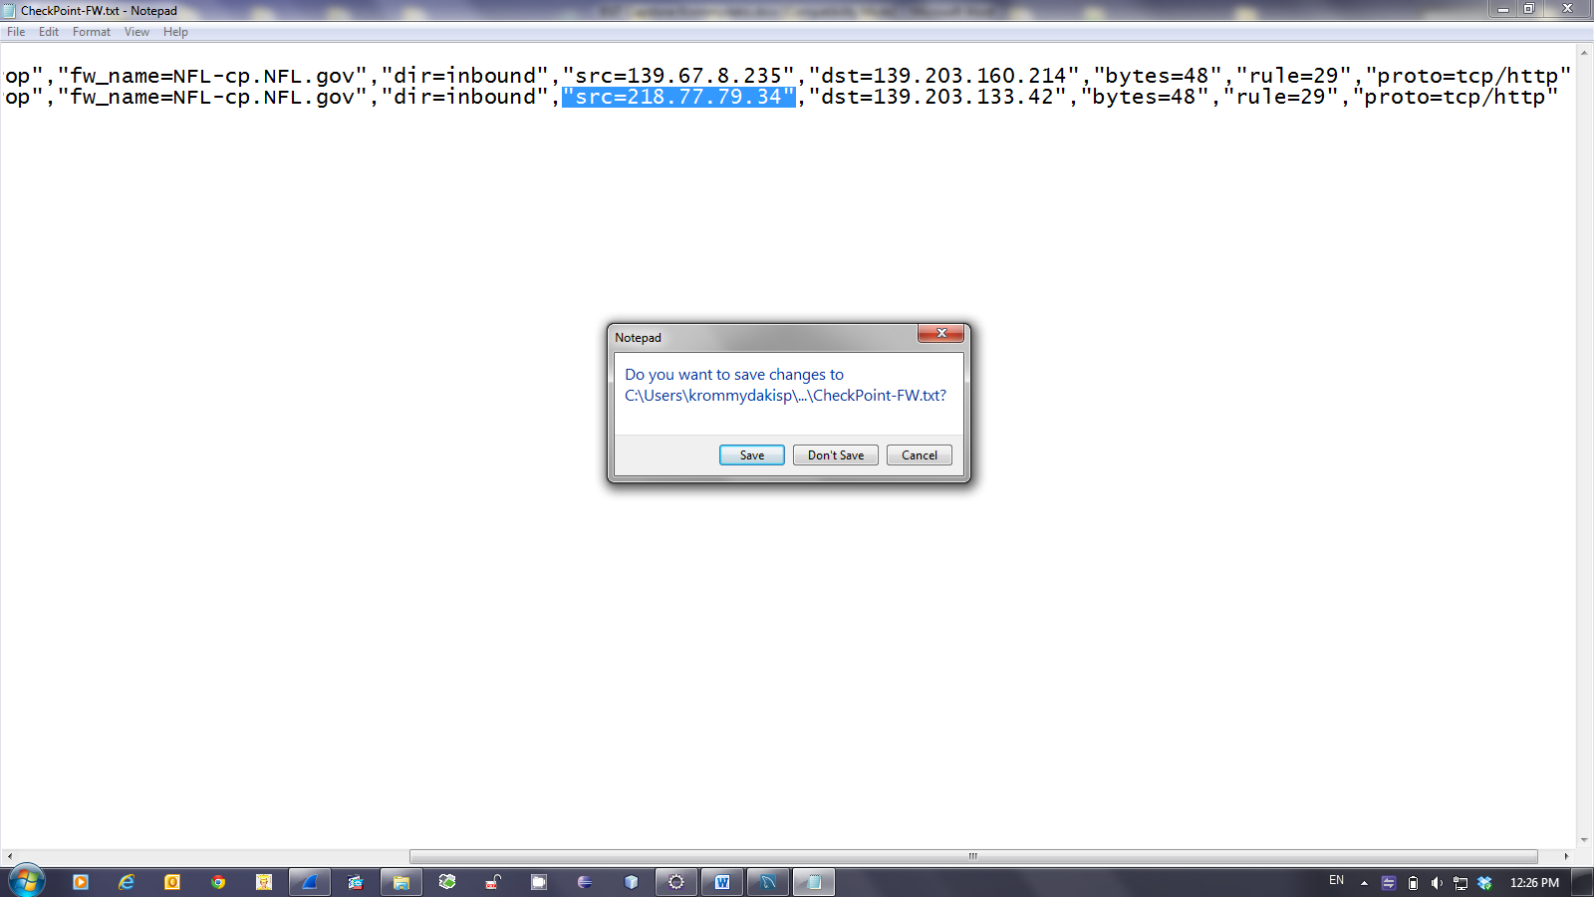

## Step 4 – Parse the Firewall Log and Search for Well-Known Threats

“Open” and “Run” the “JavaFileScanner” project in Eclipse. Verify, through the Eclipse Console, that an IP has been matched between the contents of the firewall log file and the records of the “sans” table in the “threat” database:

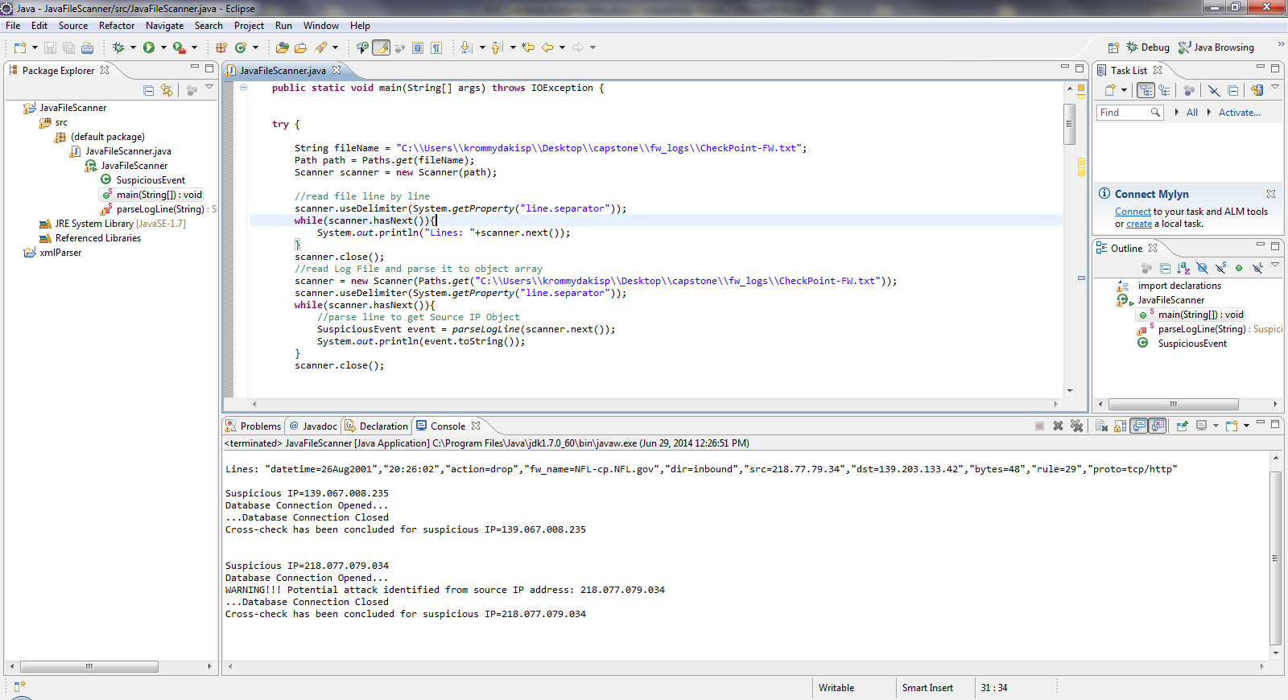

Using the MySQL Workbench, verify that contents of the “threat” table have been updated accordingly:

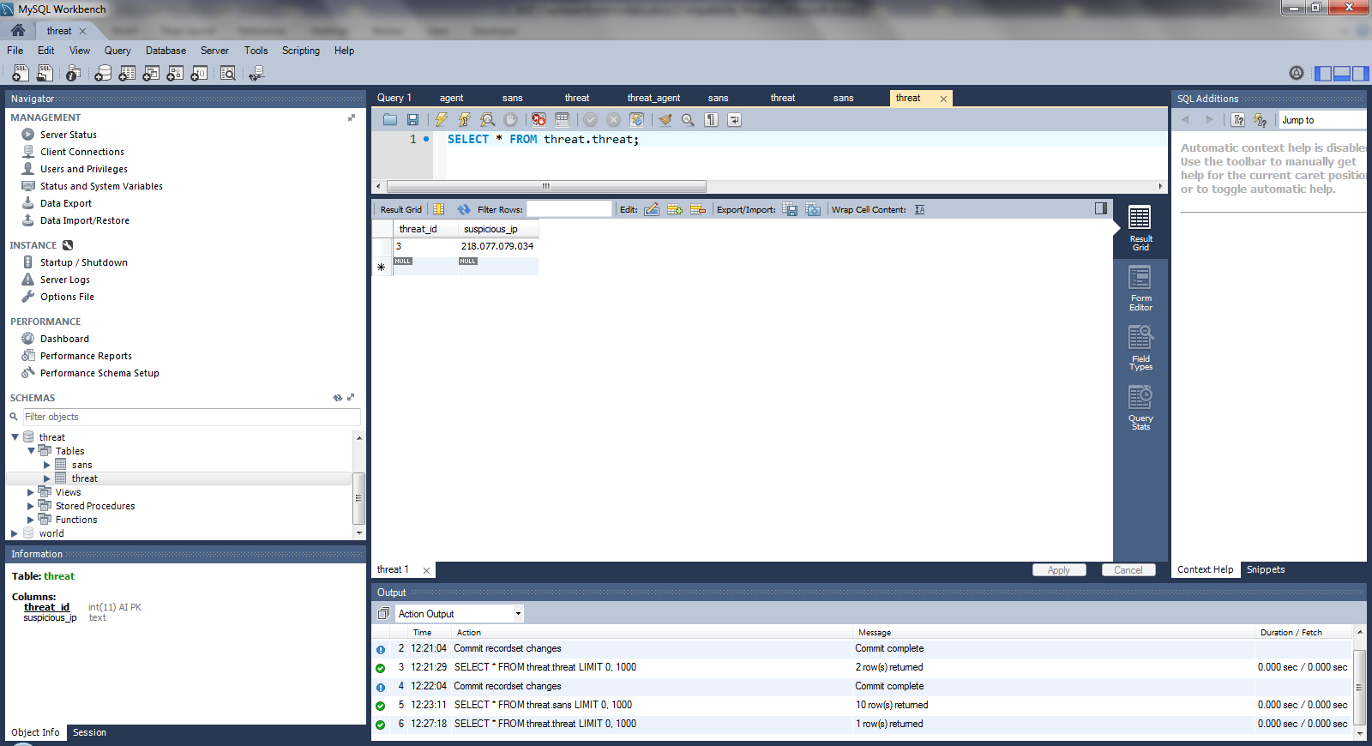

## Step 5 – Publish the Information regarding the Identified Attacks

In NetBeans, right click on the “MySQLService” project and select “Test RESTFUL Web Services”:

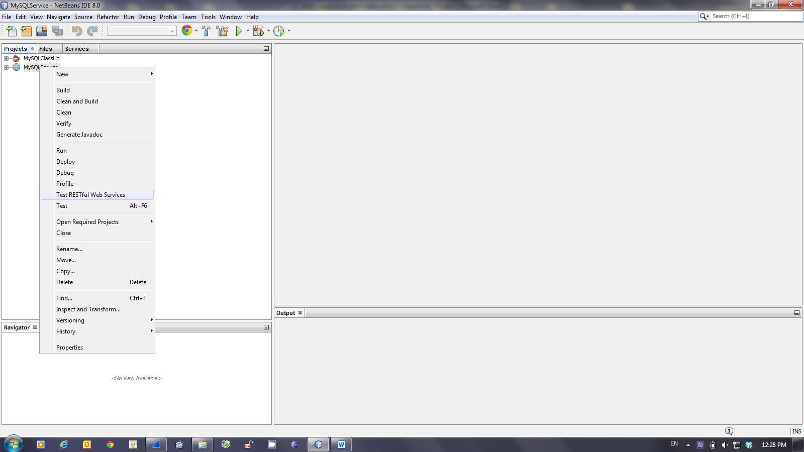

The “Web Test Client in Project” has been properly configured during implementation. Therefore just push the “OK” button:

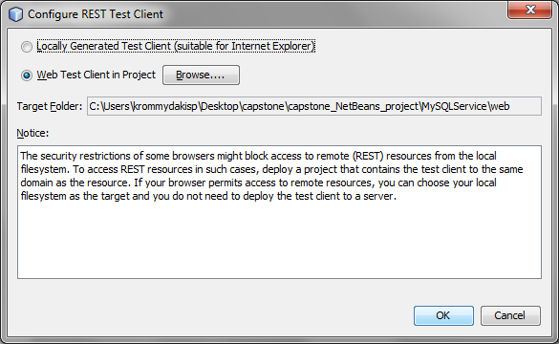

The default Web browser will be automatically opened on the Restful Web Services testing page:

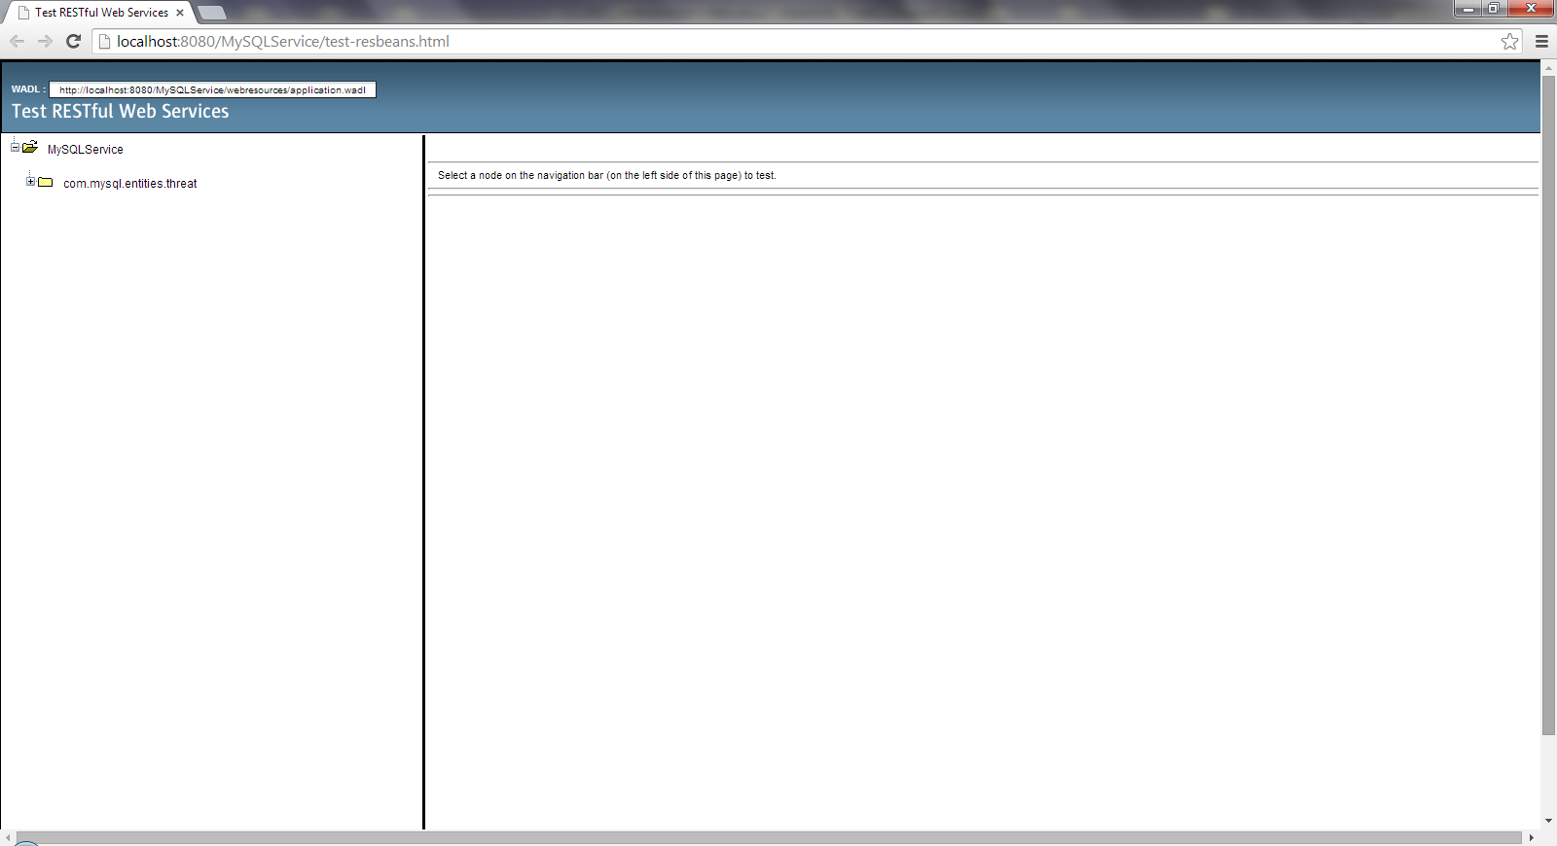

Select the available web service on the left banner on the web page:

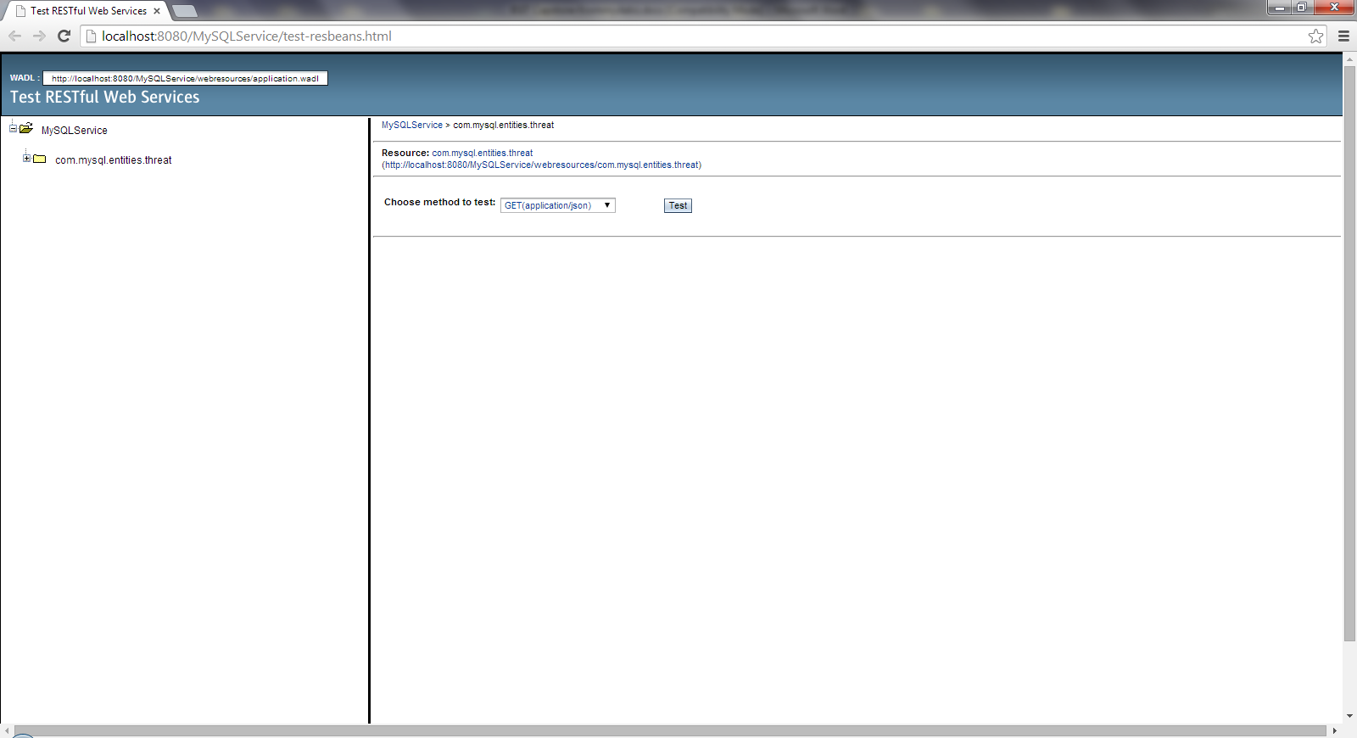

Choose “GET(application/json)” as the method to test and proceed. The contents of “threat” table have been already published as depicted in the following screenshot:

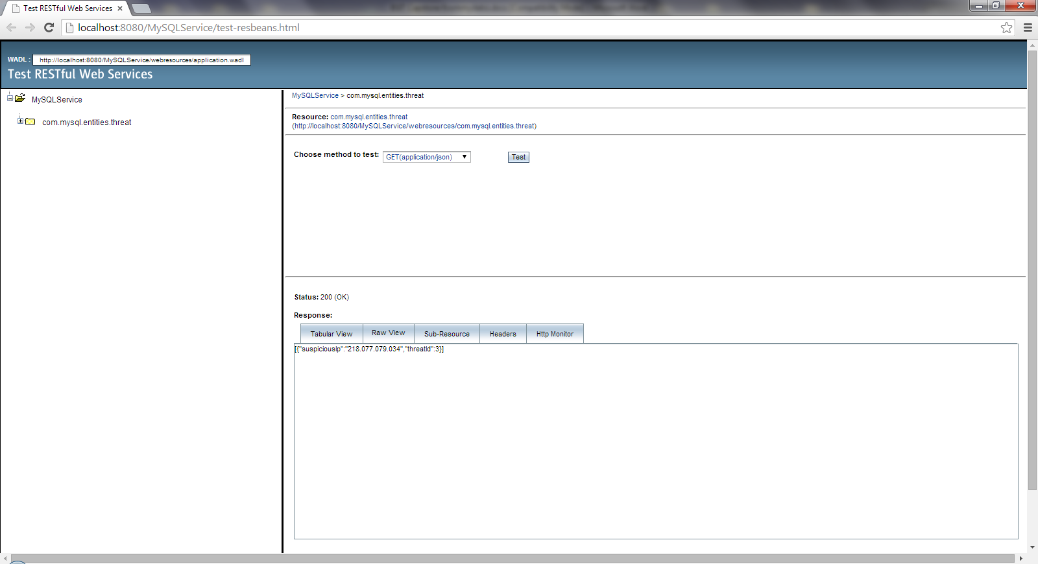

## Step 6 – Run the iOS “Attack Monitor” App

“Open” the “Attack Monitor” RestKit project on XCode:

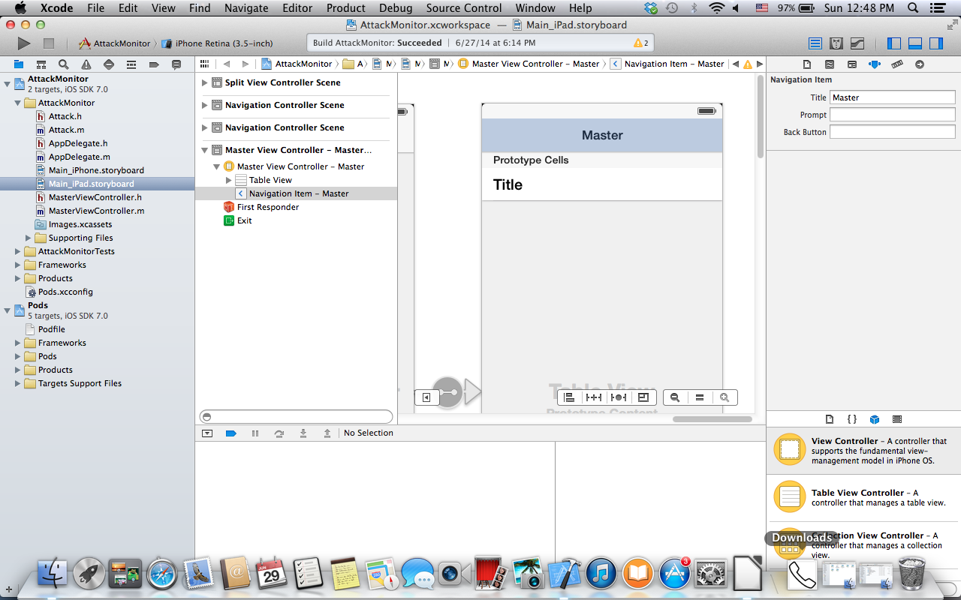

Check the IP address of the Restful Web Service from the previous step:

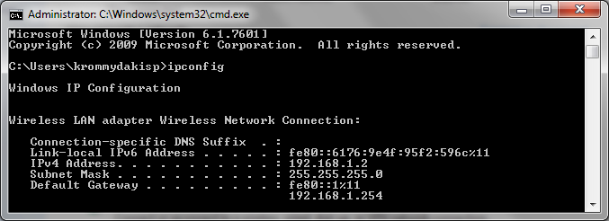

Correct the respective IP address on the given URL inside “MasterViewController.m” source file and “Run” the project (auto-build is enabled by default in XCode):

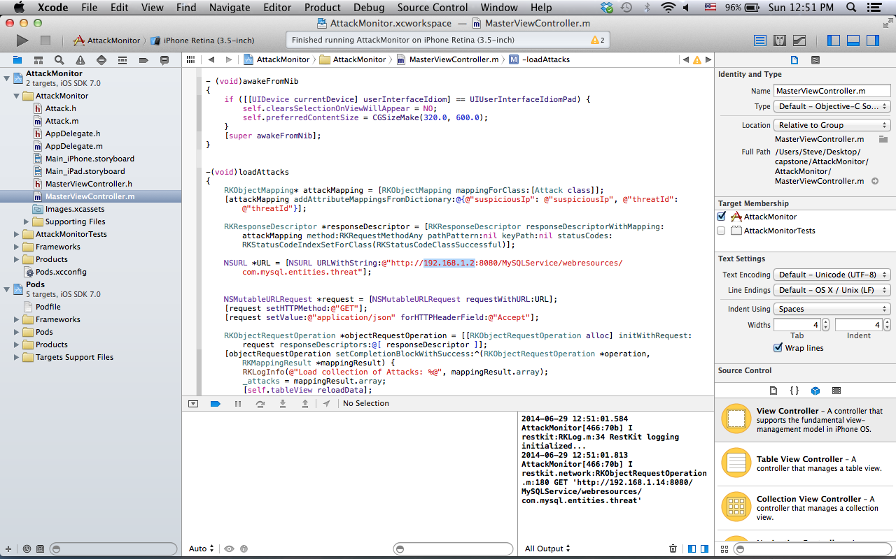

Open Wireshark in order to sniff the exchanged messages:

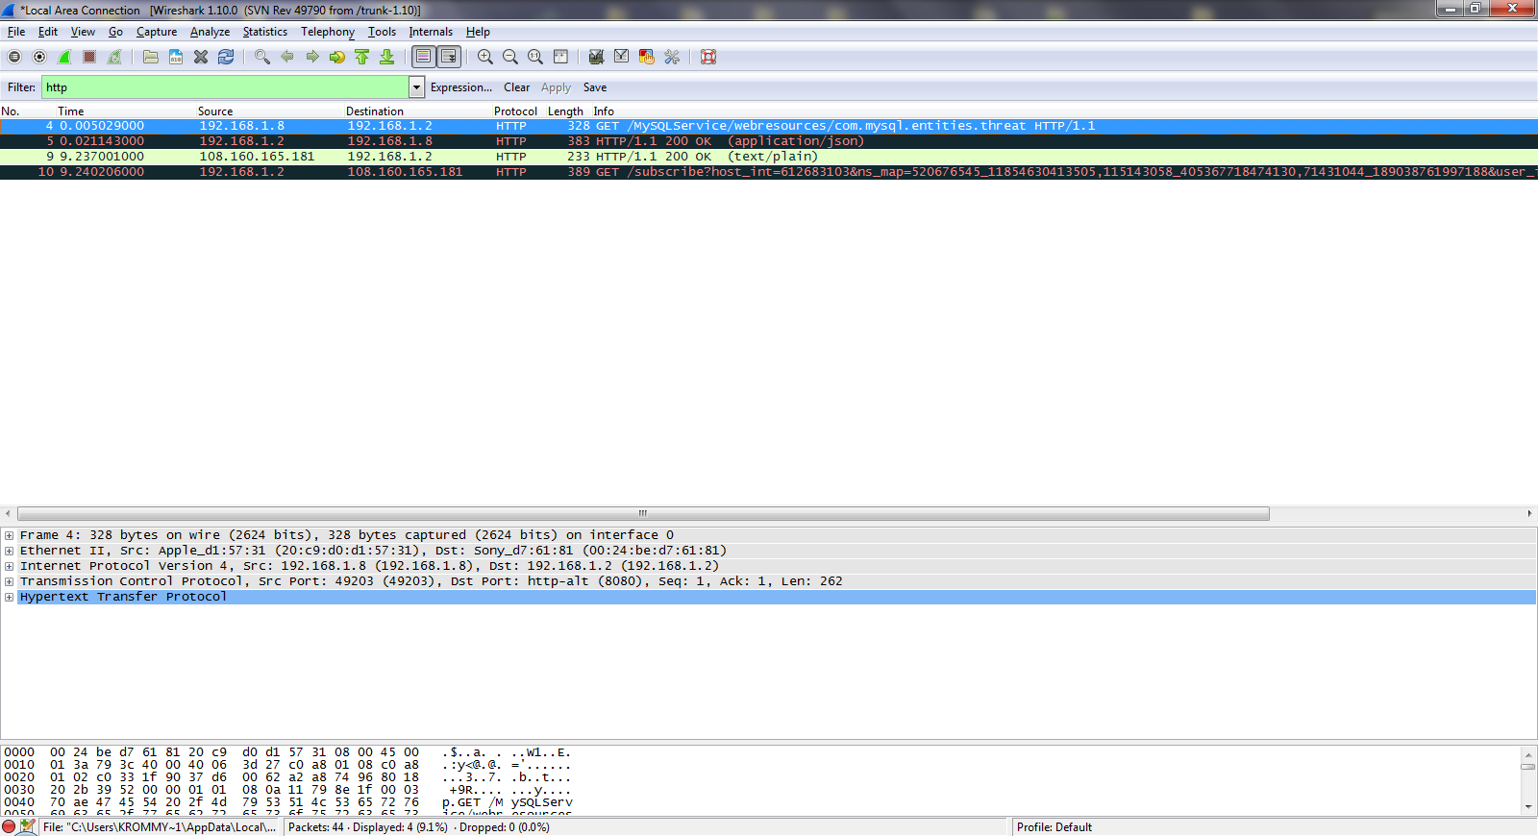

Inspect the HTTP headers of the GET request:

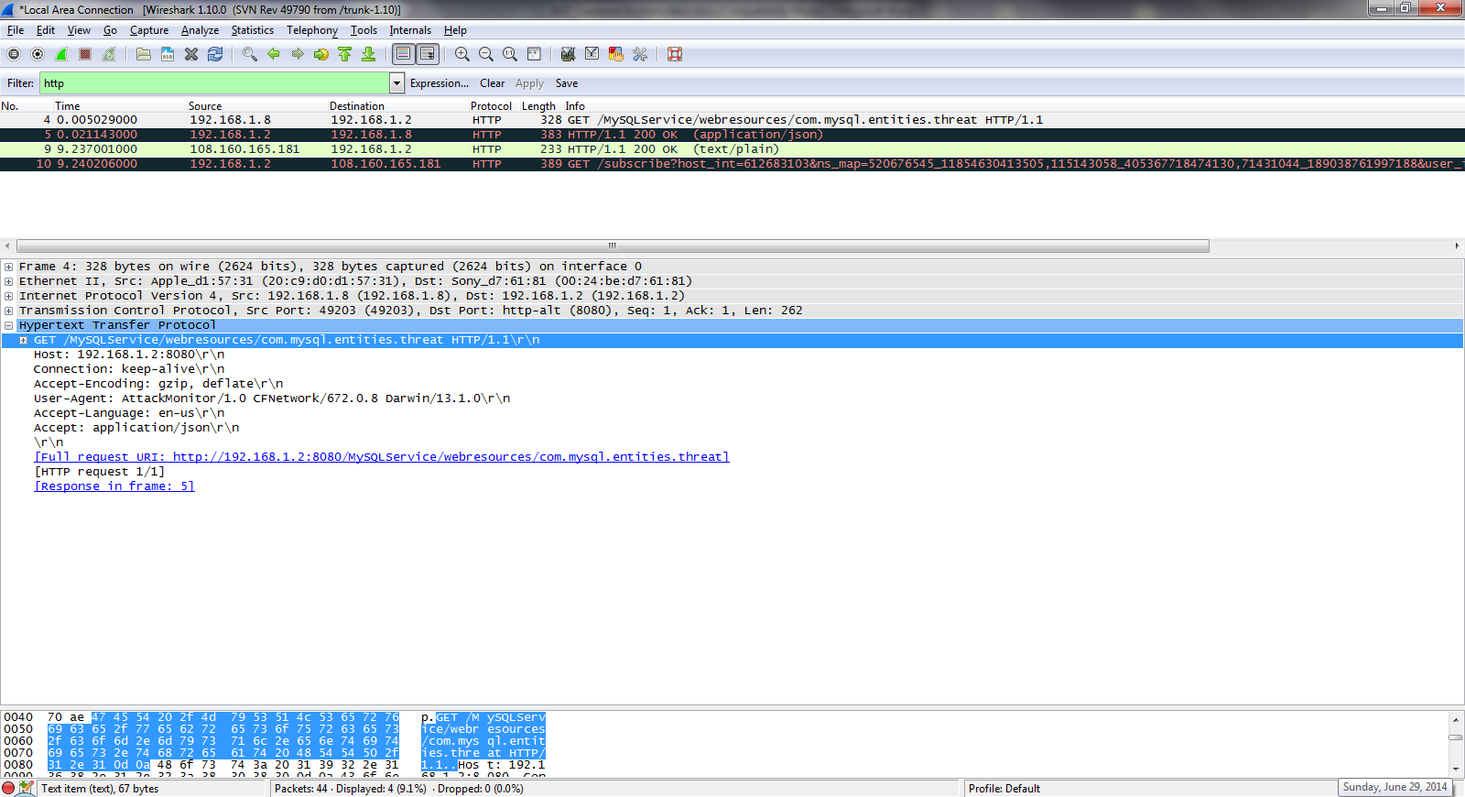

Verify that Glashfish application server response is 200 OK and that includes the expected JSON contents:

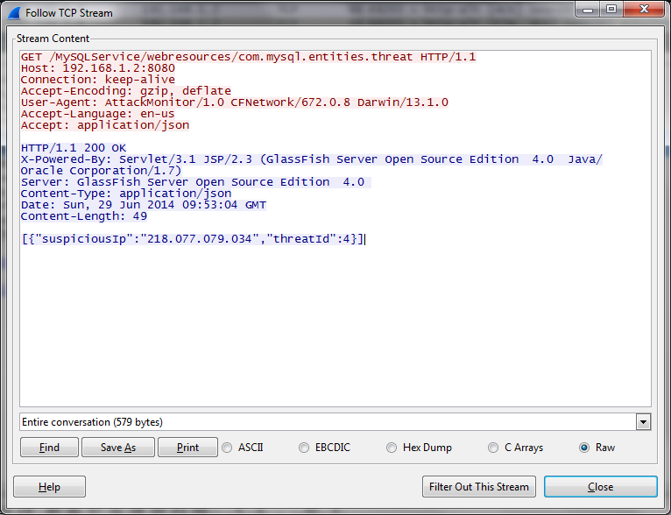

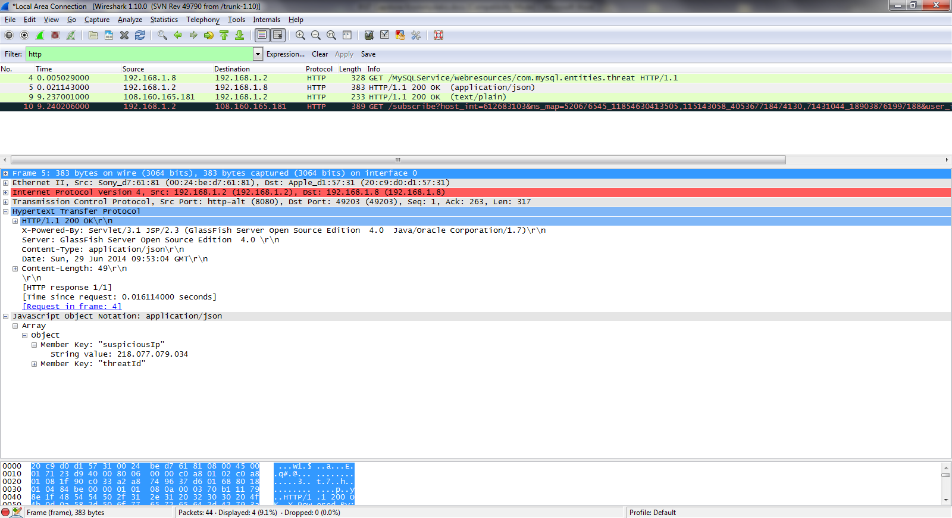

Finally, the iOS simulator is automatically opened and should display the IPs retrieved from JSON:

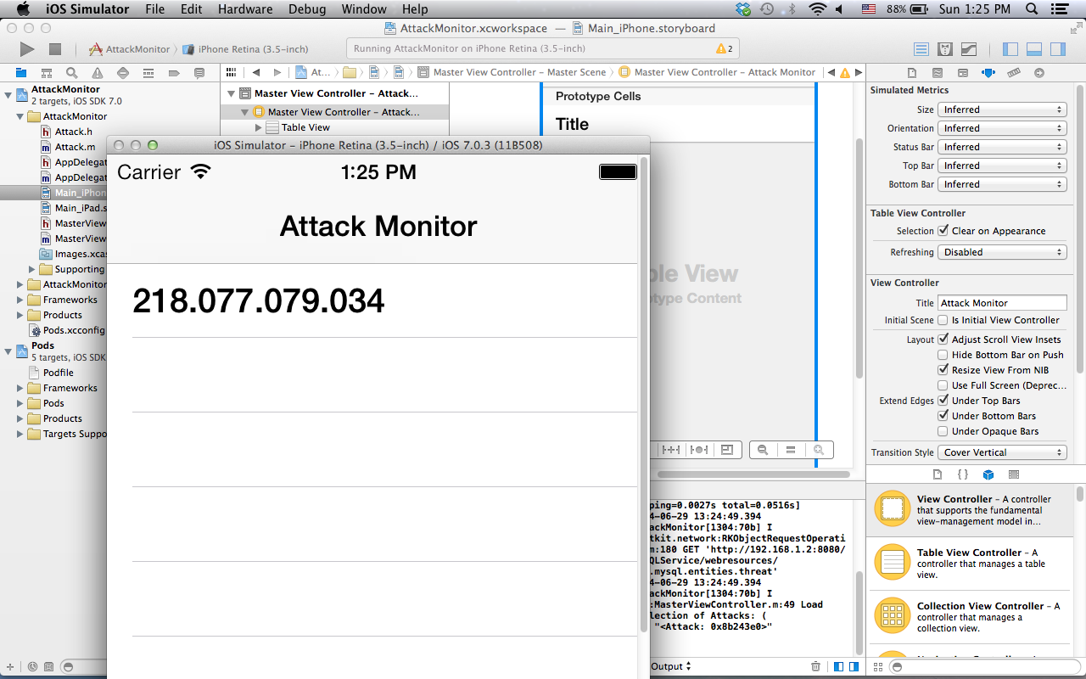

Figure 25: The Attack Monitor IOs App

## POC Evaluation

The list of User Requirements that has been verified through the proof of concept is depicted in the table below:

|  |  |  |  |  |
| --- | --- | --- | --- | --- |
| No | Requirement ID | Description | Priority | Implemented in the POC? |
| 1 | AM-UR-01 | Solution shall Use Open Source and License Free Technologies | High |  |
| 2 | AM-UR-02 | Solution shall Use Publicly Available Information from Trusted Sources | High |  |
| 3 | AM-UR-03 | Solution shall introduce Intelligence on External Attacks Identification | High |  |
| 4 | AM-UR-04 | Solution shall Identify External Attacks in a Timely Fashion | High |  |
| 5 | AM-UR-05 | External Attacks shall be displayed on Smart Devices | Low |  |
| 6 | AM-UR-06 | Solution shall alert the End Users in case of External Attacks | Medium |  |
| 7 | AM-UR-07 | Solution shall be based on Cutting-Edge Web Technologies | Medium |  |
| 8 | AM-UR-08 | Solution operation shall be fully automated | Medium |  |
| 9 | AM-UR-09 | Solution shall be Reliable | High |  |
| 10 | AM-UR-10 | Solution shall be Modular | Medium |  |
| 11 | AM-UR-11 | Solution shall be Scalable | Low |  |
| 12 | AM-UR-12 | Solution shall be Secure | High |  |
| 13 | AM-UR-13 | Solution shall be User Friendly | Low |  |
| 14 | AM-UR-14 | Solution shall support Regulatory Compliance | High |  |

Table 7: User Requirements implemented in the POC

In author’s opinion the POC has verified the concept as it has been proved that automatic detection of external attacks against the perimeter of SME’s is possible. Actual value of the proposed solution relies heavily on how reliable and sophisticated the detection mechanism is and how fast the system related actors are notified in case of an attack. Regarding the first factor, POC is able to identify DoS and DDos attacks as well as already established and/or attempts to establish “direct channels”, because analysis is based on the source IP address. To that end and as a feature that has been overlooked up to now, Security Officers will be also alerted by the Attack Monitor in case one of the SME’s network components of the DMZ (i.e. servers having public IP address) has been included in a malicious IPs lists (botnet scenario). As far as the second factor is concerned, it is absolutely necessary to update the JSON contents as soon as the related table on the database is updated. In addition the Security Officers should get a notification on their smart device as soon as JSON contents have changed.

# Future Work

Only limited functionality (by means of POC) has been implemented in the context of this capstone. However, guidelines for the following iterations have been presented in the previous chapters. It is recommended to follow the following approach in future implementations:

1. Take advantage of various, and not only a sole one, published lists of malicious IPs. This control will significantly increase both reliability and effectiveness of the Attack Monitor.
2. Take into account, on the detection mechanism implementation the number of occurrences - in the firewall log file - for a given source IP to increase system effectiveness.
3. Pay special attention on protocols and ports that are widely used in case of attacks to increase system effectiveness.
4. Crosscheck also the destination IP address, against the public lists of malicious IPs, in order to identify already configured “reverse channels” attacks with a view to increase system effectiveness
5. Evolve the system reporting functionality so as to fulfil ISO/IEC 27k requirements (regulatory compliance) as far as record with respect to network access controls and incident management are concerned.

# Conclusion

The governing principle behind ISMS, according to ISO/IEC 27000, is that an organization should design, implement and maintain a coherent set of policies, processes and systems to manage risks to its information assets, thus ensuring acceptable levels of information security risk. Moreover, ISMS operational status shall be verifiable in case of internal and external audits by the respective records to achieve regulatory compliance. As with all management processes, an ISMS must remain effective and efficient in the long term, adapting to changes in the internal organization and external environment. Attack Monitor can be a valuable tool on the hands of the Security Officers in the attempt to achieve regulatory compliance.

#### Appendix I – Additional Public Lists of Malicious IPs

Several organizations maintain and publish blacklists of IP addresses and URLs of systems and networks suspected in malicious activities on the internet. Many of these lists are available for free while some have usage restrictions and may require registration and/or subscription as mentioned on <http://zeltser.com/combating-malicious-software/malicious-ip-blocklists.html>:

* [ATLAS from Arbor Networks](https://atlas.arbor.net/): Free; registration required by contacting Arbor
* [CLEAN-MX Realtime Database](http://support.clean-mx.de/clean-mx/viruses): Free; XML output available
* [CYMRU Bogon List](http://www.cymru.com/Documents/bogon-dd.html): Free
* [DShield Blocklist](http://www.dshield.org/ipsascii.html): Free
* [DShield Highly Predictive Blacklist](http://www.dshield.org/hpbinfo.html): Free; registration required
* [EmergingThreats Lists](http://www.emergingthreats.net/index.php/rules-mainmenu-38.html): Free; includes Known Compromised Host List and Control Server Rules
* [Google Safe Browsing API](http://code.google.com/apis/safebrowsing/): Free; programmatic access; restrictions apply
* [hpHosts File](http://hosts-file.net/): Free; limited automation on request
* [Malc0de Database](http://malc0de.com/database/): Free
* [Malware Domain Blocklist](http://www.malwaredomains.com/wordpress/?page_id=66): Free for non-commercial use
* [Malware-Control Blacklist](http://www.malware-control.com/): Commercial service; free licensing options available
* [Malwared](http://malwared.ru/database.php?page=1): Free
* [MalwareDomainList.com Hosts List](http://www.malwaredomainlist.com/hostslist/hosts.txt): Free
* [Malware Patrol's Malware Block Lists](http://www.malware.com.br/lists.shtml): Free for non-commercial use
* [MalwareURL List](http://www.malwareurl.com/): Commercial service; free licensing options may be available
* [Nictatech](http://zeltser.com/): Free
* [ParetoLogic URL Clearing House](http://mdl.paretologic.com/): Free for non-commerical use; registration required
* [PhishTank Phish Archive](http://www.phishtank.com/phish_archive.php): Free; query database via API
* [Project Honey Pot's Directory of Malicious IPs](http://www.projecthoneypot.org/list_of_ips.php): Free; registration required to view more than 25 IPs
* [Scumware.org](http://www.scumware.org/): Free
* [Shadowserver IP and URL Reports](http://www.shadowserver.org/wiki/pmwiki.php?n=Services/Reports): Free; registration and approval required
* [Sourcefire Vulnerability Research](http://labs.snort.org/iplists/): Free
* [SpyEye Tracker URLs](https://spyeyetracker.abuse.ch/monitor.php?browse=binaries): Free
* [SRI Threat Intelligence Lists](http://mtc.sri.com/): Free; re-distribution prohibited
* [Sucuri Blacklists](http://sucuri.net/?page=tools&title=blacklist): Free; blacklists of sites hosting malware and of IPs scanning networks
* [ThreatStop](http://www.threatstop.com/): Paid; free trial available
* [URL Blacklist](http://urlblacklist.com/): Paid; first download free
* [ZeuS Tracker Blocklist](https://zeustracker.abuse.ch/blocklist.php) and [URLs](https://zeustracker.abuse.ch/monitor.php?browse=binaries): Free
* [BLADE Malicious URL Analysis](http://www.blade-defender.org/eval-lab/): A free auto-generated list of URLs recently identified as malicious

#### Appendix II – Sample Firewall Log Files

Checkpoint Log File format follows the scheme "Date","Time","Action","FW.Name","Direction","Source","Destination","Bytes","Rules","Protocol":

**"datetime=26Aug2001","20:26:02","action=drop","fw_name=NFL-cp.NFL.gov","dir=inbound","src=139.67.8.235","dst=139.203.160.214","bytes=48","rule=29","proto=tcp/http"**

**"datetime=26Aug2001","20:26:02","action=drop","fw_name=NFL-cp.NFL.gov","dir=inbound","src=210.22.4.200","dst=139.203.133.42","bytes=48","rule=29","proto=tcp/http"**

**"datetime=26Aug2001","20:26:02","action=drop","fw_name=NFL-cp.NFL.gov","dir=inbound","src=200.211.147.23","dst=139.203.18.177","bytes=48","rule=29","proto=tcp/http"**

**"datetime=26Aug2001","20:26:02","action=drop","fw_name=NFL-cp.NFL.gov","dir=inbound","src=139.184.77.8","dst=139.203.141.128","bytes=48","rule=29","proto=tcp/http"**

**"datetime=26Aug2001","20:26:02","action=drop","fw_name=NFL-cp.NFL.gov","dir=inbound","src=61.129.122.129","dst=139.203.250.160","bytes=64","rule=29","proto=tcp/http"**

**"datetime=26Aug2001","20:26:02","action=drop","fw_name=NFL-cp.NFL.gov","dir=inbound","src=61.142.57.208","dst=139.203.67.133","bytes=48","rule=29","proto=tcp/http"**

**"datetime=26Aug2001","20:26:02","action=drop","fw_name=NFL-cp.NFL.gov","dir=inbound","src=206.247.102.9","dst=139.203.111.23","bytes=48","rule=29","proto=tcp/http"**

**"datetime=26Aug2001","20:26:02","action=drop","fw_name=NFL-cp.NFL.gov","dir=inbound","src=211.75.239.157","dst=139.203.152.208","bytes=48","rule=29","proto=tcp/http"**

**"datetime=26Aug2001","20:26:02","action=drop","fw_name=NFL-cp.NFL.gov","dir=inbound","src=209.165.171.246","dst=139.203.73.178","bytes=48","rule=29","proto=tcp/http"**

**"datetime=26Aug2001","20:26:02","action=drop","fw_name=NFL-cp.NFL.gov","dir=inbound","src=64.70.1.57","dst=139.203.241.128","bytes=48","rule=29","proto=tcp/http"**

**"datetime=26Aug2001","20:26:03","action=drop","fw_name=NFL-cp.NFL.gov","dir=inbound","src=61.138.33.102","dst=139.203.13.45","bytes=48","rule=29","proto=tcp/http"**

**"datetime=26Aug2001","20:26:03","action=drop","fw_name=NFL-cp.NFL.gov","dir=inbound","src=139.142.143.60","dst=139.203.131.222","bytes=48","rule=29","proto=tcp/http"**

**"datetime=26Aug2001","20:26:03","action=drop","fw_name=NFL-cp.NFL.gov","dir=inbound","src=139.184.155.183","dst=139.203.143.53","bytes=48","rule=29","proto=tcp/http"**

**"datetime=26Aug2001","20:26:03","action=drop","fw_name=NFL-cp.NFL.gov","dir=inbound","src=139.44.116.240","dst=139.203.241.7","bytes=48","rule=29","proto=tcp/http"**

**"datetime=26Aug2001","20:26:03","action=drop","fw_name=NFL-cp.NFL.gov","dir=inbound","src=61.141.206.1","dst=139.203.43.222","bytes=48","rule=29","proto=tcp/http"**

**"datetime=26Aug2001","20:26:03","action=drop","fw_name=NFL-cp.NFL.gov","dir=inbound","src=139.111.50.220","dst=139.203.31.197","bytes=48","rule=29","proto=tcp/http"**

**"datetime=26Aug2001","20:26:04","action=drop","fw_name=NFL-cp.NFL.gov","dir=inbound","src=194.244.77.147","dst=139.203.212.209","bytes=48","rule=29","proto=tcp/http"**

**"datetime=26Aug2001","20:26:04","action=drop","fw_name=NFL-cp.NFL.gov","dir=inbound","src=139.139.67.57","dst=139.203.219.68","bytes=48","rule=29","proto=tcp/http"**

**"datetime=26Aug2001","20:26:04","action=drop","fw_name=NFL-cp.NFL.gov","dir=inbound","src=139.142.136.156","dst=139.203.111.30","bytes=48","rule=29","proto=tcp/http"**

**"datetime=26Aug2001","20:26:04","action=drop","fw_name=NFL-cp.NFL.gov","dir=inbound","src=64.171.190.52","dst=139.203.15.41","bytes=48","rule=29","proto=tcp/http"**

**"datetime=26Aug2001","20:26:05","action=drop","fw_name=NFL-cp.NFL.gov","dir=inbound","src=155.230.173.173","dst=139.203.69.144","bytes=48","rule=29","proto=tcp/http"**

**"datetime=26Aug2001","20:26:05","action=drop","fw_name=NFL-cp.NFL.gov","dir=inbound","src=202.109.152.6","dst=139.203.15.106","bytes=48","rule=29","proto=tcp/http"**

**"datetime=26Aug2001","20:26:05","action=drop","fw_name=NFL-cp.NFL.gov","dir=inbound","src=63.197.11.52","dst=139.203.50.90","bytes=48","rule=29","proto=tcp/http"**

**"datetime=26Aug2001","20:26:05","action=drop","fw_name=NFL-cp.NFL.gov","dir=inbound","src=139.30.215.152","dst=139.203.18.136","bytes=48","rule=29","proto=tcp/http"**

**"datetime=26Aug2001","20:26:05","action=drop","fw_name=NFL-cp.NFL.gov","dir=inbound","src=139.53.190.31","dst=139.203.182.11","bytes=48","rule=29","proto=tcp/http"**

**"datetime=26Aug2001","20:26:05","action=drop","fw_name=NFL-cp.NFL.gov","dir=inbound","src=139.139.113.4","dst=139.203.100.71","bytes=48","rule=29","proto=tcp/http"**

**"datetime=26Aug2001","20:26:05","action=drop","fw_name=NFL-cp.NFL.gov","dir=inbound","src=170.76.19.10","dst=139.203.93.145","bytes=48","rule=29","proto=tcp/http"**

**"datetime=26Aug2001","20:26:05","action=drop","fw_name=NFL-cp.NFL.gov","dir=inbound","src=200.211.147.23","dst=139.203.163.144","bytes=48","rule=29","proto=tcp/http"**

**"datetime=26Aug2001","20:26:05","action=drop","fw_name=NFL-cp.NFL.gov","dir=inbound","src=139.67.52.12","dst=139.203.76.153","bytes=48","rule=29","proto=tcp/http"**

**"datetime=26Aug2001","20:26:05","action=drop","fw_name=NFL-cp.NFL.gov","dir=inbound","src=139.142.136.156","dst=139.203.28.153","bytes=48","rule=29","proto=tcp/http"**

**"datetime=26Aug2001","20:26:05","action=drop","fw_name=NFL-cp.NFL.gov","dir=inbound","src=203.246.131.200","dst=139.203.115.233","bytes=48","rule=29","proto=tcp/http"**

**"datetime=26Aug2001","20:26:05","action=drop","fw_name=NFL-cp.NFL.gov","dir=inbound","src=218.11.168.18","dst=139.203.126.155","bytes=48","rule=29","proto=tcp/http"**

**"datetime=26Aug2001","20:26:05","action=drop","fw_name=NFL-cp.NFL.gov","dir=inbound","src=61.132.63.11","dst=139.203.165.81","bytes=48","rule=29","proto=tcp/http"**

**"datetime=26Aug2001","20:26:05","action=accept","fw_name=NFL-cp.NFL.gov","dir=inbound","src=204.127.131.51","dst=139.203.16.1","rule=16","proto=tcp/smtp",""**

**"datetime=26Aug2001","20:26:06","action=drop","fw_name=NFL-cp.NFL.gov","dir=inbound","src=139.184.75.28","dst=139.203.108.176","bytes=48","rule=29","proto=tcp/http"**

**"datetime=26Aug2001","20:26:06","action=drop","fw_name=NFL-cp.NFL.gov","dir=inbound","src=139.67.27.107","dst=139.203.156.98","bytes=48","rule=29","proto=tcp/http"**

**"datetime=26Aug2001","20:26:06","action=drop","fw_name=NFL-cp.NFL.gov","dir=inbound","src=202.110.160.231","dst=139.203.130.65","bytes=48","rule=29","proto=tcp/http"**

**"datetime=26Aug2001","20:26:06","action=drop","fw_name=NFL-cp.NFL.gov","dir=inbound","src=139.139.113.4","dst=139.203.172.82","bytes=48","rule=29","proto=tcp/http"**

**"datetime=26Aug2001","20:26:06","action=drop","fw_name=NFL-cp.NFL.gov","dir=inbound","src=139.139.17.61","dst=139.203.104.75","bytes=48","rule=29","proto=tcp/http"**

**"datetime=26Aug2001","20:26:06","action=drop","fw_name=NFL-cp.NFL.gov","dir=inbound","src=139.252.10.51","dst=139.203.170.137","bytes=48","rule=29","proto=tcp/http"**

**"datetime=26Aug2001","20:26:06","action=drop","fw_name=NFL-cp.NFL.gov","dir=inbound","src=139.139.67.57","dst=139.203.107.120","bytes=48","rule=29","proto=tcp/http"**

**"datetime=26Aug2001","20:26:06","action=drop","fw_name=NFL-cp.NFL.gov","dir=inbound","src=139.184.35.169","dst=139.203.160.241","bytes=48","rule=29","proto=tcp/http"**

**"datetime=26Aug2001","20:26:07","action=accept","fw_name=NFL-cp.NFL.gov","dir=inbound","src=139.203.15.11","dst=209.219.149.24","bytes=60","rule=14","proto=tcp/smtp"**

**"datetime=26Aug2001","20:26:07","action=drop","fw_name=NFL-cp.NFL.gov","dir=inbound","src=167.83.96.21","dst=139.203.187.176","bytes=48","rule=29","proto=tcp/http"**

**"datetime=26Aug2001","20:26:07","action=drop","fw_name=NFL-cp.NFL.gov","dir=inbound","src=200.36.20.243","dst=139.203.97.13","bytes=48","rule=29","proto=tcp/http"**

**"datetime=26Aug2001","20:26:07","action=accept","fw_name=NFL-cp.NFL.gov","dir=inbound","src=204.127.131.51","dst=139.203.15.2","rule=16","proto=tcp/smtp",""**

**"datetime=26Aug2001","20:26:07","action=drop","fw_name=NFL-cp.NFL.gov","dir=inbound","src=139.139.67.59","dst=139.203.54.84","bytes=48","rule=29","proto=tcp/http"**

**"datetime=26Aug2001","20:26:07","action=drop","fw_name=NFL-cp.NFL.gov","dir=inbound","src=139.67.84.50","dst=139.203.247.214","bytes=48","rule=29","proto=tcp/http"**

**"datetime=26Aug2001","20:26:08","action=drop","fw_name=NFL-cp.NFL.gov","dir=inbound","src=203.65.234.8","dst=139.203.176.26","bytes=48","rule=29","proto=tcp/http"**

**"datetime=26Aug2001","20:26:08","action=drop","fw_name=NFL-cp.NFL.gov","dir=inbound","src=139.97.139.94","dst=139.203.100.202","bytes=48","rule=29","proto=tcp/http"**

**"datetime=26Aug2001","20:26:08","action=drop","fw_name=NFL-cp.NFL.gov","dir=inbound","src=139.184.47.103","dst=139.203.193.78","bytes=48","rule=29","proto=tcp/http"**

**"datetime=26Aug2001","20:26:08","action=drop","fw_name=NFL-cp.NFL.gov","dir=inbound","src=200.211.147.23","dst=139.203.88.26","bytes=48","rule=29","proto=tcp/http"**

**"datetime=26Aug2001","20:26:09","action=drop","fw_name=NFL-cp.NFL.gov","dir=inbound","src=12.109.200.2","dst=139.203.14.209","bytes=48","rule=29","proto=tcp/http"**

**"datetime=26Aug2001","20:26:09","action=reject","fw_name=NFL-cp.NFL.gov","dir=inbound","src=216.120.117.22","dst=139.203.15.2","rule=15","proto=tcp/smtp",""**

**"datetime=26Aug2001","20:26:09","action=reject","fw_name=NFL-cp.NFL.gov","dir=inbound","src=216.120.117.22","dst=139.203.15.2","rule=15","proto=tcp/smtp",""**

**"datetime=26Aug2001","20:26:09","action=reject","fw_name=NFL-cp.NFL.gov","dir=inbound","src=216.120.117.22","dst=139.203.15.2","rule=15","proto=tcp/smtp",""**

**"datetime=26Aug2001","20:26:09","action=drop","fw_name=NFL-cp.NFL.gov","dir=inbound","src=202.103.201.45","dst=139.203.215.250","bytes=48","rule=29","proto=tcp/http"**

**"datetime=26Aug2001","20:26:09","action=drop","fw_name=NFL-cp.NFL.gov","dir=inbound","src=139.184.139.57","dst=139.203.42.50","bytes=48","rule=29","proto=tcp/http"**

**"datetime=26Aug2001","20:26:09","action=drop","fw_name=NFL-cp.NFL.gov","dir=inbound","src=139.184.139.57","dst=139.203.135.62","bytes=48","rule=29","proto=tcp/http"**

**"datetime=26Aug2001","20:26:09","action=drop","fw_name=NFL-cp.NFL.gov","dir=inbound","src=63.142.92.2","dst=139.203.15.12","bytes=48","rule=29","proto=tcp/http"**

**"datetime=26Aug2001","20:26:09","action=drop","fw_name=NFL-cp.NFL.gov","dir=inbound","src=61.168.8.78","dst=139.203.109.218","bytes=48","rule=29","proto=tcp/http"**

**"datetime=26Aug2001","20:26:09","action=drop","fw_name=NFL-cp.NFL.gov","dir=inbound","src=139.139.39.239","dst=139.203.117.7","bytes=48","rule=29","proto=tcp/http"**

**"datetime=26Aug2001","20:26:09","action=drop","fw_name=NFL-cp.NFL.gov","dir=inbound","src=139.142.136.156","dst=139.203.193.40","bytes=48","rule=29","proto=tcp/http"**

**"datetime=26Aug2001","20:26:09","action=drop","fw_name=NFL-cp.NFL.gov","dir=inbound","src=139.252.2.5","dst=139.203.173.162","bytes=48","rule=29","proto=tcp/http"**

**"datetime=26Aug2001","20:26:10","action=drop","fw_name=NFL-cp.NFL.gov","dir=inbound","src=139.53.190.31","dst=139.203.69.82","bytes=48","rule=29","proto=tcp/http"**

**"datetime=26Aug2001","20:26:10","action=accept","fw_name=NFL-cp.NFL.gov","dir=inbound","src=172.141.105.78","dst=139.203.15.15","bytes=44","rule=5","proto=tcp/https"**

**"datetime=26Aug2001","20:26:10","action=drop","fw_name=NFL-cp.NFL.gov","dir=inbound","src=155.212.139.51","dst=139.203.244.161","bytes=48","rule=29","proto=tcp/http"**

**"datetime=26Aug2001","20:26:10","action=drop","fw_name=NFL-cp.NFL.gov","dir=inbound","src=139.196.252.173","dst=139.203.125.108","bytes=48","rule=29","proto=tcp/http"**

**"datetime=26Aug2001","20:26:10","action=drop","fw_name=NFL-cp.NFL.gov","dir=inbound","src=139.139.39.239","dst=139.203.68.152","bytes=48","rule=29","proto=tcp/http"**

**"datetime=26Aug2001","20:26:10","action=drop","fw_name=NFL-cp.NFL.gov","dir=inbound","src=211.192.91.195","dst=139.203.74.225","bytes=64","rule=29","proto=tcp/http"**

**"datetime=26Aug2001","20:26:10","action=drop","fw_name=NFL-cp.NFL.gov","dir=inbound","src=139.139.113.4","dst=139.203.174.155","bytes=48","rule=29","proto=tcp/http"**

**"datetime=26Aug2001","20:26:10","action=drop","fw_name=NFL-cp.NFL.gov","dir=inbound","src=139.67.26.51","dst=139.203.151.172","bytes=48","rule=29","proto=tcp/http"**

**"datetime=26Aug2001","20:26:11","action=drop","fw_name=NFL-cp.NFL.gov","dir=inbound","src=202.97.38.2","dst=139.203.63.176","bytes=48","rule=29","proto=tcp/http"**

**"datetime=26Aug2001","20:26:11","action=drop","fw_name=NFL-cp.NFL.gov","dir=inbound","src=61.179.190.68","dst=139.203.81.251","bytes=48","rule=29","proto=tcp/http"**

**"datetime=26Aug2001","20:26:11","action=drop","fw_name=NFL-cp.NFL.gov","dir=inbound","src=211.21.196.44","dst=139.203.215.51","bytes=48","rule=29","proto=tcp/http"**

**"datetime=26Aug2001","20:26:11","action=drop","fw_name=NFL-cp.NFL.gov","dir=inbound","src=139.44.116.240","dst=139.203.29.165","bytes=48","rule=29","proto=tcp/http"**

**"datetime=26Aug2001","20:26:11","action=drop","fw_name=NFL-cp.NFL.gov","dir=inbound","src=139.139.39.239","dst=139.203.225.12","bytes=48","rule=29","proto=tcp/http"**

**"datetime=26Aug2001","20:26:11","action=drop","fw_name=NFL-cp.NFL.gov","dir=inbound","src=139.184.77.8","dst=139.203.158.150","bytes=48","rule=29","proto=tcp/http"**

**"datetime=26Aug2001","20:26:11","action=drop","fw_name=NFL-cp.NFL.gov","dir=inbound","src=139.139.69.27","dst=139.203.195.186","bytes=48","rule=29","proto=tcp/http"**

**"datetime=26Aug2001","20:26:11","action=drop","fw_name=NFL-cp.NFL.gov","dir=inbound","src=139.139.127.63","dst=139.203.59.40","bytes=48","rule=29","proto=tcp/http"**

**"datetime=26Aug2001","20:26:11","action=drop","fw_name=NFL-cp.NFL.gov","dir=inbound","src=61.218.181.90","dst=139.203.181.122","bytes=48","rule=29","proto=tcp/http"**

**"datetime=26Aug2001","20:26:11","action=drop","fw_name=NFL-cp.NFL.gov","dir=inbound","src=210.217.27.82","dst=139.203.128.142","bytes=48","rule=29","proto=tcp/http"**

**"datetime=26Aug2001","20:26:11","action=drop","fw_name=NFL-cp.NFL.gov","dir=inbound","src=210.22.4.200","dst=139.203.133.42","bytes=48","rule=29","proto=tcp/http"**

**"datetime=26Aug2001","20:26:11","action=drop","fw_name=NFL-cp.NFL.gov","dir=inbound","src=139.184.77.8","dst=139.203.171.208","bytes=48","rule=29","proto=tcp/http"**

**"datetime=26Aug2001","20:26:12","action=drop","fw_name=NFL-cp.NFL.gov","dir=inbound","src=139.139.68.46","dst=139.203.137.141","bytes=48","rule=29","proto=tcp/http"**

**"datetime=26Aug2001","20:26:12","action=drop","fw_name=NFL-cp.NFL.gov","dir=inbound","src=24.156.204.8","dst=139.203.238.188","bytes=48","rule=29","proto=tcp/http"**

**"datetime=26Aug2001","20:26:12","action=drop","fw_name=NFL-cp.NFL.gov","dir=inbound","src=139.139.17.61","dst=139.203.210.148","bytes=48","rule=29","proto=tcp/http"**

**"datetime=26Aug2001","20:26:12","action=drop","fw_name=NFL-cp.NFL.gov","dir=inbound","src=200.226.36.175","dst=139.203.23.137","bytes=48","rule=29","proto=tcp/http"**

**"datetime=26Aug2001","20:26:12","action=drop","fw_name=NFL-cp.NFL.gov","dir=inbound","src=139.139.113.4","dst=139.203.167.7","bytes=48","rule=29","proto=tcp/http"**

**"datetime=26Aug2001","20:26:13","action=drop","fw_name=NFL-cp.NFL.gov","dir=inbound","src=212.38.173.158","dst=139.203.50.175","bytes=48","rule=29","proto=tcp/http"**

**"datetime=26Aug2001","20:26:13","action=drop","fw_name=NFL-cp.NFL.gov","dir=inbound","src=139.184.103.222","dst=139.203.128.149","bytes=48","rule=29","proto=tcp/http"**

**"datetime=26Aug2001","20:26:13","action=accept","fw_name=NFL-cp.NFL.gov","dir=inbound","src=172.149.153.165","dst=139.203.15.15","bytes=48","rule=5","proto=tcp/https"**

**"datetime=26Aug2001","20:26:13","action=drop","fw_name=NFL-cp.NFL.gov","dir=inbound","src=139.139.68.46","dst=139.203.101.85","bytes=48","rule=29","proto=tcp/http"**

**"datetime=26Aug2001","20:26:13","action=drop","fw_name=NFL-cp.NFL.gov","dir=inbound","src=139.139.67.57","dst=139.203.20.47","bytes=48","rule=29","proto=tcp/http"**

**"datetime=26Aug2001","20:26:14","action=drop","fw_name=NFL-cp.NFL.gov","dir=inbound","src=139.97.139.94","dst=139.203.168.137","bytes=48","rule=29","proto=tcp/http"**

**"datetime=26Aug2001","20:26:14","action=drop","fw_name=NFL-cp.NFL.gov","dir=inbound","src=129.250.240.197","dst=139.203.77.5","bytes=44","rule=29","proto=tcp/32469"**

**"datetime=26Aug2001","20:26:14","action=drop","fw_name=NFL-cp.NFL.gov","dir=inbound","src=140.122.76.216","dst=139.203.182.73","bytes=48","rule=29","proto=tcp/http"**

**"datetime=26Aug2001","20:26:14","action=drop","fw_name=NFL-cp.NFL.gov","dir=inbound","src=66.48.127.50","dst=139.203.234.138","bytes=48","rule=29","proto=tcp/http"**

**"datetime=26Aug2001","20:26:14","action=drop","fw_name=NFL-cp.NFL.gov","dir=inbound","src=200.36.20.243","dst=139.203.97.13","bytes=48","rule=29","proto=tcp/http"**

**"datetime=26Aug2001","20:26:14","action=drop","fw_name=NFL-cp.NFL.gov","dir=inbound","src=139.252.2.5","dst=139.203.168.4","bytes=48","rule=29","proto=tcp/http"**

**"datetime=26Aug2001","20:26:14","action=drop","fw_name=NFL-cp.NFL.gov","dir=inbound","src=139.139.39.239","dst=139.203.152.191","bytes=48","rule=29","proto=tcp/http"**

**"datetime=26Aug2001","20:26:14","action=drop","fw_name=NFL-cp.NFL.gov","dir=inbound","src=194.109.136.57","dst=139.203.129.24","bytes=48","rule=29","proto=tcp/http"**

**"datetime=26Aug2001","20:26:14","action=drop","fw_name=NFL-cp.NFL.gov","dir=inbound","src=139.139.21.19","dst=139.203.113.117","bytes=48","rule=29","proto=tcp/http"**

**"datetime=26Aug2001","20:26:15","action=drop","fw_name=NFL-cp.NFL.gov","dir=inbound","src=196.40.54.153","dst=139.203.60.2","bytes=40","rule=29","proto=tcp/http"**

**"datetime=26Aug2001","20:26:15","action=drop","fw_name=NFL-cp.NFL.gov","dir=inbound","src=211.90.223.78","dst=139.203.164.83","bytes=48","rule=29","proto=tcp/http"**

**"datetime=26Aug2001","20:26:15","action=drop","fw_name=NFL-cp.NFL.gov","dir=inbound","src=38.178.54.170","dst=139.203.72.254","bytes=48","rule=29","proto=tcp/http"**

**"datetime=26Aug2001","20:26:15","action=drop","fw_name=NFL-cp.NFL.gov","dir=inbound","src=211.156.20.166","dst=139.203.47.86","bytes=48","rule=29","proto=tcp/http"**

**"datetime=26Aug2001","20:26:15","action=drop","fw_name=NFL-cp.NFL.gov","dir=inbound","src=211.238.54.70","dst=139.203.242.210","bytes=48","rule=29","proto=tcp/http"**

**"datetime=26Aug2001","20:26:15","action=drop","fw_name=NFL-cp.NFL.gov","dir=inbound","src=65.80.203.70","dst=139.203.23.241","bytes=48","rule=29","proto=tcp/http"**

**"datetime=26Aug2001","20:26:15","action=drop","fw_name=NFL-cp.NFL.gov","dir=inbound","src=151.4.21.30","dst=139.203.49.6","bytes=48","rule=29","proto=tcp/http"**

**"datetime=26Aug2001","20:26:16","action=drop","fw_name=NFL-cp.NFL.gov","dir=inbound","src=139.184.35.169","dst=139.203.57.217","bytes=48","rule=29","proto=tcp/http"**

**"datetime=26Aug2001","20:26:16","action=drop","fw_name=NFL-cp.NFL.gov","dir=inbound","src=200.211.147.23","dst=139.203.86.181","bytes=48","rule=29","proto=tcp/http"**

**"datetime=26Aug2001","20:26:16","action=drop","fw_name=NFL-cp.NFL.gov","dir=inbound","src=63.142.92.2","dst=139.203.15.12","bytes=48","rule=29","proto=tcp/http"**

**"datetime=26Aug2001","20:26:16","action=drop","fw_name=NFL-cp.NFL.gov","dir=inbound","src=139.139.67.61","dst=139.203.182.40","bytes=48","rule=29","proto=tcp/http"**

**"datetime=26Aug2001","20:26:16","action=drop","fw_name=NFL-cp.NFL.gov","dir=inbound","src=139.139.127.180","dst=139.203.125.195","bytes=48","rule=29","proto=tcp/http"**

**"datetime=26Aug2001","20:26:17","action=drop","fw_name=NFL-cp.NFL.gov","dir=inbound","src=206.246.128.5","dst=139.203.31.6","bytes=48","rule=29","proto=tcp/http"**

**"datetime=26Aug2001","20:26:17","action=drop","fw_name=NFL-cp.NFL.gov","dir=inbound","src=148.221.159.204","dst=139.203.135.98","bytes=48","rule=29","proto=tcp/http"**

References

Conrad, E., Misenar, S., & Feldman J (2012). *CISSP Study Guide, Second Edition*.Books24x7. Syngress Publishing.

Harris Shon (2008). CISSP All-in-One Guide, Fourth Edition. McGraw-Hill, 53-154.

Pierre-Luis, Samuel and Rene Sanchez (2013). “Governance, Risk and Compliance -

Trying It All Together.” Isaca Journal 2.

Pironti, John P. (2013). *Key Elements of an Information Risk Profile.* Isaca Journal 4.

Majdalawieh, Munir A. (2014). *An Integrated Approach to Enterprise Risk.* Isaca Journal 1.

Scherling, Mark (2011). *Practical Risk Management for the CIO.* Books24x7. Auerbach Publications.